S40S
Suzuki GSX-S1000 ´16-
Left side: Right side:
ID | Description | Cat. | Qt
1 | Alu.spacer d=30mm | 353 | 1
2 | Bolt M10x60x1,25 | 896 | 1
3 | Bolt M6x25 | 877 | 3
4 | Bolt M4x12 | 876 | 2
ID | Description | Cat. | Qt
1 | Alu. spacer d=31,5 | 354 | 1
2 | Bolt M10x70x1,25 | 898 | 1
3 | Bolt M6x25 | 877 | 3
4 | Bolt M4x12 | 876 | 2

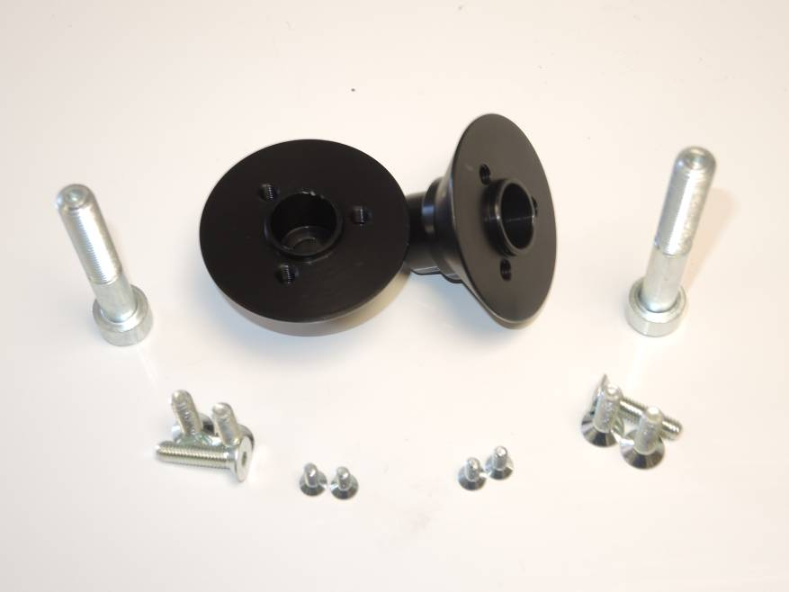
1
1
Assembly:
2
- Dismantle bolts M10 from chassi.
2
- Insert bolts ID.2 into the alu. spacers.
- These kits assembly from left and right side chassi. For left side use shorter bolt and spacer.
- Place sliders on the spacers and fix it by bolts ID.3.
- Insert alu. cover and fix it by bolts ID.4.

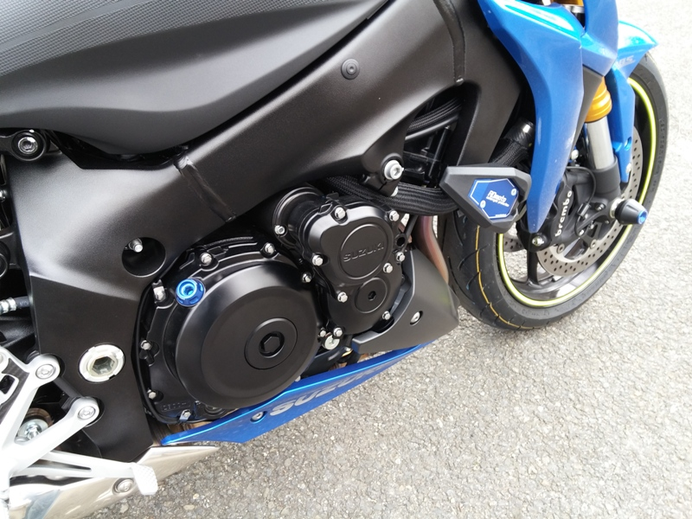
Note: Use gule of all threads during assembly.
4
3
4
3

