S41SDM
Suzuki GSX-S1000 /F

Kit for the left side: Kit for the right side:
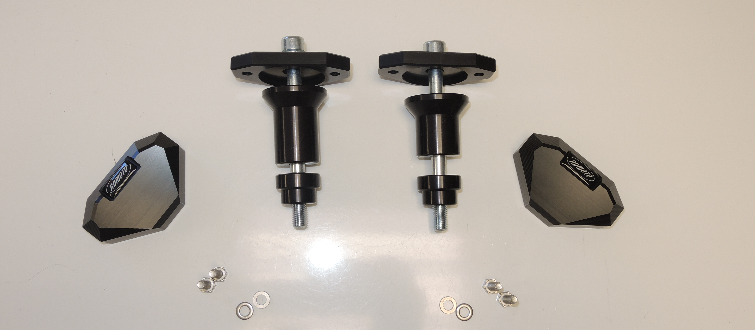
ID1
ID2
ID4
ID | Description | Cat.N | Qty
1 | Alu.adapter for slider | 537/B | 1
2 | Alu. spacer (kuželovitý) | 13 | 1
3 | Alu spacer d=20mm | 1188 | 1
4 | Bolt M10x120x1,25 | 895 | 1
5 | Bolt M6x20 | 1024 | 2
6 | Washer M6 | 1023 | 2
ID | Description | Cat.N | Qty
1 | Alu.adapter for slider | 537/B | 1
2 | Alu. spacer (kuželovitý) | 12 | 1
3 | Alu spacer d=20mm | 1188 | 1
4 | Bolt M10x120x1,25 | 895 | 1
5 | Bolt M6x20 | 1024 | 2
6 | Washer M6 | 1023 | 2
Ilustrační foto
ID3
ID5
ID6
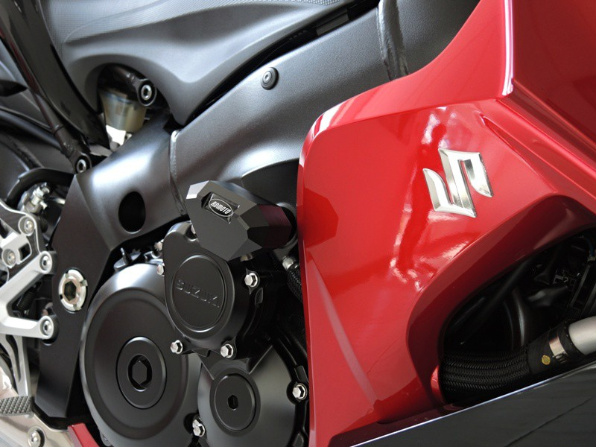
Instructions:

- Remove original bolts from the frame of motorcycle.
- Fit slider adapter (ID1 + ID2 + ID3 + ID4) on the frame of motorcycle in order according to the picture above.
- Fit slider on slider adapter using two M6 bolts.

Warning – we recommend to use safety glue on threads of all bolts (moderate strong – blue colour).

