S41S
Suzuki GSX-S1000F
Left side: Right side:
ID | Description | Cat. | Qt
1 | Slider adapter | 316 | 1
2 | Dural roller | 1188 | 1
3 | Screw M10x75x1,25 | 938 | 1
4 | Screw M6x25 | 877 | 3
5 | Screw M4x12 | 876 | 2
ID | Description | Cat. | Qt
1 | Slider adapter | 316 | 1
2 | Dural roller | 1188 | 1
3 | Screw M10x85x1,25 | 934 | 1
4 | Screw M6x25 | 877 | 3
5 | Screw M4x12 | 876 | 2

We recommend to use medium strong glue on all threads.
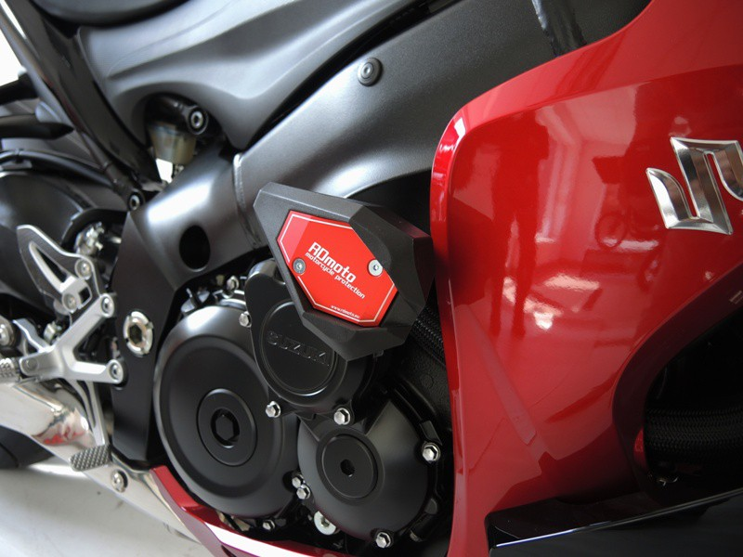
Installation:
- Remove original screws from frame.
- Fit slider adapter (ID1) and dural roller (ID2) using screw M10 (ID3.1 – left side) + (ID3.2 – right side) according to the picture below.
- Fit slider on slider adapter with three M6 screws (ID4).
- Fit Colored cover on slider with two M4 screws (ID5).
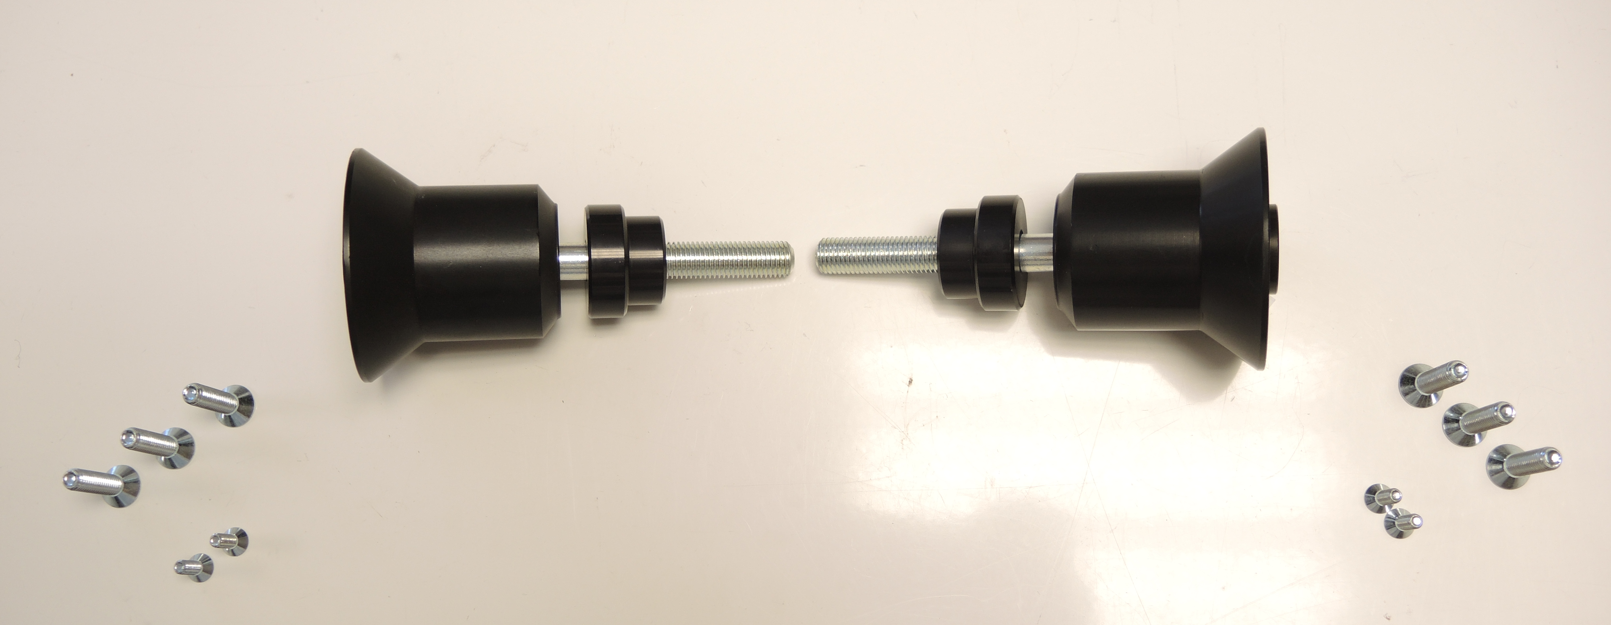
ID4
ID4
ID5
ID5
ID1
ID3.1
ID3.2
ID2
ID1
ID2

