S41
Suzuki GSX-S1000F ´16-
Left side: Right side:
ID | Description | Cat. | Qt
1 | Steel insert | X1 | 1
2 | Bolt M10x90x1,25 | 890 | 1
3 | Alu.spacer d=20 | 1188 | 1
ID | Description | Cat. | Qt
1 | Steel insert | X1 | 1
2 | Bolt M10x100x1,25 | 892 | 1
3 | Alu.spacer d=21,5 | 1189 | 1

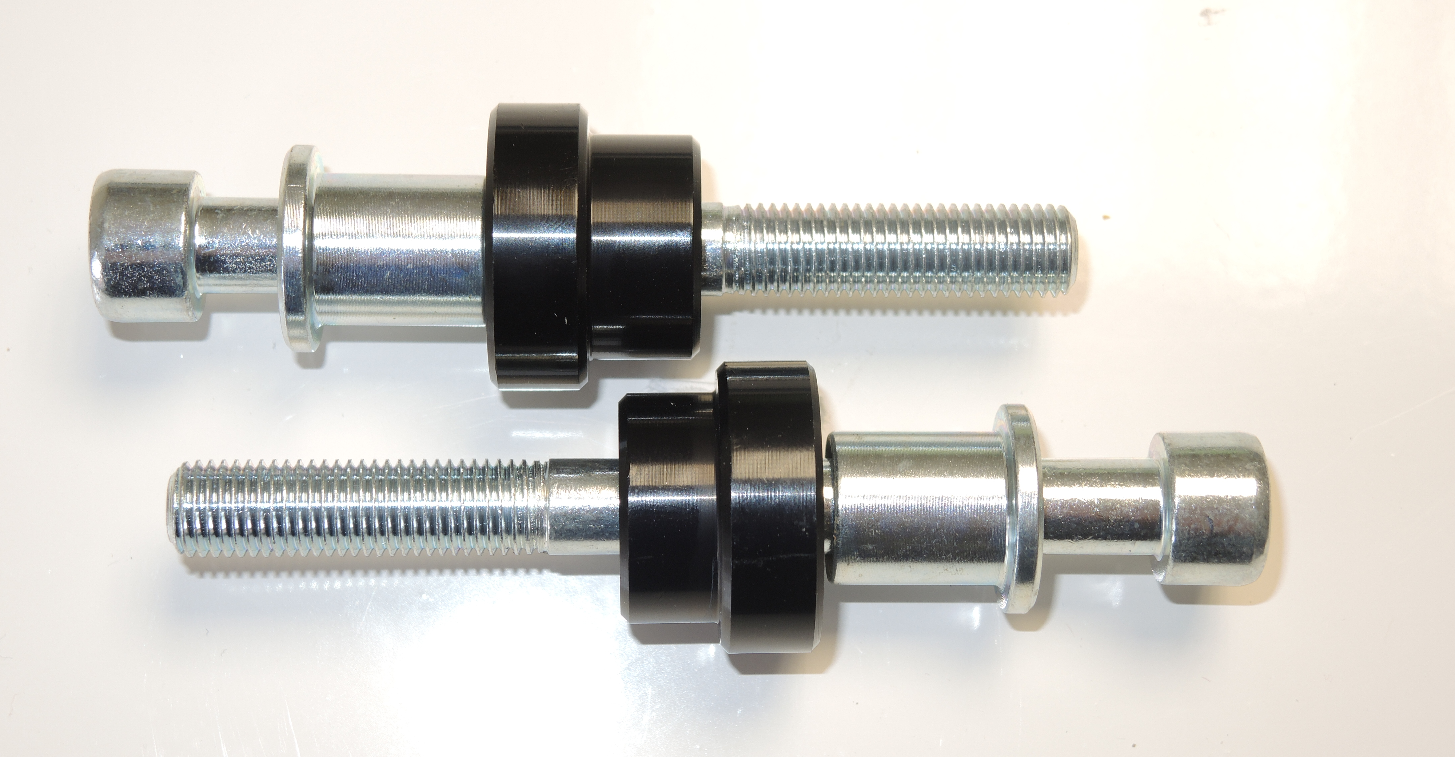
1
3
2

2

3
1

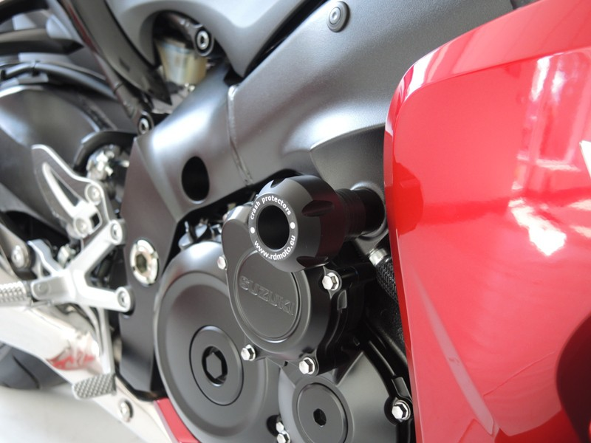
Instructions:

- Start with the left side.
- Insert ID.1 into the protectors.
- Place alu spacers under protectors. For the left side use bolt M10x90 for tightening.
- For the right side use bolt M10x110 for tightening.

Note: Use gule of all threads during assembly.

