S42SD
Suzuki SV 650 2018-

Kit for the Left Side: Kit for the Right Side:
ID | Description | Cat.No | Pcs
1 | Dural. sleeve l=52,5 | 1309 | 1
2 | Lock nut M12 | 811 | 1
3 | Bolt M8x25 | 815 | 2
4 | Washer M8 | 800 | 2
5 | Dural. sleeve l=23,5 | 257 | 1
6 | SLD Adapter | 537 | 1
7 | Rod M12x405x1,25 |  | 1
ID | Description | Cat.No | Pcs
1 | Dural. sleeve l=52,5 | 1309 | 1
2 | Lock nut M12 | 811 | 1
3 | Bolt M8x25 | 815 | 2
4 | Washer M8 | 800 | 2
5 | Dural. sleeve l=23,5 | 257 | 1
6 | SLD adapter | 537 | 1
7

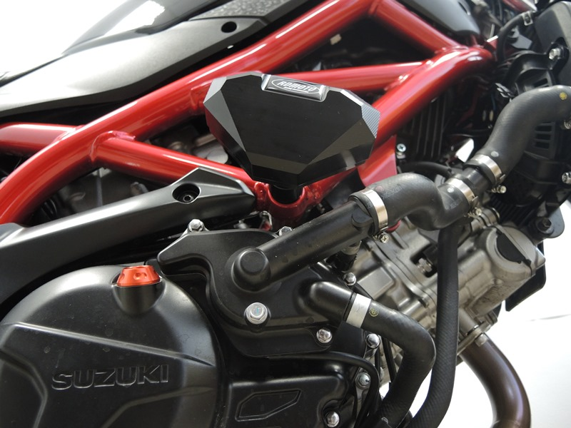

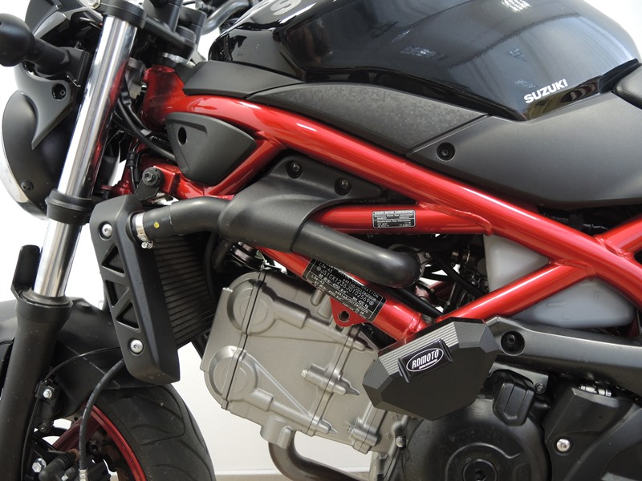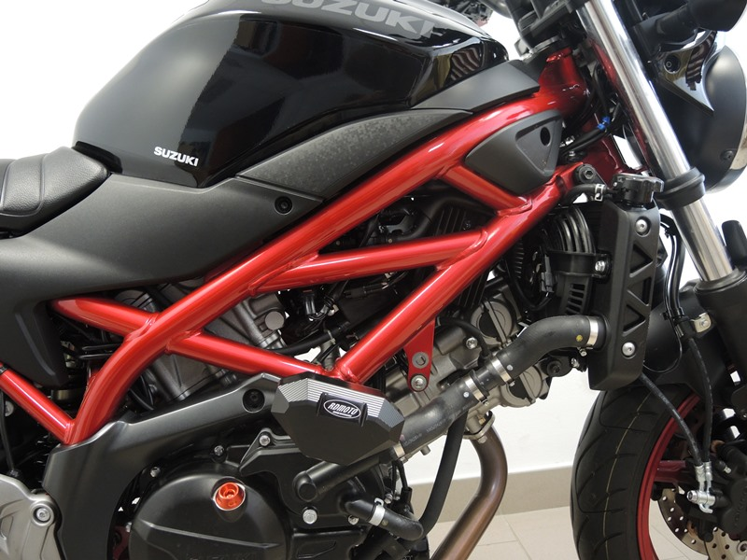

Mounting – left and right side:
- Remove the original M12 bolts that runs through the motorcycle frame.
- Insert the M12 (ID7) rod through the frame and place sleeve (ID 1), sleeve (ID5) and SLD adapter (ID 6) on both sides. Tighten in both sides with M12 nuts (ID 2)
- Attach the slider with M8 bolts (ID3) and M8 washers (ID4).

Warning - We recommend using medium strength thread glue during assembly.

