S42S
Suzuki SV 650 2018-

Mounting Kit Left Side: Mounting Kit Right Side:
ID | Description | Cat.No | Pcs
1 | Dural.roller d=77mm | 300 | 1
2 | Steel nut M12 | X12 | 1
3 | Bolt M6x25 | 877 | 3
4 | Bolt M4x16 | 876 | 2
5 | Rod M12x405x1,25 |  | 1
ID | Description | Cat.No | Pcs
1 | Dural.roller d=77mm | 300 | 1
2 | Steel nut M12 | X12 | 1
3 | Bolt M6x25 | 877 | 3
4 | Bolt M4x16 | 876 | 2

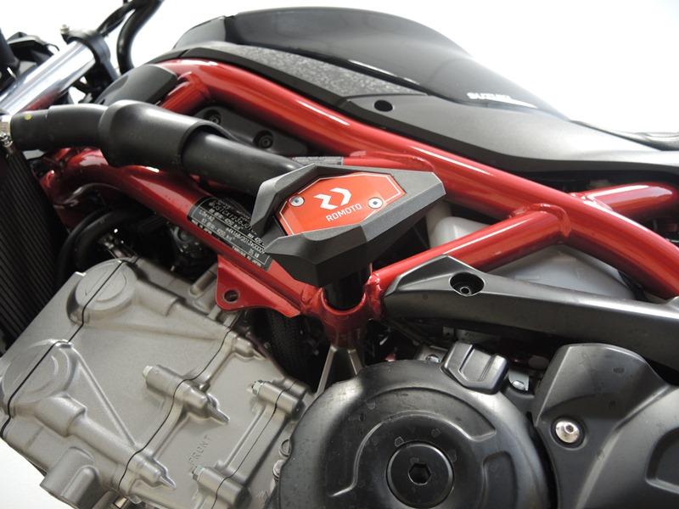

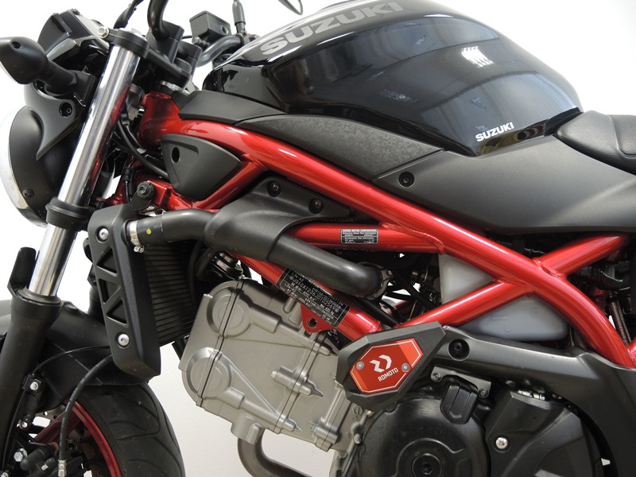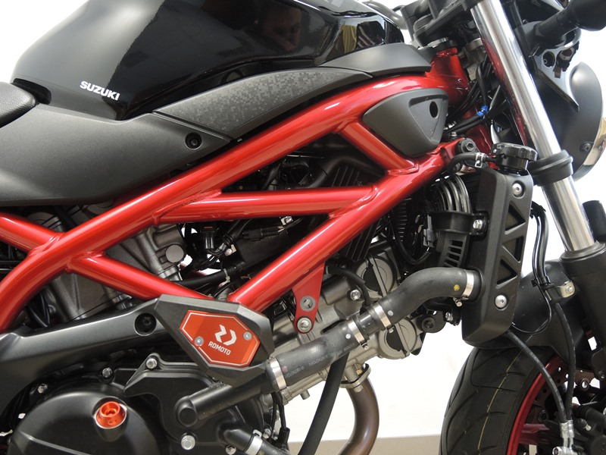

Mounting instructions for both sides:
- Unscrew the original M12 bolt which goes through the motorcycle.
- Take the ID.5 M12 rod and push it through the frame, equipping it with ID.1 roller from both sides. Finally, tighten it on both sides using ID.2 M12 steel nuts.
- Use ID.3 M6 bolts to attach the slider and ID.4 M4 bolts to attach the cover.

Note: We recommend using blue medium strenght thread glue during assembly.

