S42
Suzuki SV 650 2018-

Mounting Kit Left Side: Mounting Kit Right Side:
ID | Description | Cat.No. | Pcs
1 | Dural. roller d=52,5 | 1309 | 1
2 | Steel nut M12 | X12/X2 | 1
3 | Rod M12x430x1,25x30x30 |  | 1
ID | Description | Cat. No. | Pcs.
1 | Dural. roller d=52,5 | 1309 | 1
2 | Steel nut M12 | X12/X2 | 1

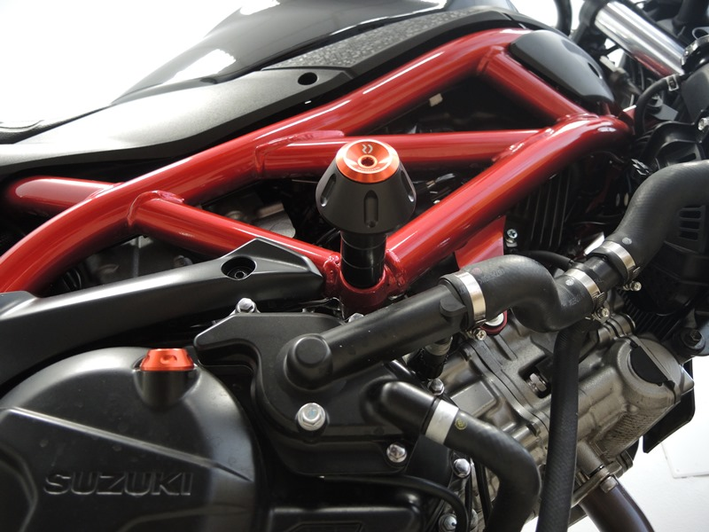
1

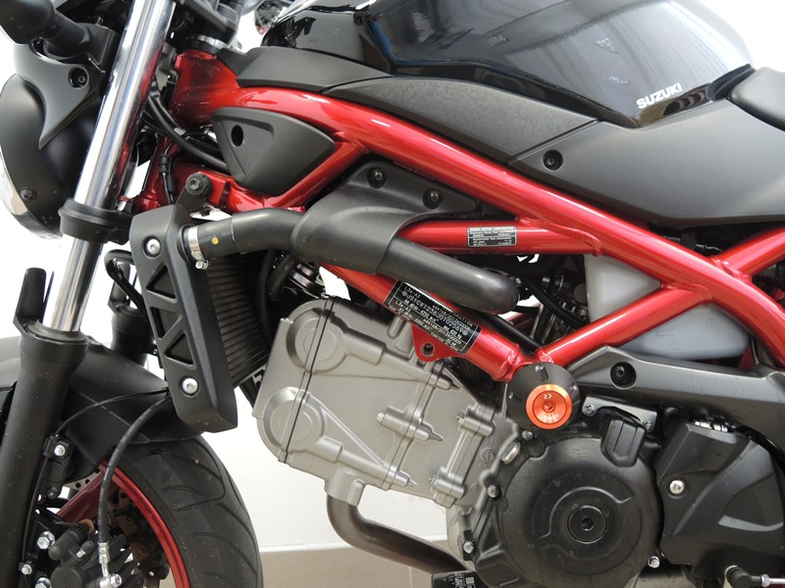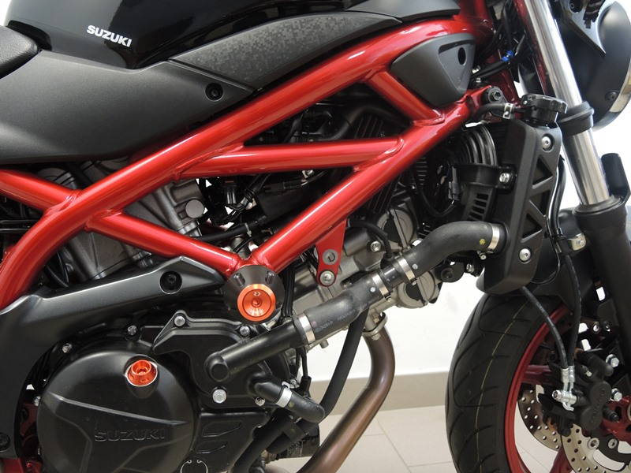

Mounting instructions for both sides:
- Unscrew original M12 bolt going through the motorcycle frame.
- Take the ID.3 M12 rod and push it through the frame. Then equip it with ID.1 roller, crash protector and M12 ID.2 steel nut from both sides.
- Finally, tighten all bolts on both sides.

Note: We recommend using medium strenght thread glue during assembly (blue color).

