S43SD
Suzuki GSX-S 750 2017-

Mounting kit:

No. | Description | Cat.no. | Pcs
1 | Slider holder | 537 | 2
2 | Bolt M10x105x1,25 | 893 | 2
3 | Dural. cylinder d=37mm left side | 195 | 1
4 | Dural. cylinder d=35mm right side | 189 | 1
5 | Cone.spacer d=15mm | 9 | 2
6 | Bolt M8x25 | 815 | 4
7 | Washer M8 | 802 | 4

Installation:

- Dismantle original bolts from chassi.
- Insert ID.1, ID.5 and ID.3 on the bolt ID.2. (left side). This kit fix into the engine thread.
- Insert ID.1, ID.5 and ID.4 on the bolt ID.2. (right side). This kit fix into the engine thread.
- Place slider and use bolts ID.6 with washers ID.7 and mount slider on the aluminium holder.

Warning – we recommend to use safety glue on threads of all bolts (moderate strong – blue colour).

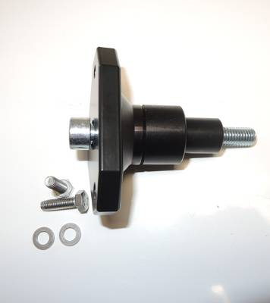
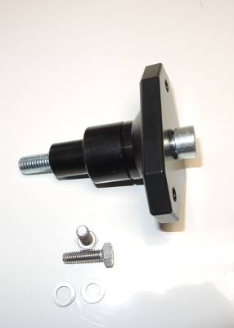
1
1
5
3
2
5
2
4

7
7
6
6
