S47SD
Suzuki GSX-S1000 ´15-
Kit for the Left Side: Kit for the Right Side:
ID | Description | Cat.No | Pcs
1 | SLD sleeve l=20mm | 292 | 1
2 | Bolt M10x45 | 848 | 1
3 | Dural.sleeve l=15 | 1281 | 2
4 | Bolt M10x65x1,25 | 945 | 2
5 | Plastic cap | X4 | 2
6 | Aluminum adapter left | 735 | 1
7 | Bolt M8x25 | 815 | 2
8 | Washer M8 | 800 | 2
9 | SLD adapter | 537 | 1
10 | Spring washer M10 | 801 | 1
ID | Description | Cat.No | Pcs
1 | SLD sleeve l=20mm | 292 | 1
2 | Bolt M10x45 | 848 | 1
3 | Dural. sleeve d=15mm | 1281 | 1
4 | Dural. sleeve d=10mm | 1282 | 1
5 | Plastic cap | X4 | 2
6 | Bolt M10x75x1,25 | 938 | 1
7 | Bolt M10x70x1,25 | 898 | 1
8 | Aluminum adapter- right | 734 | 1
9 | Bolt M8x25 | 815 | 2
10 | Washer M8 | 800 | 2
11 | SLD adapter | 537 | 1
12 | Spring washer M10 | 801 | 1

3 - front
6 - front
4
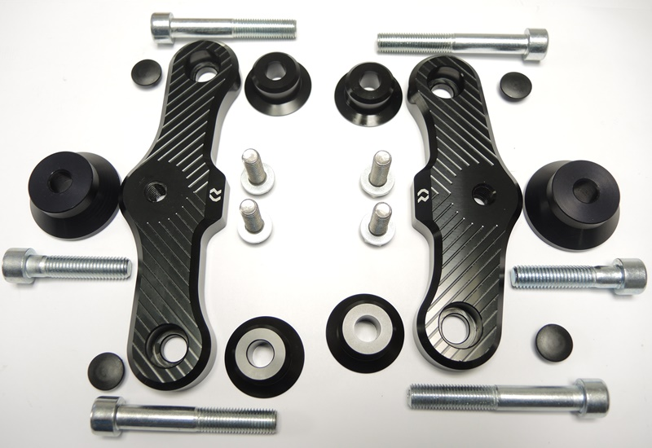

1
1
6 - left
8 - right
9,10

3
3

2
2
7,8

5
5

4 - rear
7 - rear
4
Instructions:
- Remove original bolts on the right side.
- Insert the bolt (ID6) in the front part into the adapter (ID 8), insert the sleeve (ID3), insert the bolt (ID7) in the rear part and insert the sleeve (ID4). Mount this assembly in the motorcycle frame.
- Place on the bolt M10 (ID2), spring washer M10 (ID12), SLD adapter (ID11) and sleeve (ID1). Mount this assembly in the adapter on the motorcycle.
- Attach the slider using bolts M8 (ID9) and washer M8 (ID10)
- Tighten all bolts and put on plastic caps (ID5)
- Finish one side first then assemble the other side

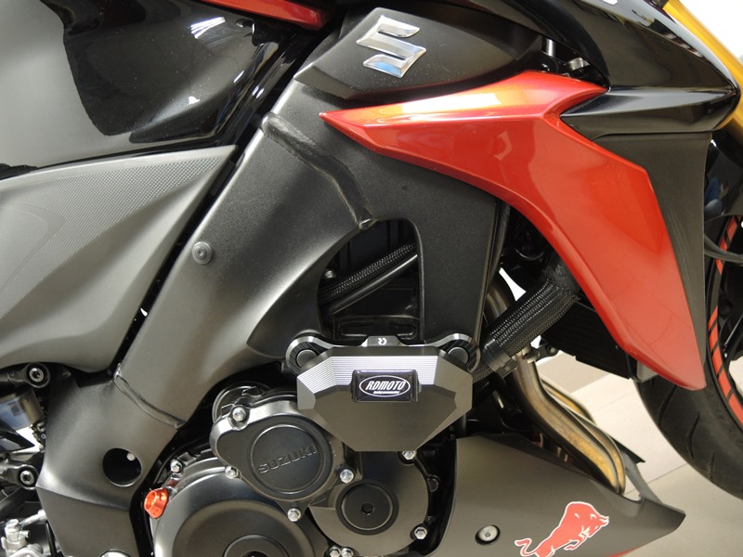
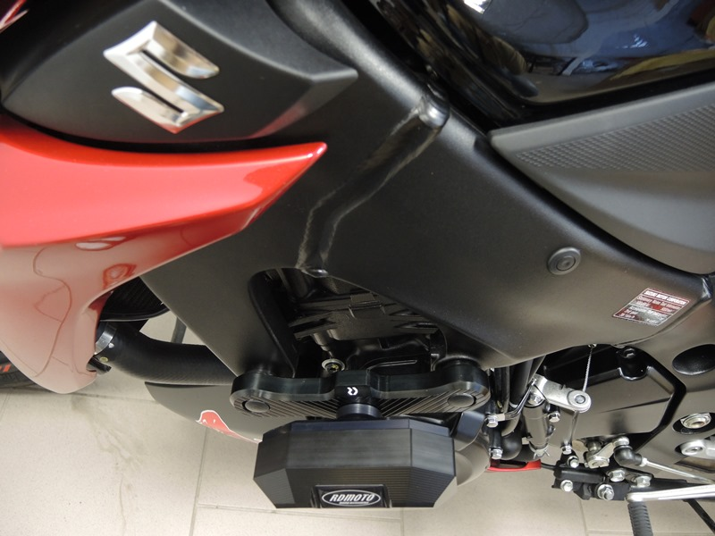
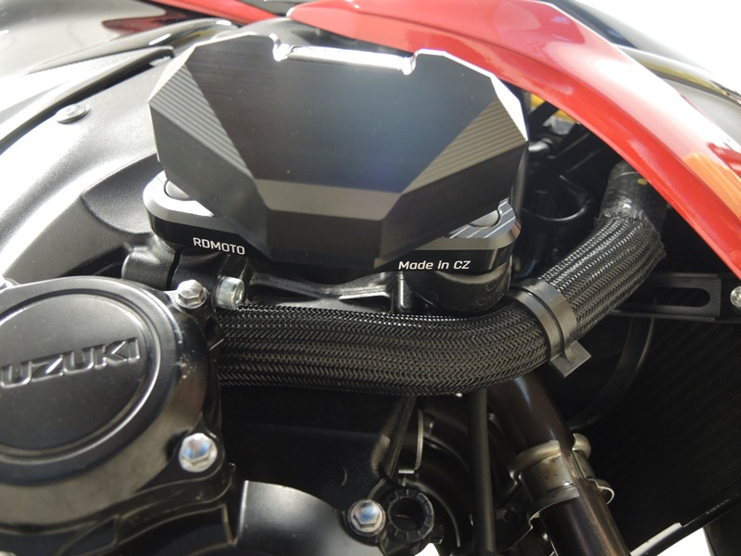
Warning - We recommend using medium strength thread glue during assembly

