S47S
Suzuki GSX-S1000 ´15-
Mounting Kit Left Side: Mounting Kit Right Side:
ID | Description | Cat. No. | Pcs.
1 | SL adapter | 292 | 1
2 | Bolt M10x30 | 882 | 1
3 | Dural.roller d=15 | 1281 | 2
4 | Bolt M10x65x1,25 | 945 | 2
5 | Plastic cover | X4 | 2
6 | Aluminium adapter-Left side | 735 | 1
7 | Bolt M6x25 | 877 | 3
8 | Bolt M4x16 | 876 | 2
ID | Description | Cat. No. | Pcs.
1 | SL adapter | 292 | 1
2 | Bolt M10x30 | 882 | 1
3 | Dural.roller d=15 | 1281 | 1
4 | Dural.roller d=10mm | 1282 | 1
5 | Plastic cover | X4 | 2
6 | Bolt M10x75x1,25 | 938 | 1
7 | Bolt M10x70x1,25 | 898 | 1
8 | Aluminium adapter – Right side | 734 | 1
9 | Bolt M6x25 | 877 | 3
10 | Bolt M4x16 | 876 | 2

4
3 - front
6 - front
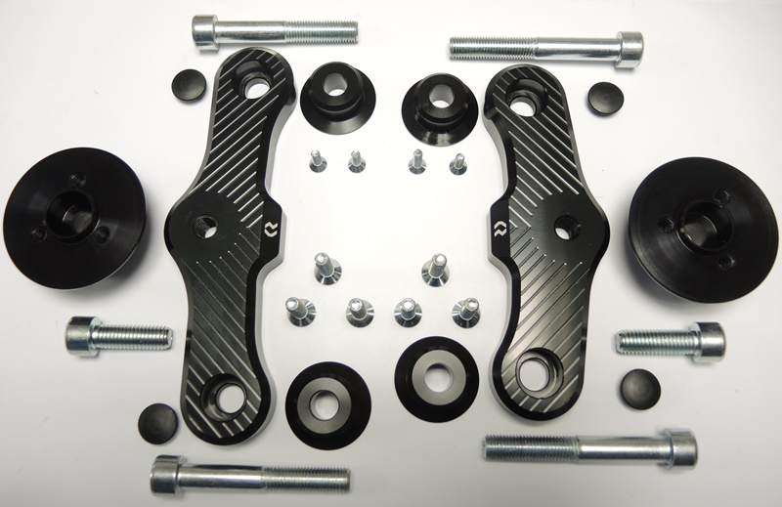

1
1
6 - left
8 - right

10
3
3
8

9
7

2
2

5
5

7 - rear
4 - rear
4

Mounting instructions
- Unscrew the original bolts on right side.
- Put the ID.6 bolt into the front part of ID.8 adapter and fit with ID.3 roller. In rear part, do the same with ID.7 bolt and ID.4 roller. Then, mount this assembly into the motorcycle frame.
- Now put the ID.1 Sl Adapter onto the ID.2 bolt and mount into adapter already on your motorcycle.
- Use the M6 ID.9 bolts to fit the slider and M4 ID.10 bolts to fit the cover.
- Finally, tighten all screws and fit the ID.5 covers.
- We recommend fully finishing one side before proceeding with the other.

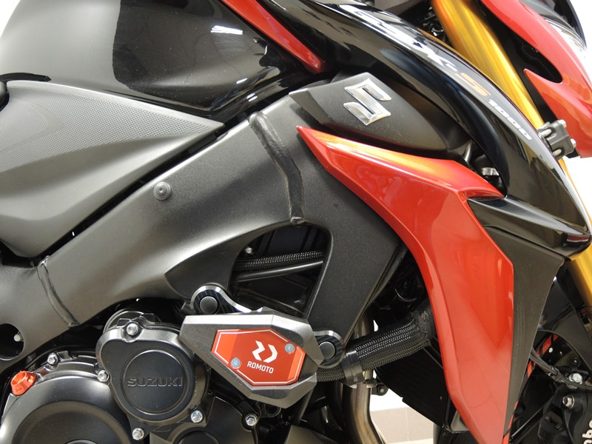
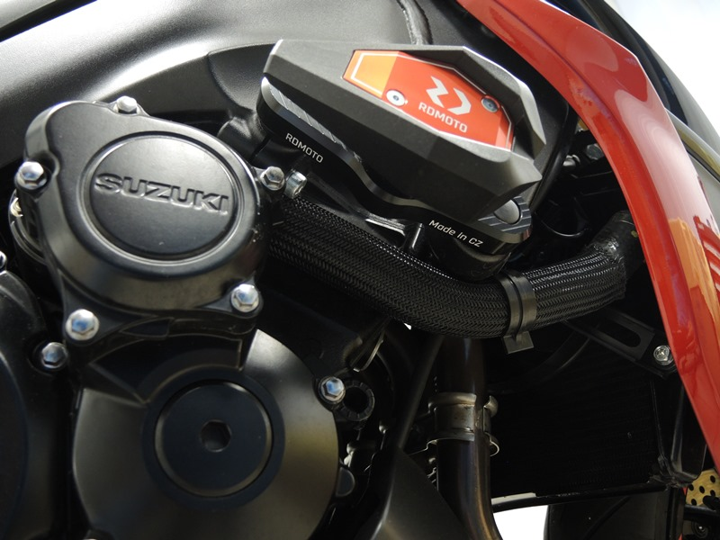
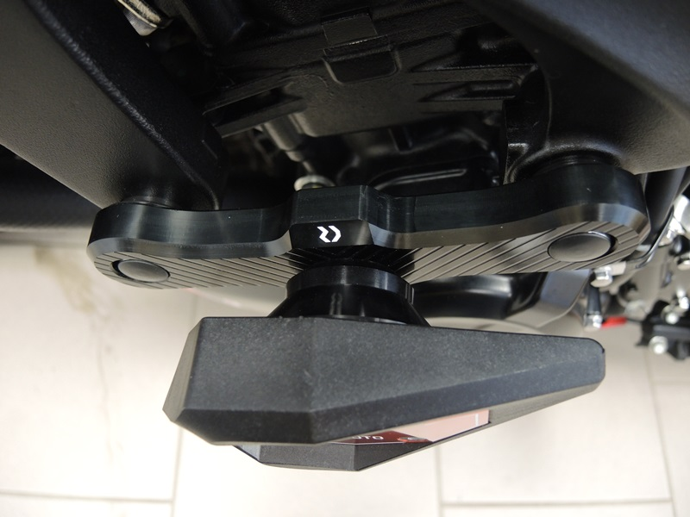
Note: We recommend using medium strenght thread glue (blue color) during assembly.

