S47
Suzuki GSX-S1000 ´15-
Mounting Kit Left Side: Mounting Kit Right Side:
ID | Description | Cat.No. | Pcs
1 | Steel Insert | X1 | 1
2 | Bolt M10x40 | 854 | 1
3 | Dural.Roller d=15 | 1281 | 2
4 | Bolt M10x65x1,25 | 945 | 2
5 | Plastic cover | X4 | 2
6 | Aluminium adapter-left side | 735 | 1
7
ID | Description | Cat.No. | Pcs.
1 | Steel Insert | X1 | 1
2 | Bolt M10x40 | 854 | 1
3 | Dural.Roller d=15mm | 1281 | 1
4 | Dural.Roller d=10mm | 1282 | 1
5 | Plastic cover | X4 | 2
6 | Bolt M10x75x1,25 | 938 | 1
7 | Bolt M10x70x1,25 | 898 | 1
8 | Aluminium adapter – right side | 734 | 1

6 - front
4
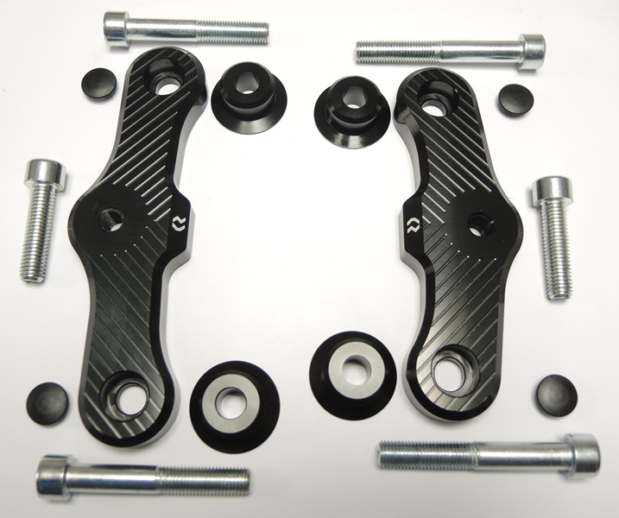

6 - left
8 - right

2
2
3 - front

3
3

4 - rear

5
5

7 - rear
4

Mounting Instructions
- Unscrew original bolts on the right side.
- Take the ID.8 adapter and push through ID.6 bolt with ID.3 roller at the front part. In rear part, do the same with ID.7 bolt and ID.4 roller. When you have the full assembly, take it and mount into the motorcycle frame.
- Now equip the ID.2 bolt with ID.1 steel insert and the crash protector.
- Fully set-up protector now mount into the adapter on your motorcycle.
- Finally, tighten all bolts and put the ID.5 plastic covers on them.
- Remmember to fully finish one side before moving onto the other one.

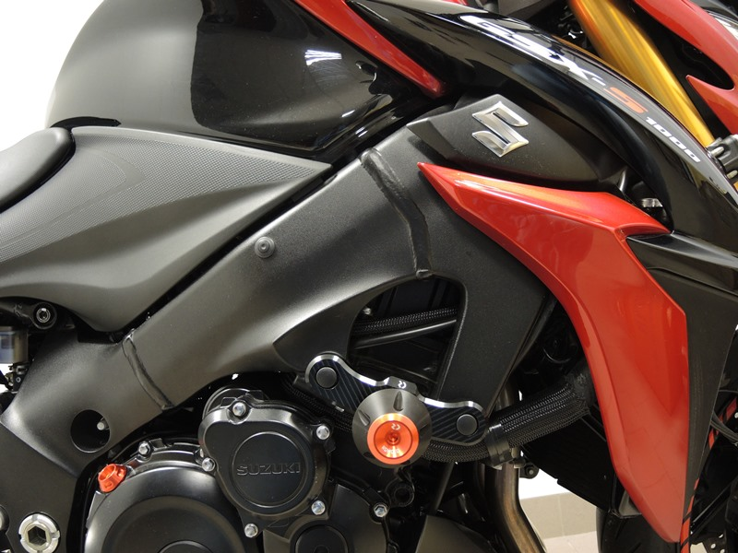
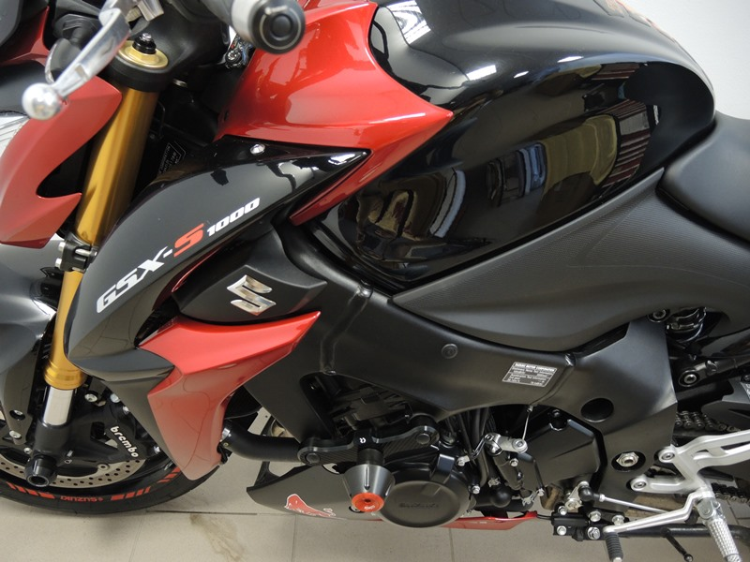
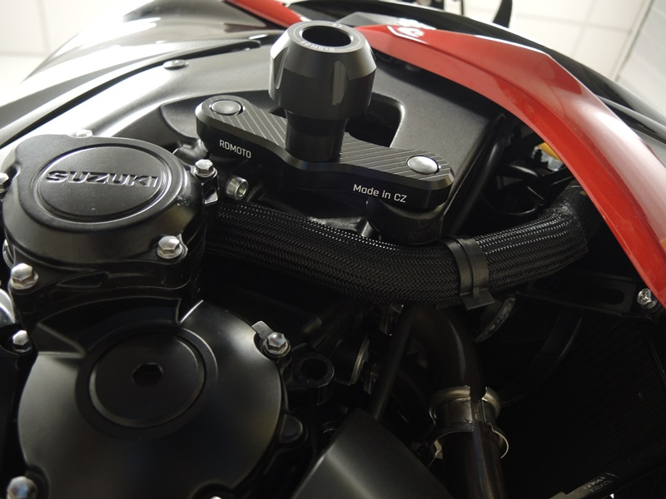
Note: We recommend using medium strenght thread glue during assembly (blue color).

