S4S
Suzuki SV1000 N/S 2003-

No. | Description | Cat.n | Pc
1 | Adapter moto d=56 | DV-334 | 1
2 | Bolt M10x105x1,25mm | 893 | 1
3 | Bolt M6x25 | 877 | 3
4 | Bolt M4x16 | 876 | 2
5 | Washer M10 | 801 | 1
No. | Description | Cat.n | Pc
1 | Adapter moto d=58 | DV-333 | 1
2 | Bolt M10x85x1,25mm | 934 | 1
3 | Bolt M6x25 | 877 | 3
4 | Bolt M4x16 | 876 | 2
5 | Washer M10 | 801 | 1
Left side kit: Right side kit:

Installation – the left side:

- remove the original bolt
- use the bolt (No. 2) for mounting of duralumin cylinder (No. 1).
- Use the bolts (No. 6) for mounting
- insert in slider the plate and use the bolts (No. 8) for gripping
Installation – the right side:
- remove the original bolt
- use the bolt (No. 2) for mounting of duralumin cylinder (No. 1).
- Use the bolts (No. 6) for mounting
- insert in slider the plate and use the bolts (No. 8) for gripping

Warning – we recommend to use safety glue on threads of all bolts (moderate strong – blue colour).

ILLUSTRATIVE PHOTOS OF Place of the installation

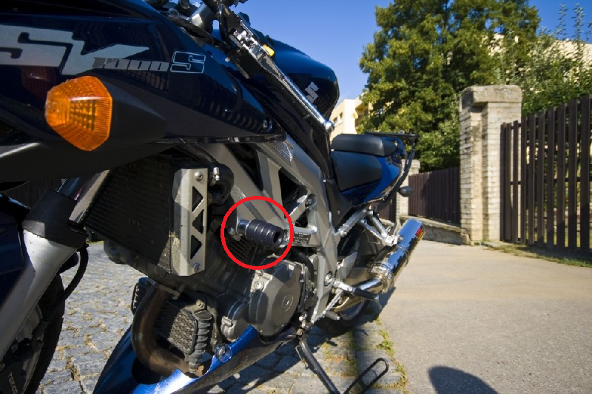

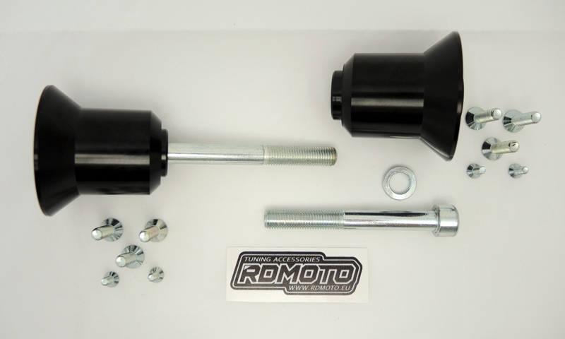

1

1

2
3
5
3
5
2
4
4

