S4
Suzuki SV 1000

Fitting kit left side: Fitting kit right side:
ID | Description | Cat.N | Qt
1 | Alu. spacer d=33mm | 47 | 1
2 | Bolt M10x140x1,25 | 923 | 1
3 | Steel sleeve | X1 | 1

Assembly:
ID | Description | Cat.N | Qt
1 | Alu. spacer d=35mm | 46 | 1
2 | Bolt M10x120x1,25 | 895 | 1
3 | Steel sleeve | X1 | 1
- Dismantle original bolts from chassi.
- Insert steel sleeve ID.3. into the protectors. Under the protectors place alu. spacers. For left side spacer lenght 35mm. Tighten it by bolt ID.2 M10x140x1,25.
- Assembly for right side is same. There are only different snes bolt and spacer.

Note: We recommend to use medium glue for threads during assembly.
2
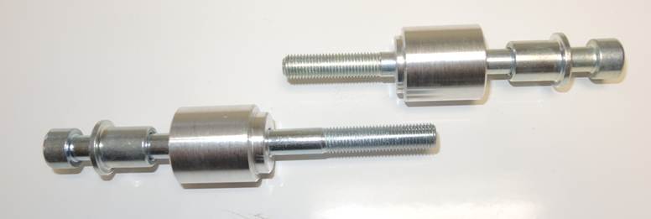

3
2
1

1
3

