S5
Suzuki GSX-R600 SRAD 1997-2000
Suzuki GSX-R750 SRAD 1996-1999

Kit for left side: |  |  |  |  | Kit for right side:
ID | Description | Cat.No. | QTY |  |  | ID | Description | Cat.No. | QTY
1 | Steel box M10 | X1 | 1 |  |  | 1 | Steel box M10 | X1 | 1
2 | Bolt M10x105x1,25mm | 893 | 1 |  |  | 2 | Bolt M10x105x1,25mm | 893 | 1
3 | dural. cylinder d=40mm | 45 | 1 |  |  | 3 | dural. cylinder d=30mm | 44 | 1

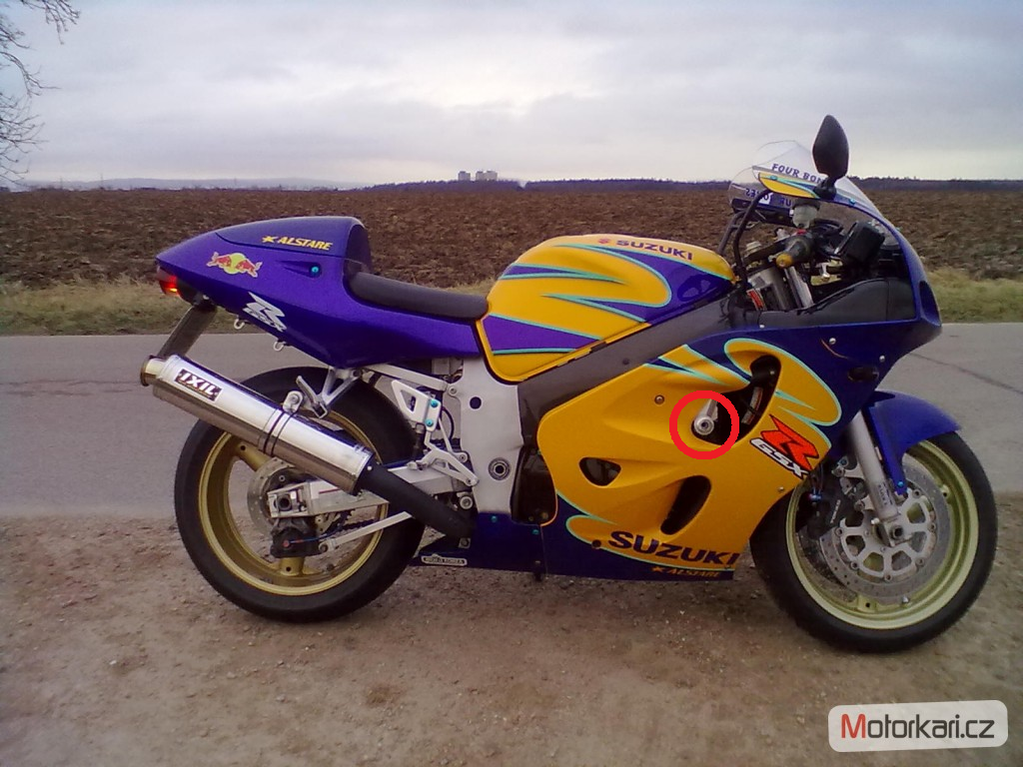
Instruction to Assemble:
- Remove the original bolts from frame.
- Put on the bolts steel box (ID1). Insert the dural. cylinder (ID3) under the bolt (ID2) and fixed, on the left side.
- Under the protector on the right side, insert dural cylinder d=30mm (ID3) and use bolt (ID2).
- The first time make left side and after do right side.

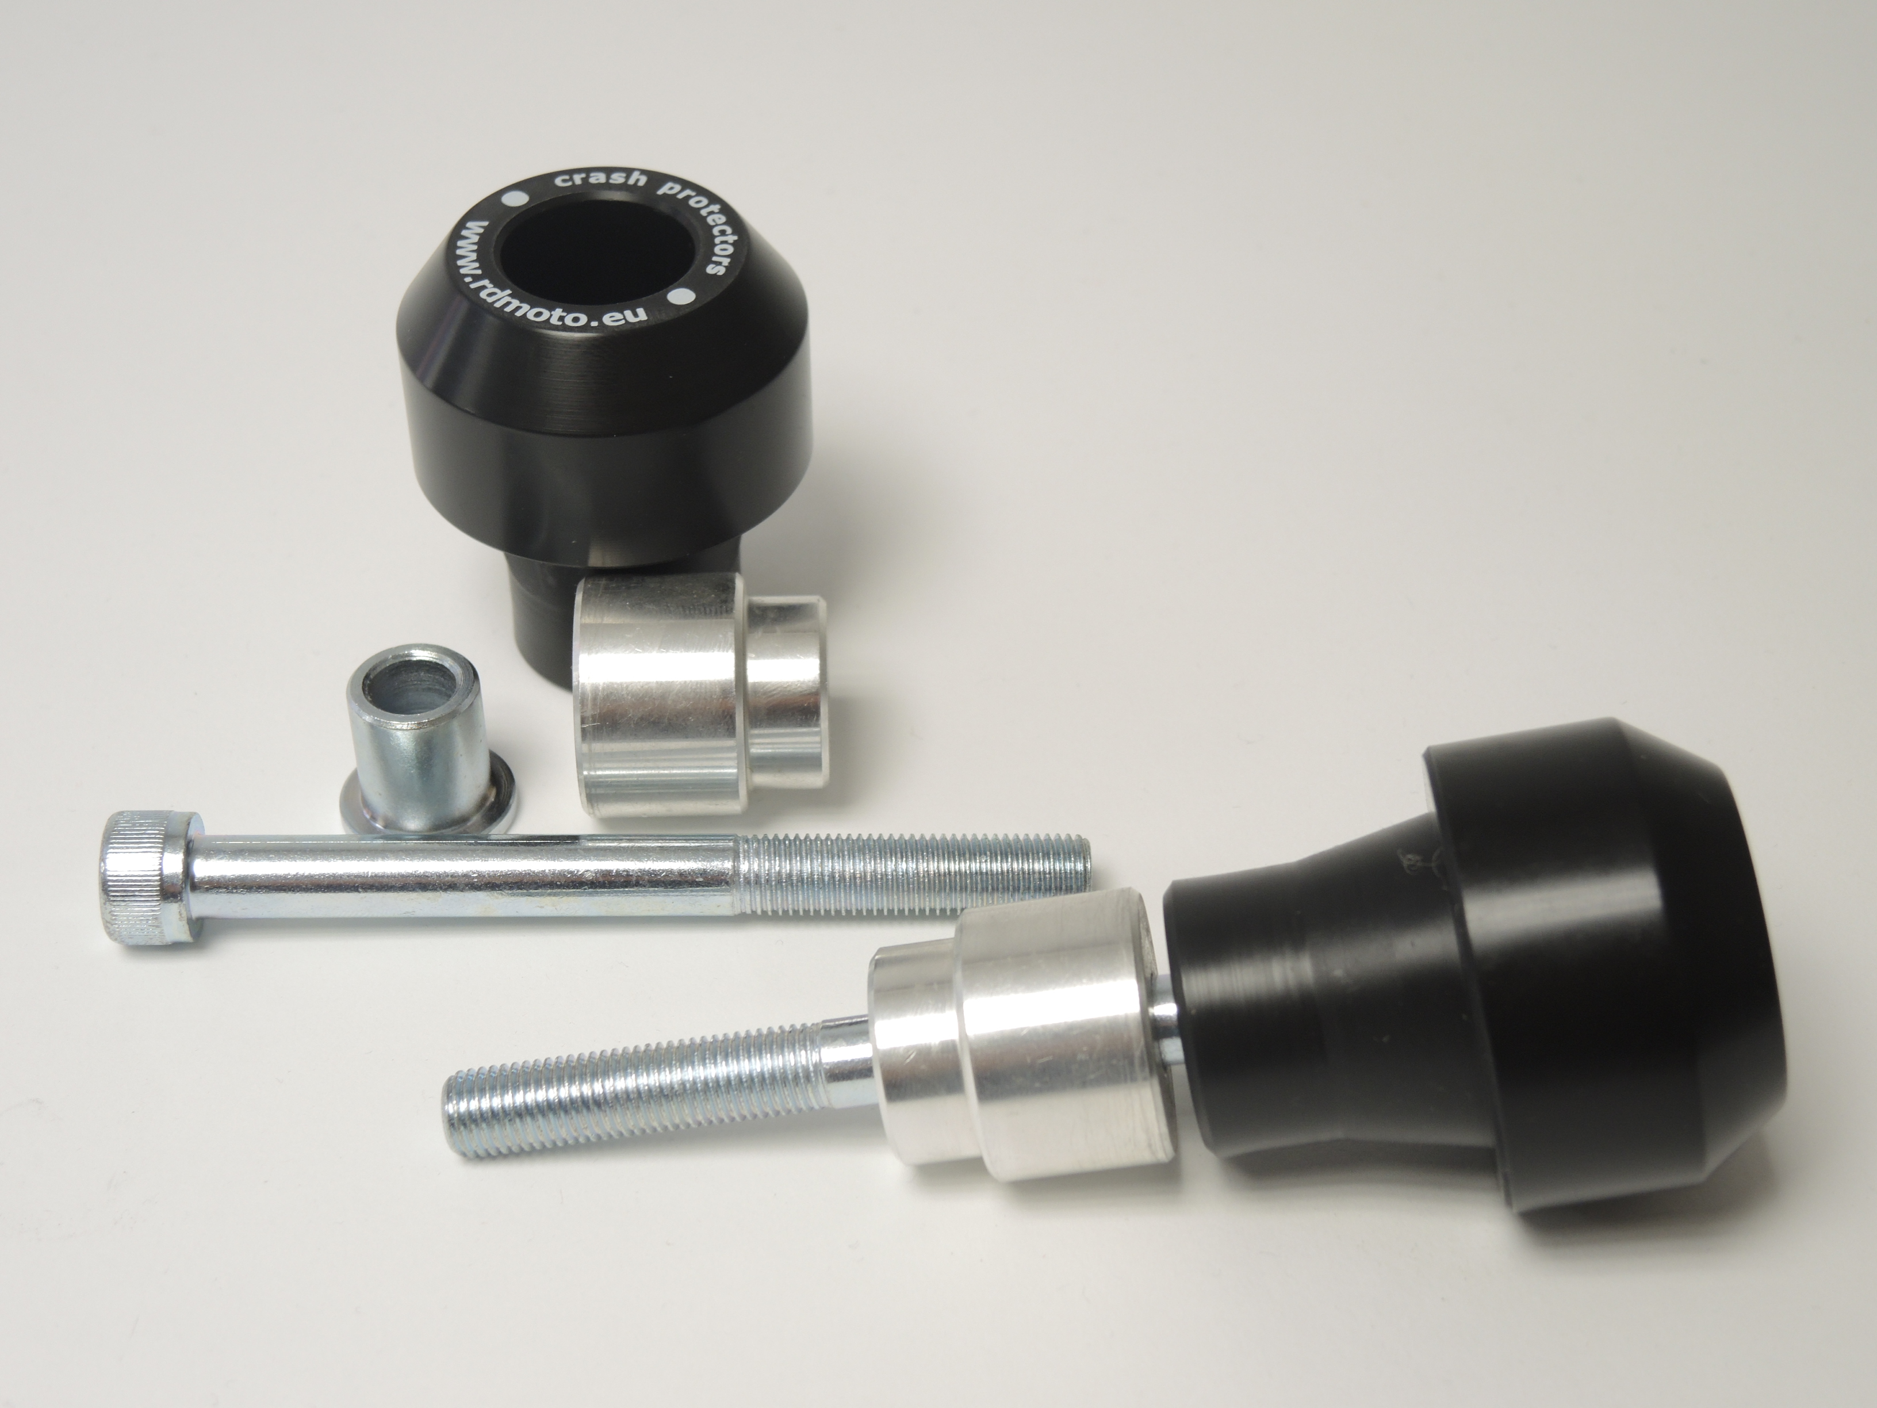
Warning - for the threads of the screws is recommended to use premium adhesive moderate (blue color)
PH01
2
1
3
2
3

