S6
Suzuki GSX-R600/750 ´01- ´03

Kit for the left side |  |  |  |  | Kit for the right side
ID. | Description | Cat.No. | Pcs |  |  | ID. | Description | Cat.No. | Pcs
1 | Steel box M10 | X1 | 1 |  |  | 1 | Steel box M10 | X1 | 1
2 | Bolt M10x100x1,25mm | 892 | 1 |  |  | 2 | Bolt M10x90x1,25mm | 890 | 1
3 | Dural. cylinder d=28mm | 67 | 1 |  |  | 3 | Dural. cylinder d=15mm | 65 | 1

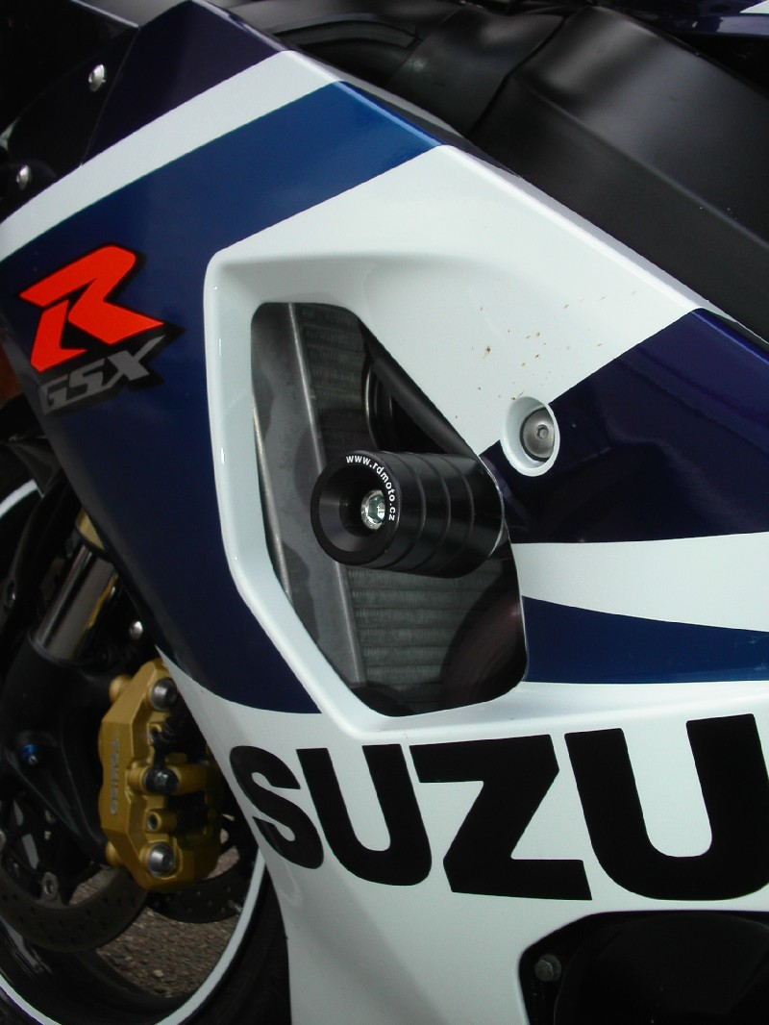
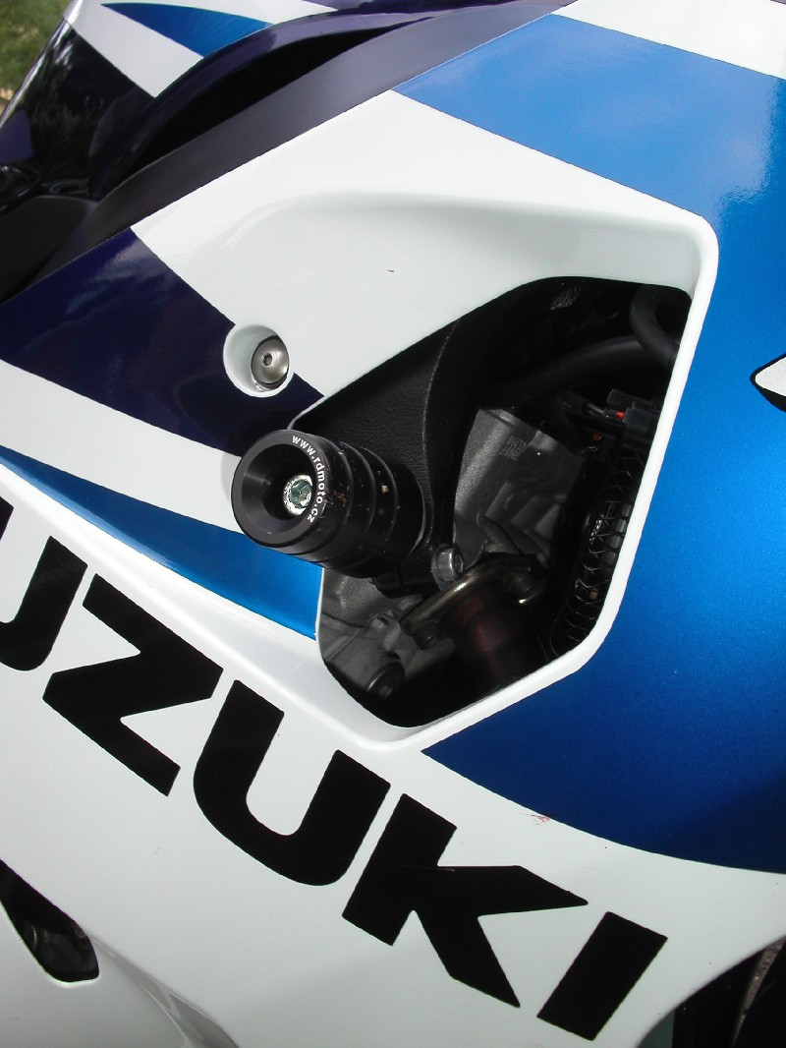

Ilustration photos of protectors.
Installation:
- Installation of the left and right protector make in gripping about the attached photo above.
- Give the steel box M10 ID.1 on both bolts.
- Put the duralumin cylinder ID.3 under the protector on the left side and use the bolt ID.2 for tightening.
- Put the duralumin cylinder ID.3 under the protector on the right side and use the bolt ID.2 for tightening.
- At first finish the one side and then mount the second side.

Warning – we recommend to use safety glue on threads of all bolts (moderate strong – blue colour).
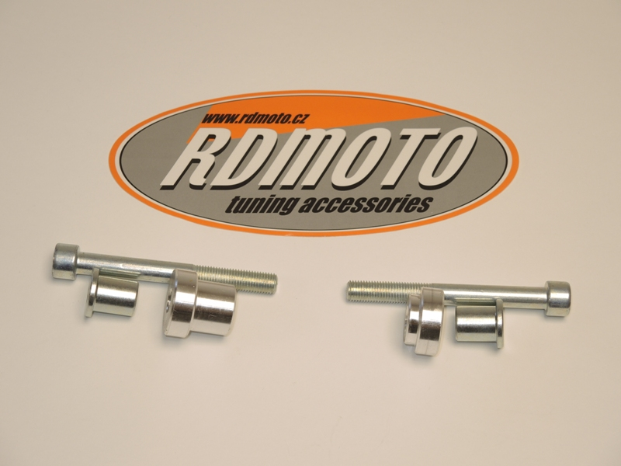

2
2
1
1
3
3

