S8SDM
Suzuki GSF 650 Bandit ´07-

LEFT SIDE KIT RIGHT SIDE KIT
ID | Description | Cat.no. | Pcs
1 | Bolt M8x40 | 828 | 2
2 | Frame alu adapter | 568 | 1
3 | Cylinder (cut) | 187 | 1
4 | Adapter | 566 | 1
5 | Bolt M8x20 | 823 | 2
6 | Bolt M12x40 | 858 | 1
7 | Bolt M8x30 | 834 | 1
8 | Washer M8 | 802 | 1
9 | Cylinder adapter | 283 | 1
10 | SLDM adapter | 537/B | 1
11 | Bolt M12x40 | 857 | 1
12 | Cylinder 15mm | DV149 | 1
13 | Bolt M6x20 | 1024 | 2
14 | Washer M6 | 1023 | 2
ID | Description | Cat.no. | Pcs
1 | Alu cilinder (cut) | 186 | 1
2 | Bolt M10x30 | 882 | 1
3 | Imbus cover | X4 | 1
4 | Steel stirrup | 950 | 1
5 | Nut M8 | 951 | 2
6 | Washer M8 | 802 | 2
7 | Bolt M12x40 | 858 | 1
8 | Cylinder adapter | 283 | 1
9 | Bolt M12x40 | 857 | 1
10 | SLDM adapter | 537/B | 1
11 | Adapter | 567 | 1
12 | 3M tape | 3M | 1
13 | Cylinder 15mm | DV149 | 1
14 | Bolt M6x20 | 1024 | 2
15 | Washer M6 | 1023 | 2

5
4
5
5,6
12
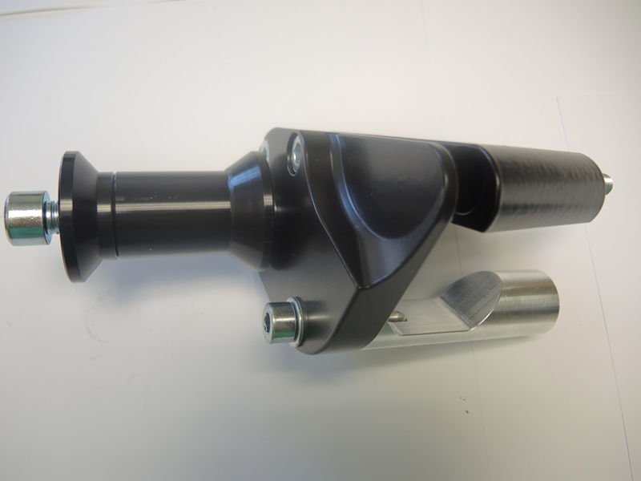
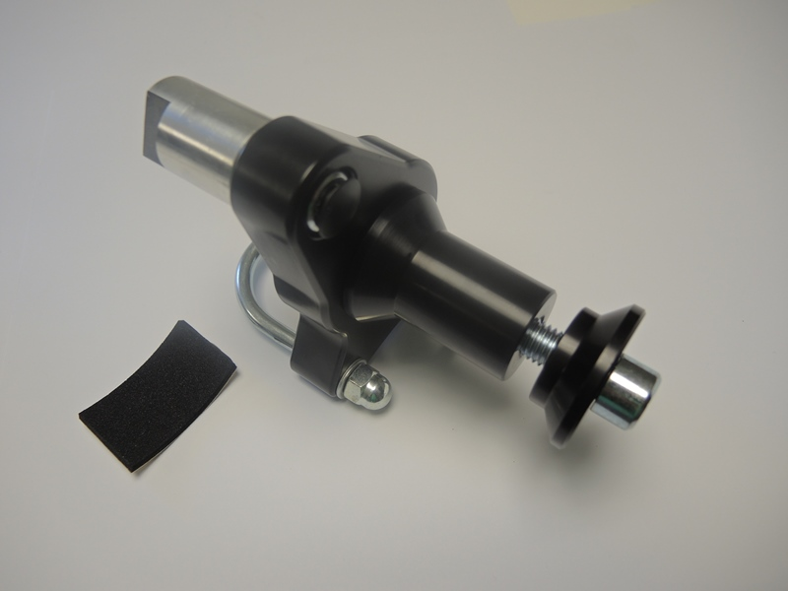
1
2,3
11
9
5
5
4
9
7
11
10
11
1
2
8
13
4

9
7, 8

5,6
3
7,8

1
2
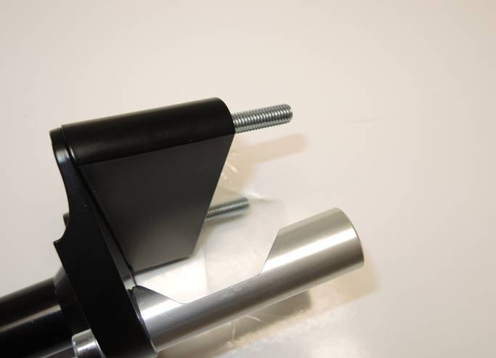
2
1
1

6

INSTRUCTIONS (LEFT SIDE)

- Unbolt bolts M8 from the frame of motorcycle.
- Fit adapter ID2 on the frame of motorcycle sing bolt ID1.
- Fit cylinder ID3 using bolt ID1 and ID8.
- Fit cylinder ID9 using bolt ID6.
- Fit whole kit on the frame using bolts ID5.
- Fit SLDM adapter ID10 and cylinder ID12 into cylinder ID9 using bolt ID11.
- Fit slider using bolts ID13 and washers ID14.

INSTRUCTIONS (RIGHT SIDE)

- Unbolt nut from the frame. Mount cylinder iD1 into it.
- Fit cylinder ID8 on the adapter ID11 using bolt ID7.
- Stick 3M tape on the frame. Place stirrup ID4 using nuts ID5 + ID6.
- Fit whole kit into cylinder ID1 using bolt ID2 and cover ID3.
- Fit SLDM adapter ID10 and cylinder ID13 into cylinder ID8 using bolt ID9.
- Fit slider using bolts ID14 and washers ID15.

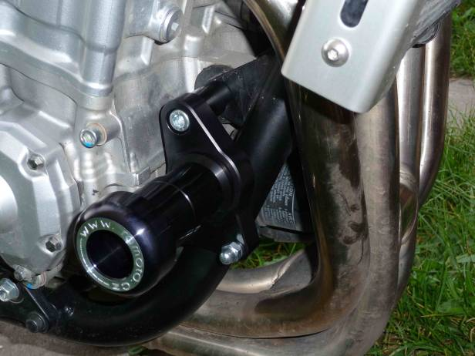
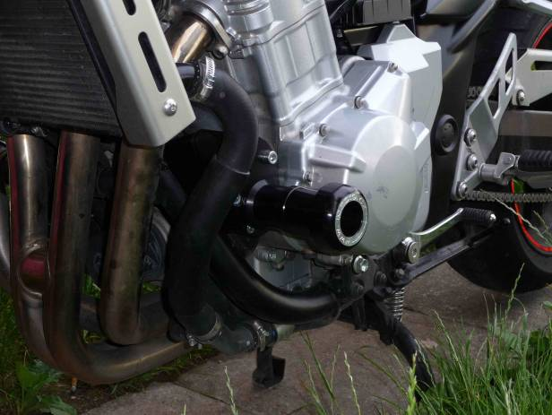
We recommend to use safety glue on all threads (medium strong).

