S8S
Suzuki GSX 650 Bandit ´07-

Left side kit: Right side kit:
ID | Description | Cat.no | Pcs
1 | Bolt M8x40 | 828 | 2
2 | Alu.adapter | 568 | 1
3 | Alu. cylinder | 187 | 1
4 | Steel adapter | 566 | 1
5 | Bolt M8x20 | 823 | 2
6 | Bolt M12x40 | 858 | 1
7 | Bolt M8x30 | 834 | 1
8 | Washer M8 | 802 | 1
9 | Slider adapter | 350 | 1
10 | Bolt M6x25 | 877 | 3
11 | Bolt M4x16 | 876 | 2
ID | Description | Cat.no | Pcs
1 | Alu. cylinder | 186 | 1
2 | Bolt M10x30 | 882 | 1
3 | Plastic cap | X4 | 1
4 | Steel stirrup | 950 | 1
5 | Nut M8 | 951 | 2
6 | Washer M8 | 802 | 2
7 | Bolt M12x40 | 858 | 1
8 | Steel adapter | 567 | 1
9 | Slider adapter | 350 | 1
10 | Bolt M6x25 | 877 | 3
11 | Bolt M4x16 | 876 | 2
12 | 3M tape | 3M | 1

ID4
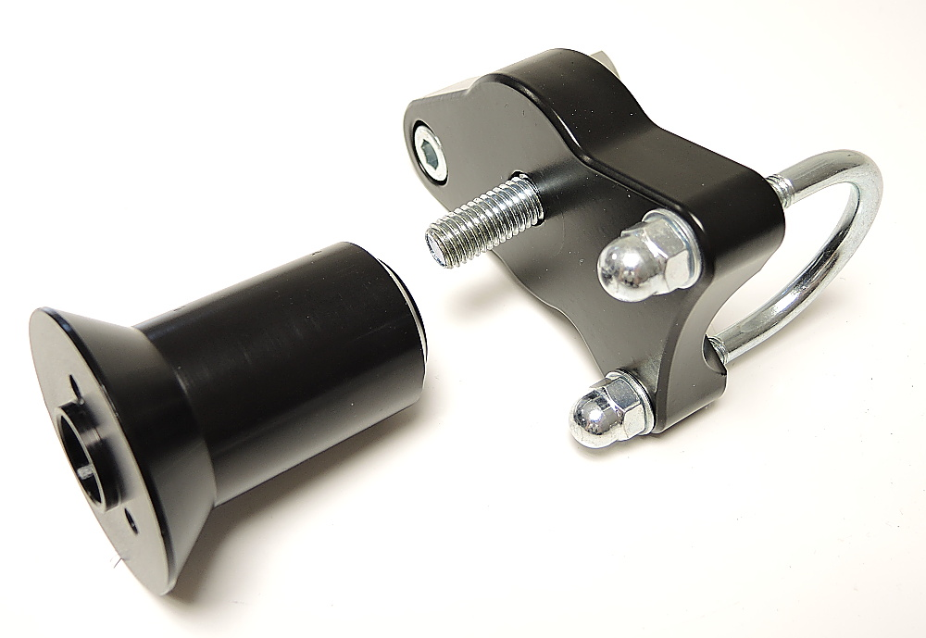
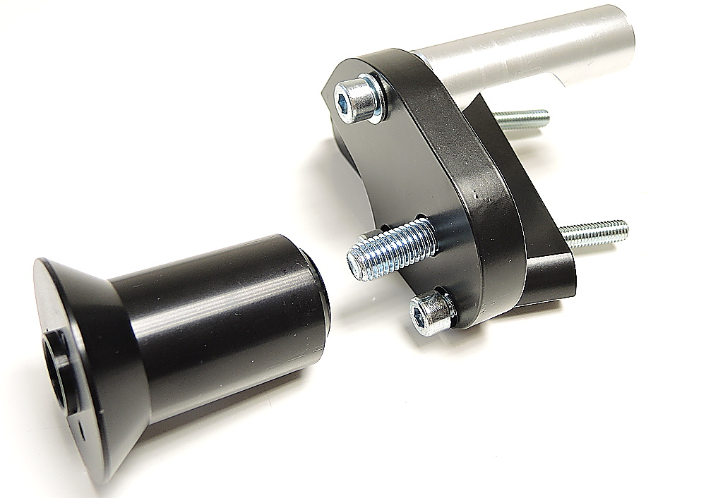
2
ID3
ID8
ID7+8
ID2
ID7
ID5
ID1
ID4

ID9
ID9
ID5+6
ID2

ID6
ID5

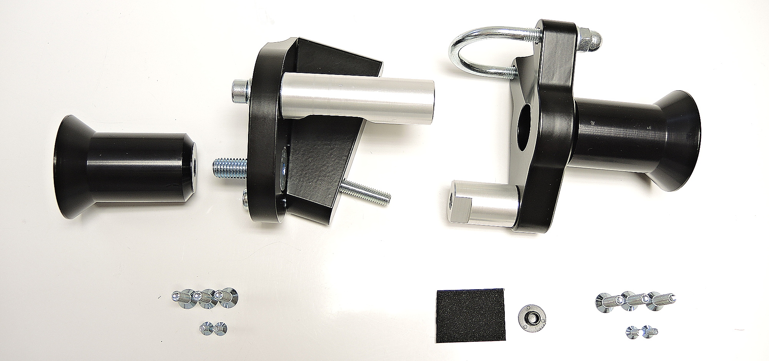

1

ID1

ID10
ID11
ID12
ID3
ID10
ID11
Instructions – left side:

- Remove original bolts M8 from the frame of motorcycle.
- Mount adapter ID2 on the frame of motorcycle using bolt ID1.
- Mount alu. Cylinder ID3 using bolt ID7+ID8 into the steel adapter ID4.
- Mount adapter for slider ID9 on the steel adapter ID4 using bolt ID6.
- Fit this kit on the frame using two botls ID5.
- Fit slider using three bolts ID10.
- Fit coloured cover using two bolts ID11.

Instructions – right side:
- Remove nut from the frame of motorcycle. Mount cylinder ID1 into the thread.
- Mount slider adapter ID9 on the steel adapter ID4 using bolt ID7.
- Stick 3M tape on the frame of motorcycle.
- Place „U“ stirrup ID4 and tighten it using nuts and washers ID5 and ID6.
- Tighten bolt ID2 with alu. Cylinder ID1. Cover bolt with plastic cap ID3.
- Fit slider using three bolts ID10.
- Fit coloured cover using two bolts ID11.

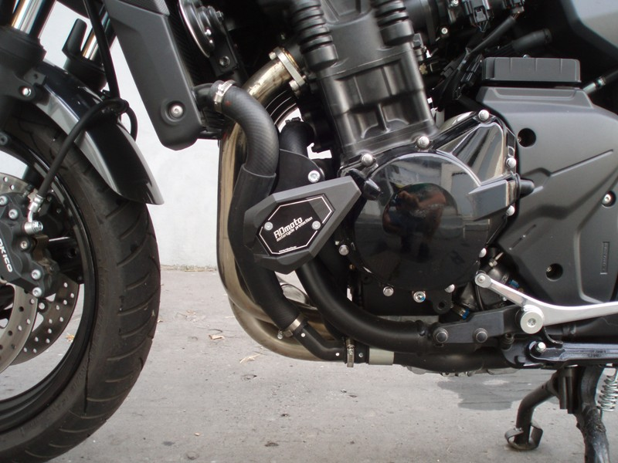
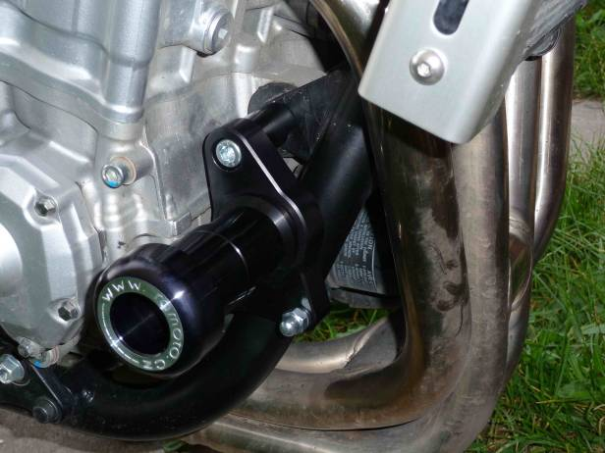
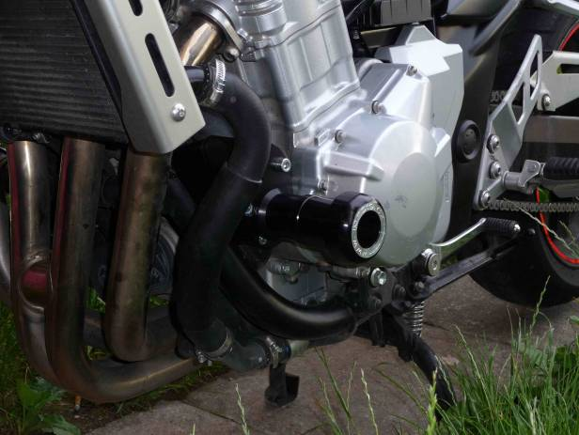
We recommend to use the glue on all threads (medium strong).

