S9-2
Suzuki GSX-R1300 Hayabusa 1999-2007

Kit for the left side |  |  |  |  | Kit for the right side
No. | Description | Cat.no. | Pcs |  |  | No. | Description | Cat.no. | Pcs
1 | Steel box M10 | X1 | 1 |  |  | 1 | Steel box M10 | X1 | 1
2 | Bolt M10x80x1,25mm | 920 | 1 |  |  | 2 | Bolt M10x95x1,25mm | 927 | 1
3 | Dural. cylinder d=20mm | 421 | 1 |  |  | 3 | Dural. cylinder d=15mm | 422 | 1
ILLUSTRATIVE PHOTOS OF Place of the installation

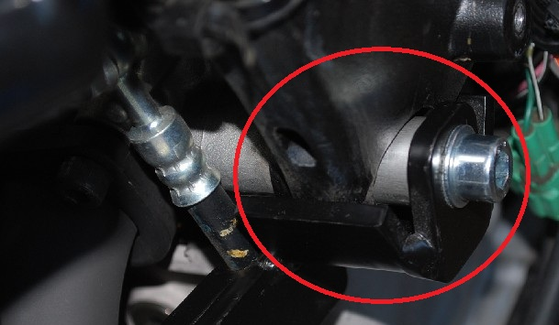

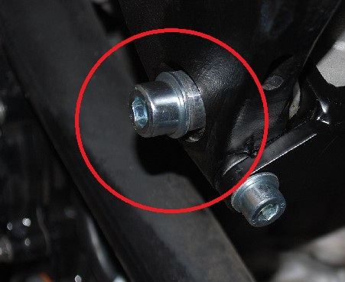

You will have to drill the hole in the cowl during installation. It is therefore necessary intervention in the original cowl!

Installation:

Installation of the left and right protector make in gripping about the attached photo above. Give the steel box M10 (No. 1) on both bolts. Put the duralumin cylinder (No. 3) under the protector on the left side and use the bolt (No. 2) for tightening. Put the duralumin cylinder (No. 3) under the protector on the right side and use the bolt (No. 2) for tightening. At first finish the one side and then mount the second side.

Warning – we recommend to use safety glue on threads of all bolts (moderate strong – blue colour).

