S9S
Suzuki GSX-R1300 Hayabusa 1999-2007

Left side kit |  |  |  |  | Right side kit
ID. | Description | Cat.no. | Pcs |  |  | ID. | Description | Cat.no. | Pcs
1 | Bolt M10x60x1,25mm | 896 | 1 |  |  | 1 | Bolt M10x60x1,25mm | 896 | 1
2 | Dural. cylinder 55mm | 140 | 1 |  |  | 2 | Dural. cylinder 70mm | 141 | 1
3 | Bolt M8x20mm | 830 | 1 |  |  | 3 | Bolt M8x20mm | 830 | 1
4 | Bolt M10x90mm | 880 | 1 |  |  | 4 | Bolt M10x100mm | 885 | 1
5 | Washer M10 (spring) | 801 | 1 |  |  | 5 | Washer M10 (spring) | 801 | 1
6 | Steel adapter | 601 | 1 |  |  | 6 | Steel adapter | 602 | 1
7 | Tape 3M |  | 1 |  |  | 7 | Tape 3M |  | 1
8 | Dural. cylinder 15mm | 109 | 1 |  |  | 8 | Bolt M8x40mm | 828 | 1
9 | Steel rod 365mm, | S9-365 | 1 |  |  | 9 | Washer M8 (spring) | 800 | 1
10 | SL adapter 45mm | 313 | 1 |  |  | 10 | SL adapter 45mm | 313 | 1
11 | Bolt M6x25 | 877 | 3 |  |  | 11 | Bolt M6x25 | 877 | 3
12 | Bolt m4x16 | 876 | 2 |  |  | 12 | Bolt m4x16 | 876 | 2
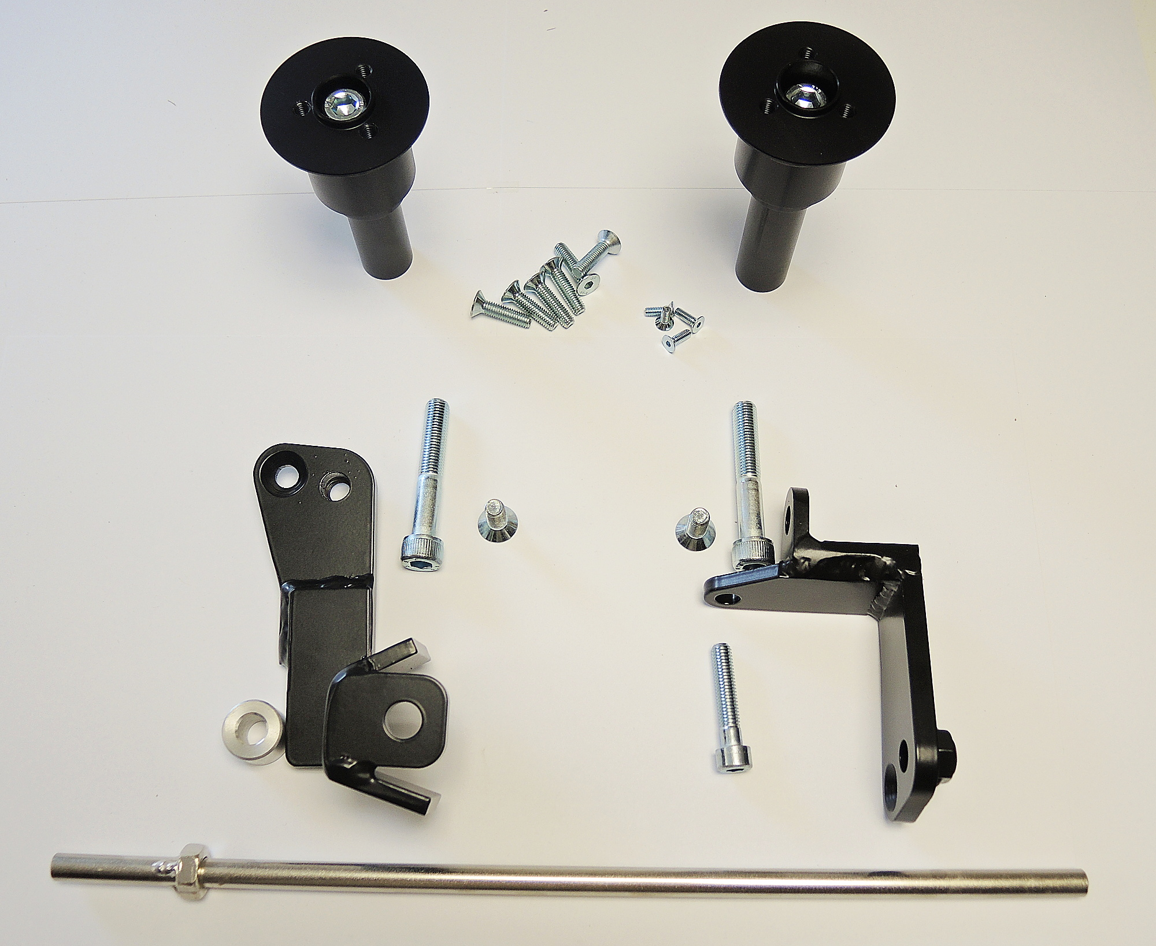 |  |  | 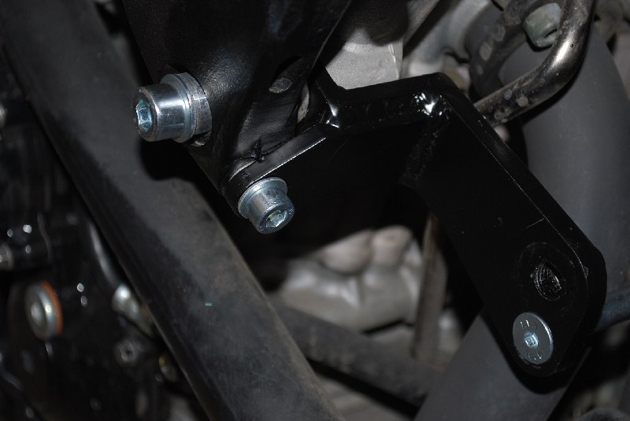

INSTRUCTIONS

- Dismantle side fairing of your motorcycle.
- Dismantle original bolts M10 and M8 on the right side.
- Stick tape ID7 on the frame to prevent its damage.
- Mount steel adapters ID6 using bolts ID1 and ID8 and washers ID5 and ID9 according to the picture below.
- Place cylinder ID8 between the left side adapter and frame of motorcycle.
- Insert steel rod between both adapters and fit it using bolts ID3.
- Mount fairing back on the motorcycle.
- Put slider adapter ID10 and dural cylinder ID2 on the bolt ID4. Mount this kit into the adapter on motorcycle.
- Fit slider using three bolts M6.
- Fit coloured cover using two bolts M4.

We recommend to use the glue on all threads (medium strong – blue colour).

