S9
Suzuki GSX-R1300 Hayabusa 1999-2007

Kit for left side: Kit for right side:
ID | Description | Cat | Qt
1 | Steel box M10 | X1 | 1
2 | Bolt M10x60x1,25mm | 896 | 1
3 | Dural. cylinder d=55mm | 140 | 1
4 | Bolt M8x20mm | 830 | 1
5 | Bolt M10x100mm | 885 | 1
6 | Pad M10 (spring) | 801 | 1
7 | Steel adapter | 601 | 1
8 | Tape 3M |  | 1
9 | Dural. cylinder d=15mm | 109 | 1
10 | stainless steel bar S9-365mm |  | 1

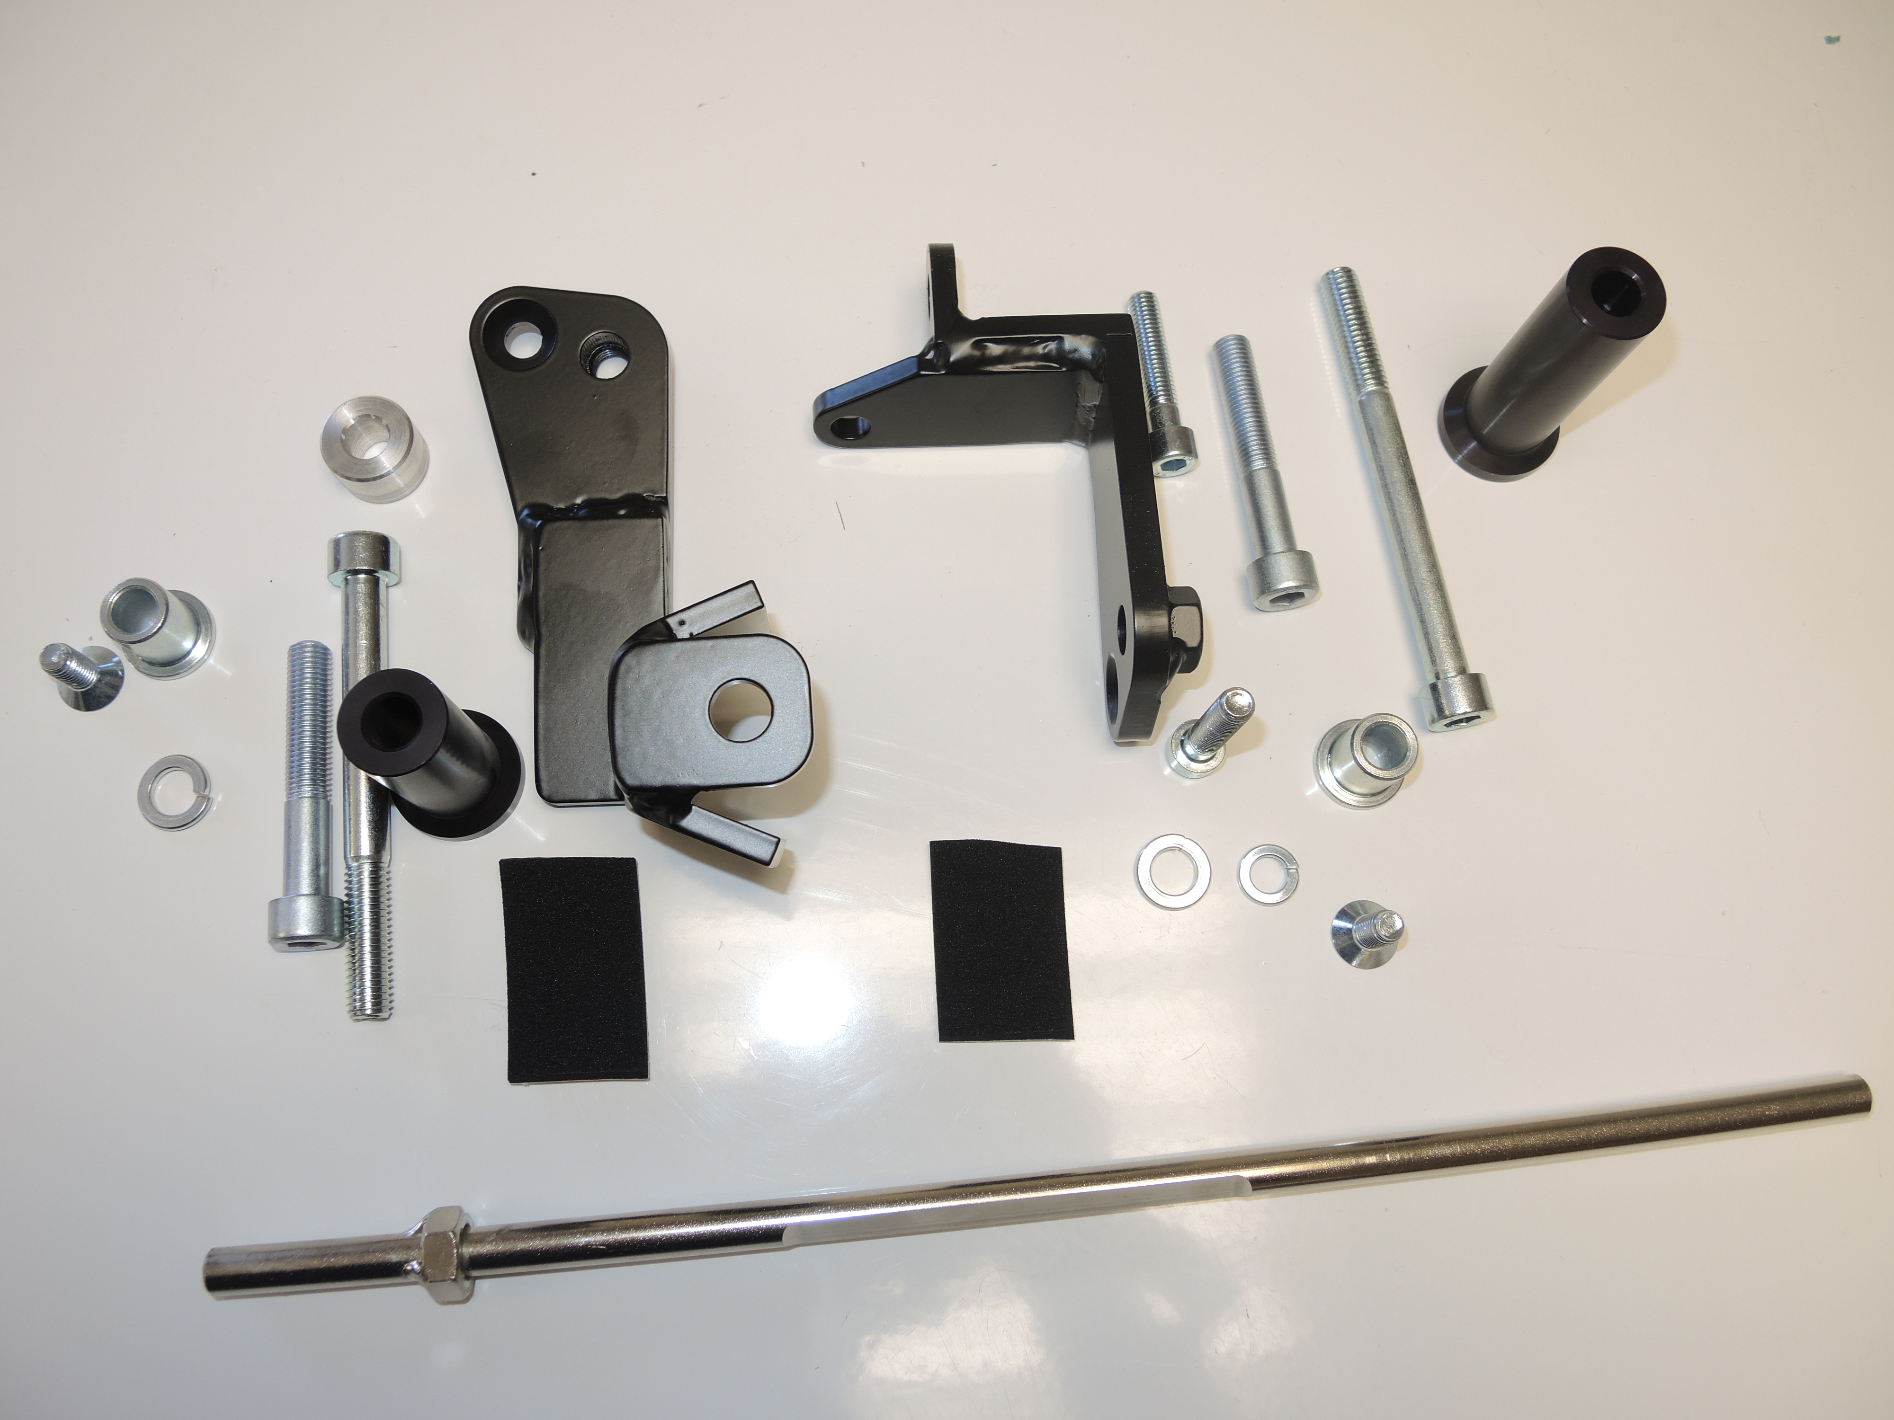
ID | Description | Cat | Qt
1 | Steel box M10 | X1 | 1
2 | Bolt M10x60x1,25mm | 896 | 1
3 | Dural. cylinder d=70mm | 141 | 1
4 | Bolt M8x20mm | 830 | 1
5 | Bolt M10x110mm | 879 | 1
6 | Pad M10 (spring) | 801 | 1
7 | Steel adapter | 602 | 1
8 | Tape 3M |  | 1
9 | Bolt M8x40mm | 828 | 1
10 | Pad M8 (spring) | 800 | 1

Installation:

- remove the complete side cowl
- remove the original bolts M10 and the bolt M8 on the right side
- use tape 3M (No. 8) for mounting of the steel adapters (No. 7) for the restricted space between adapter and frame of the motorcycle
- fix steel adapters on the left and right side of frame of the motorcycle by below listed photos, put the right adapter between the frame of the motorcycle and use bolts (No. 2) and (No. 9) for tightening. Don’t forget to give pads (No. 6 and No. 10) under bolts.
- use the bolt (No. 2) for mounting of the left adapter, don’t forget to give duralumin cylinder (No. 9) between adapter and frame of the motorcycle
- give stainless steel bar between left and right adapter, use bolts (No. 4) for tightening
- tighten all carefully and you can mount the side plastics
- give steel box (No. 1) in protector together with botl (No. 5), put duralumin cylinder (No. 3) under the protector, duralumin cylinder give on bolt
- all this set mount on adapter
- use the same process on reverse side too

Warning – we recommend to use safety glue on threads of all bolts (moderate strong – blue colour).
