T10S
Triumph Speed Triple 1050 2011-

Kit for the left side |  |  |  |  | Kit for the right side
ID. | Description | Cat.no. | Pcs |  |  | ID. | Description | Cat.no. | Pcs
1 | Slider RDmoto | SL | 1 |  |  | 1 | Slider RDmoto | SL | 1
2 | Cover | SLcap.. | 1 |  |  | 2 | Cover | SLcap.. | 1
3 | Adapter for SL01 | DV-318 | 1 |  |  | 3 | Adapter for SL01 | DV-318 | 1
4 | Botl M10x30mm | 882 | 1 |  |  | 4 | Bolt M10x30mm | 882 | 1
5 | Bolt M6x25 | 877 | 3 |  |  | 5 | Bolt M6x25 | 877 | 3
6 | Bolt M4x16 | 876 | 2 |  |  | 6 | Bolt M4x16 | 876 | 2
7 | Duralumin nut M22x1,5mm | 446 | 1 |  |  | 7 | Duralumin nut M22x1,5mm | 446 | 1
8 | Duralumin bolt M22x1,5mm | 447 | 1 |  |  | 8 | Duralumin bolt M22x1,5mm | 447 | 1
9 | Bolt M12x80mm | 956 | 1 |  |  | 9 | Bolt M12x80mm | 956 | 1
10 | Washer M12 | 803 | 1 |  |  | 10 | Pad M12-plate | 803 | 1
11 | Nut M12-safety | 811 | 1 |  |  | 11 | Nut M12-safety | 811 | 1
12 | Washer M10-spring | 801 | 1 |  |  | 12 | Washer M10-spring | 801 | 1

Instruction to assembly:

- remove the original bolt M12 from frame
- take the duralumin nut ID.7 insert the bolt M12 ID.9 into the nut
- mount dural.nut and bolt into the frame, use washer ID.10 and nut ID.11
- mount dural.bolt ID.8 into the dural.nut
- take the adapter for SL01 ID.3 insert into the adapter bolt M10x30 ID.4 and washer-spring ID.12
- mount slider ID.1, use bolts ID.5 and insert cover into the slider ID.2 use bolts ID.6

Mounting instruction for second side is same.

Warning – we recommend to use safety glue on threads of all bolts (moderate strong – blue colour).

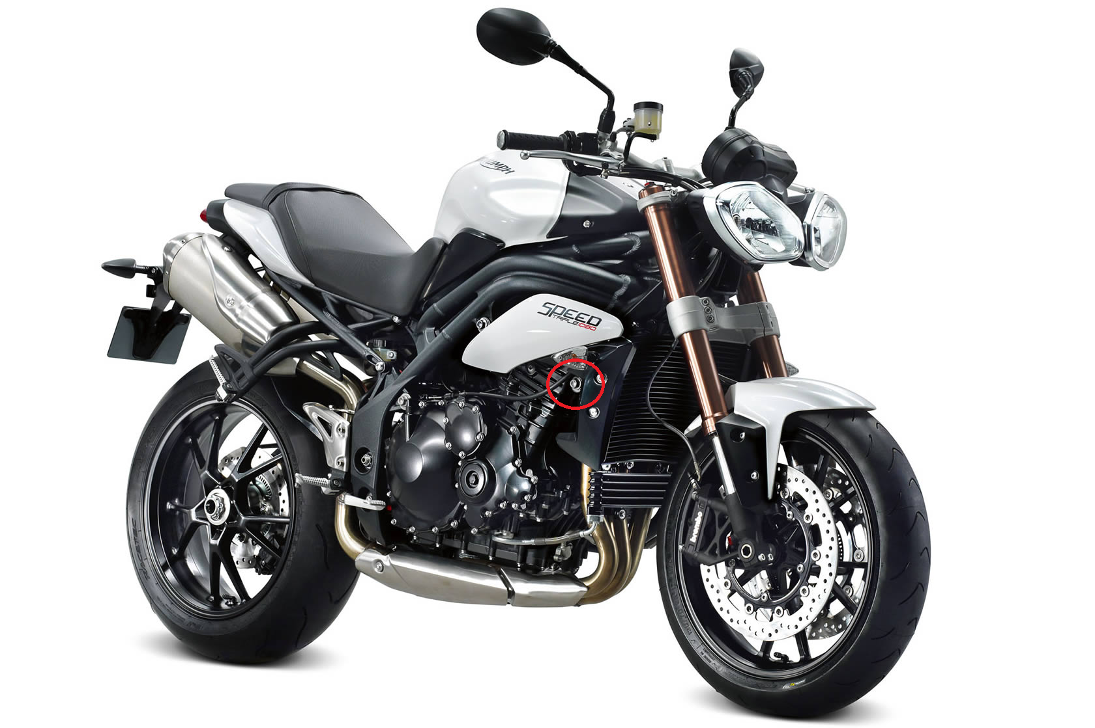
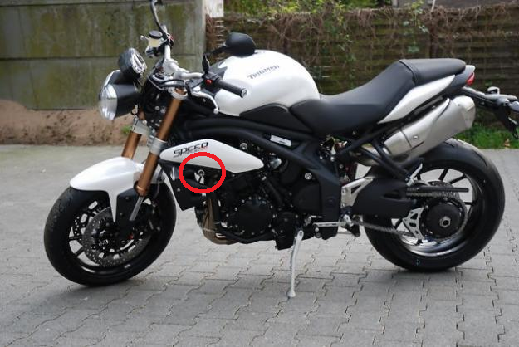

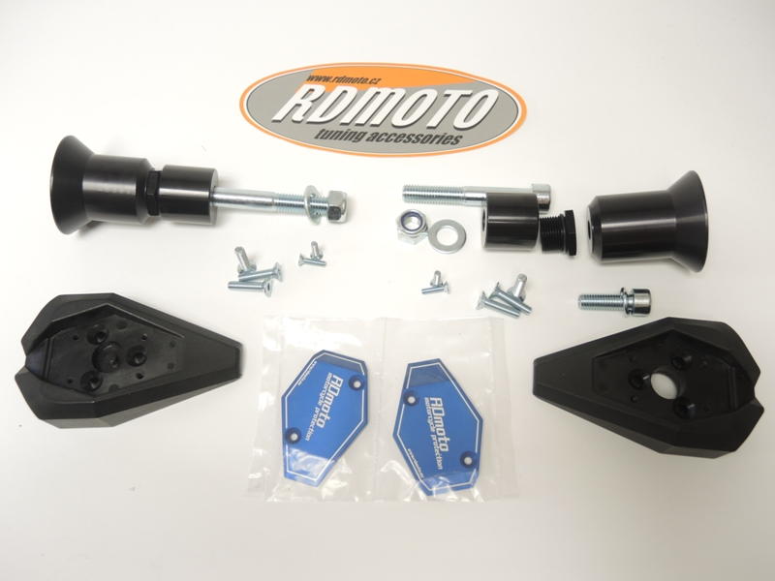
9
7
8
3
4,12
1
10,11
5
6
2
1
3
4,12
8
7
10,11
9

