T10
Triumph Speed Triple 1050 2011-

Kit for the left side |  |  |  |  | Kit for the right side
No. | Description | Cat.no. | Pcs |  |  | No. | Description | Cat.no. | Pcs
1 | Steel box M10 | X1 | 1 |  |  | 1 | Steel box M10 | X1 | 1
2 | Duralumin nut M22x1,5mm | 446 | 1 |  |  | 2 | Duralumin nut M22x1,5mm | 446 | 1
3 | Duralumin bolt M22x1,5mm | 447 | 1 |  |  | 3 | Duralumin bolt M22x1,5mm | 447 | 1
4 | Bolt M12x80mm | 956 | 1 |  |  | 4 | Bolt M12x80mm | 956 | 1
5 | Pad M12-plane | 803 | 1 |  |  | 5 | Pad M12-plane | 803 | 1
6 | Nut M12-safety | 811 | 1 |  |  | 6 | Nut M12-safety | 811 | 1
7 | Dural.cylinder d=20mm | 2 | 1 |  |  | 7 | Dural.cylinder d=15mm | 8 | 1
8 | Bolt M10x60mm | 850 | 1 |  |  | 8 | Bolt M10x60mm | 850 | 1

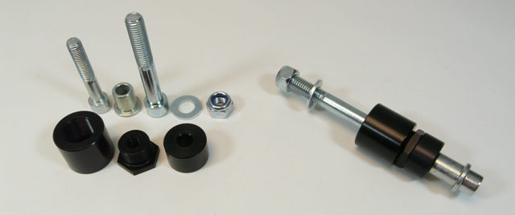

Installation – the left side:

- remove the original bolt M12
- take the duralumin nut (No. 2), give the bolt (No. 4) through the nut, mount the botl with the nut into the frame of the motorcycle, the other side use the nut (No. 6) and the pad (No. 5) for assuring
- mount the duralumin bolt (No. 3) into the duralumin nut and screw up
- give the steel box (No. 1) together with bolt (No. 8) into the crash protector, the other side of the protector give duralumin cylinder (No. 7) on the bolt
- all this set mount into the thread M10 in duralumin bolt on the motorcycle

Warning – we recommend to use safety glue on threads of all bolts (moderate strong – blue colour).

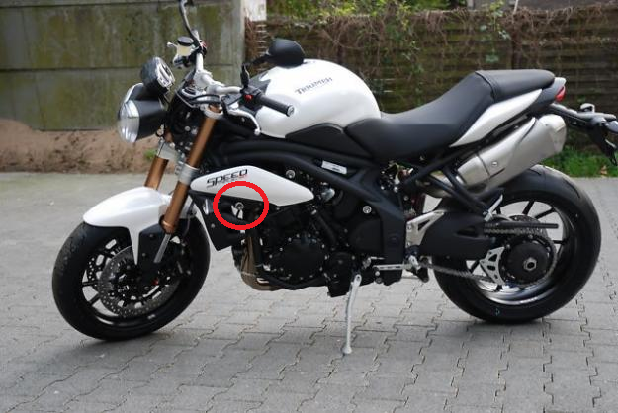

Installation – the right side:

- remove the original bolt M12
- take the duralumin nut (No. 2), give the bolt (No. 4) through the nut, mount the botl with the nut into the frame of the motorcycle, the other side use the nut (No. 6) and the pad (No. 5) for assuring
- mount the duralumin bolt (No. 3) into the duralumin nut and screw up
- give the steel box (No. 1) together with bolt (No. 8) into the crash protector, the other side of the protector give duralumin cylinder (No. 7) on the bolt
- all this set mount into the thread M10 in duralumin bolt on the motorcycle

Warning – we recommend to use safety glue on threads of all bolts (moderate strong – blue colour).

