T11SD
Triumph 1200 Explorer

Kit for left side: Kit for right side:

ID | Description | Cat.No. | Pcs
1 | Crash protector | PH | 1
2 | Steel insert | X1 | 1
3 | Dural. roller d=50mm | 13 | 1
4 | M10x80mm | 852 | 1
5 | Dural. roller d=13mm | 1100 | 1
6 | M12x70x1,25 | 937 | 1
7 | Dural. roller d=50mm | 1101 | 1
8 | M12x120x1,25 | 913 | 1
9 | Washer M12 | 803 | 2
10 | Slider adapter | 657 | 1
11 | Spring Washer M10 | 801 | 2
12 | SLD adapter | 537 | 1
13 | Bolt M8x25 | 815 | 2
14 | Washer M8 | 800 | 2

Poz. | Popis | Cat.no. | Ks
1 | Crash protector | PH | 1
2 | Steel insert | X1 | 1
3 | Bolt M10x50mm | 849 | 1
4 | Dural. roller d=13mm | 1100 | 1
5 | Bolt M12x70x1,25 | 937 | 1
6 | Dural. roller d=43mm | 1102 | 1
7 | Bolt M12x120x1,25 | 913 | 1
8 | Washer M12 | 803 | 2
9 | Slider adapter | 658 | 1
10 | Dural. roller d=20mm | 10 | 1
11 | Spring Washer M10 | 801 | 2
12 | SLD adapter | 537 | 1
13 | Bolt M8x25 | 815 | 2
14 | Washer M8 | 800 | 2
Mounting Instructions – Left Side

Attention – we recommend using medium strenght glue for threads of all screws.

- Push the ID 4 bolt through ID 12 SLD adapter, under which you place the ID 3 roller.
- Fit this assembly onto dural. adapter ID 10
- Uninstall original bolts from frame.
- Put the ID 7 roller into front part of the frame and ID 5 roller in the rear part
- Now, attach the adapter using ID 8 bolt and ID 9 washer. At front use the original nut, at rear use ID 6 bolt and ID 9 washer.
- Make sure all screws are tight.
- If you bought the PHV1 or PHV2 protectors, mount the aluminium cap at this time.

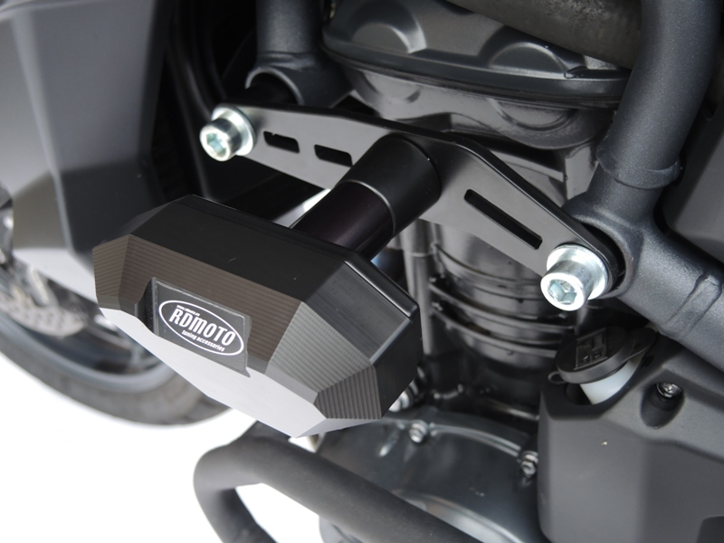

Mounting Instructions – Right Side

Attention – we recommend using medium strenght glue for threads of all screws.

- Push the ID 3 bolt through SLD adapter ID 12, under which you place the ID 10 roller.
- Fit this assembly onto dural. adapter ID 9.
- Uninstall original bolts from frame.
- Into front part of the frame, place the ID 6 roller by putting it to the engine and ID 4 roller for rear part.
- Attach the adapter with ID 7 bolt and ID 8 washer at front part using the original nut. At rear side, use ID 5 bolt as well as ID 8 washer.
- Make sure all screws are tight.
- If you bought the PHV1 or PHV2 protectors, mount the aluminium cap at this time.

