T11S
Triumph 1200 Explorer

Kit for left side: Kit for right side:

Note | Description | Cat.No | Quant
1 | Dural.adapter d=60mm | 318 | 1
2 | Bolt M10x45 | 848 | 1
3 | Bolt M4x16 | 876 | 2
4 | Bolt M6x25 | 877 | 3
5 | Dural. cylinder- 13mm | 1100 | 1
6 | Bolt M12x70x1,25 | 937 | 1
7 | Dural.spacer- 50mm | 1101 | 1
8 | Bolt M12x120x1,25 | 913 | 1
9 | Washer M12 | 803 | 2
10 | Steel adapter for slider | 657 | 1
Note | Description | Cat.No | Quant
1 | Dural.adapter d=40mm | 317 | 1
2 | Bolt M10x45 | 848 | 1
3 | Bolt M4x16 | 876 | 2
4 | Dural. cylinder- 13mm | 1100 | 1
5 | Bolt M12x70x1,25 | 937 | 1
6 | Dural. cylinder- 43mm | 1102 | 1
7 | Bolt M12x120x1,25 | 913 | 1
8 | Washer M12 | 803 | 2
9 | Steel adapter for slider | 658 | 1
10 | Bolt M6x25 | 877 | 3
Mounting instruciton- left side: Mounting instruction- right side:

- Dismantle original bolts from frame.
- For front side used duraumin cylinder (note 6) and back side insert cylinder (note 4).
- For front side mounting use the bolt (note 7) and washer (note 8) used the original nut, for rear side use bolt (note 5) and washer (note 8).
- Insert bolt (note 2) into the dural.adapter (note 1) and mounting it on the steel adapter. Check photo for right position of slider.
- Slider is mounting bolts (note 10) and cover bolts (note 3).

- Dismantle original bolts from frame.
- For front side use dural. spacer (note 7) and into the back side cylinder (note 5)
- For front side mounting use the bolt (note 8) and washer (note 9) use the original nut. For mounting use bolt (note 6) and washer (note 9).
- Insert bolt (note 2) into the dural.adapter (note 1) and mounting it on the steel adapter. Check photo for right position of slider.
- Slider is mounting bolts (note 4) and cover bolts (note 3).

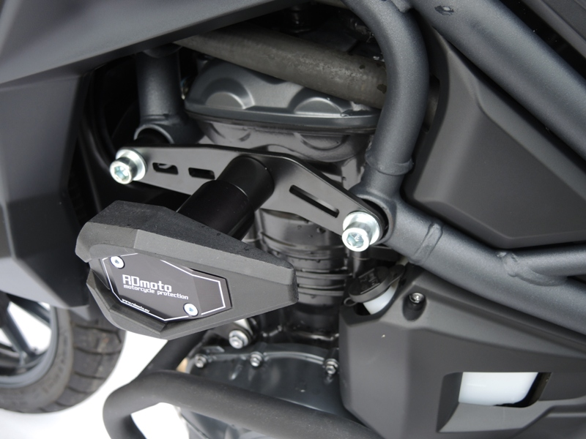
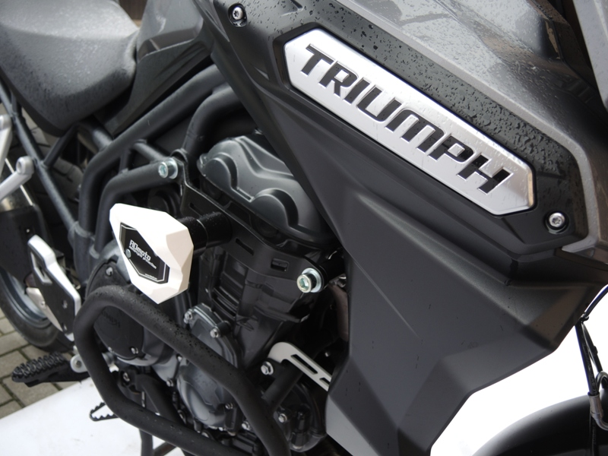

Warning- we recommended use the glue on all threads

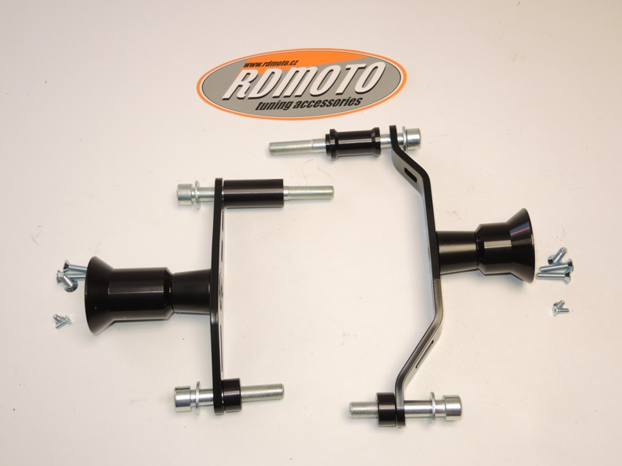
9
10
7
8,9
4
3
10
6,9
1
3
7,8
1
6
5
4
5,8
2
2

