T11
Triumph 1200 Explorer

Kit for left side: Kit for right side:

Note | Description | Cat.No | Quant
1 | Crash protectors | PH | 1
2 | Steel box | X1 | 1
3 | Dural. cylinder- 35mm | 159 | 1
4 | BoltM10x80mm | 852 | 1
5 | Dural. cylinder- 13mm | 1100 | 1
6 | Bolt M12x70x1,25 | 937 | 1
7 | Dural.cylinder- 50mm | 1101 | 1
8 | Bolt M12x120x1,25 | 913 | 1
9 | Washer M12 | 803 | 2
10 | Steel adapter for slider | 657 | 1

Note | Description | Cat.No | Quant
1 | Crash protector | PH | 1
2 | Steel box | X1 | 1
3 | Bolt M10x50mm | 849 | 1
4 | Dural. cylinder- 13mm | 1100 | 1
5 | Bolt M12x70x1,25 | 937 | 1
6 | Dural. cylinder- 43mm | 1102 | 1
7 | Bolt M12x120x1,25 | 913 | 1
8 | Washer M12 | 803 | 2
9 | Steel adapter for slider | 658 | 1
Mounting instruciton- left side:

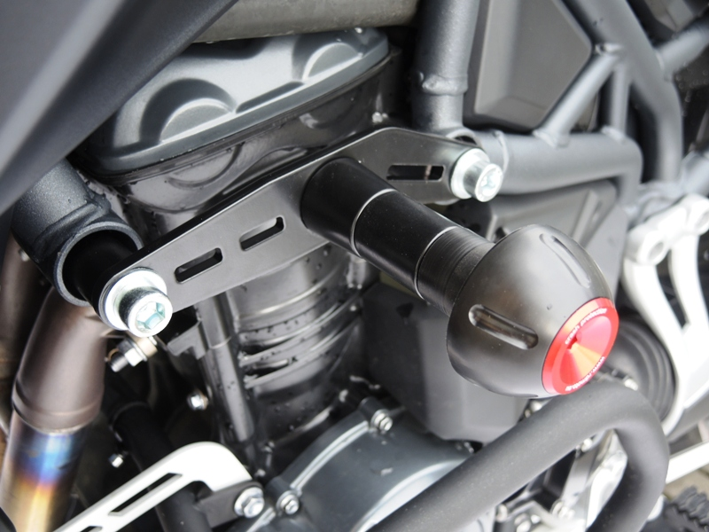
Warning- we recommended use the glue on all threads.

- Insert the steel box into the crash protector. (note 2)
- Used bolt (note 4) and insert duralumin cylinder (note 3) under the bobbins.
- This set mounting on the adapter (note 10).
- Dismantle original bolts from frame.
- For front side use dural. cylinder (note 7) and into the back side cylinder (note 5)
- For front side mounting use the bolt (note 8) and washer (note 9) use the original nut. For mounting use bolt (note 6) and washer (note 9).
- Put on the bobbins colour cover, If you have PHV1 or PHV2.

Mounting instruction- right side:

Warning- we recommended use the glue on all threads
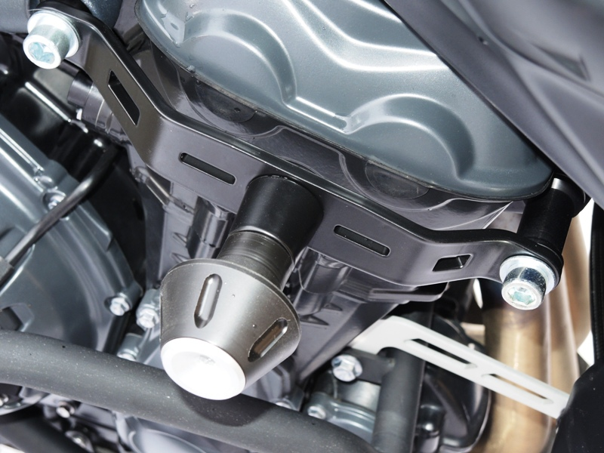

- Insert the steel box into the crash protector. (note 2)
- Use bolt (note 3) and adapter (note 9).
- Dismantle original bolts from frame.
- For front side used duraumin cylinder (note 6) and back side insert cylinder (note 4).
- For front side mounting use the bolt (note 7) and washer (note 8) used the original nut, for rear side use bolt (note 5) and washer (note 8).
- Put on the bobbins colour cover, If you have PHV1 or PHV2

