T13SD
Triumph Street Triple 675
Mounting Kit – Left Side: Mounting Kit – Right Side:
ID | Description | Cat.No | Pcs
1 | Dural. adapter | 537 | 1
2 | Dural. Sleeve l=30mm | 11 | 1
3 | Bolt M10x85x1,25 | 934 | 1
4 | Washer M8 | 800 | 2
5 | Bolt M8x25 | 815 | 2
6 | PSpring washer M10 | 801 | 1
ID | Description | Cat.No | Pcs
1 | Dural. adapter | 537 | 1
2 | Dural. sleeve l=30mm | 11 | 1
3 | Bolt M10x85x1,25 | 934 | 1
4 | Washer M8 | 800 | 2
5 | Bolt M8x25 | 815 | 2
6 | Spring washer M10 | 801 | 1
Mounting - Left Side:
- Remove original bolts from the frame.
- Insert Bolt ID.3 into the washer ID 6, dural. adapter ID.1 and dural. Sleeve ID.2.
- Install this assembly into the motorcycle frame.
- Place the slider on the plate and mount it using bolts ID.5 and washers ID.4.

Mounting – Right Side:
- Remove original bolts from the frame.
- Insert Bolt ID.3 into the washer ID 6, dural. adapter ID.1 and dural. Sleeve ID.2.
- Install this assembly into the motorcycle frame.
- Place the slider on the plate and mount it using bolts ID.5 and washers ID.4.

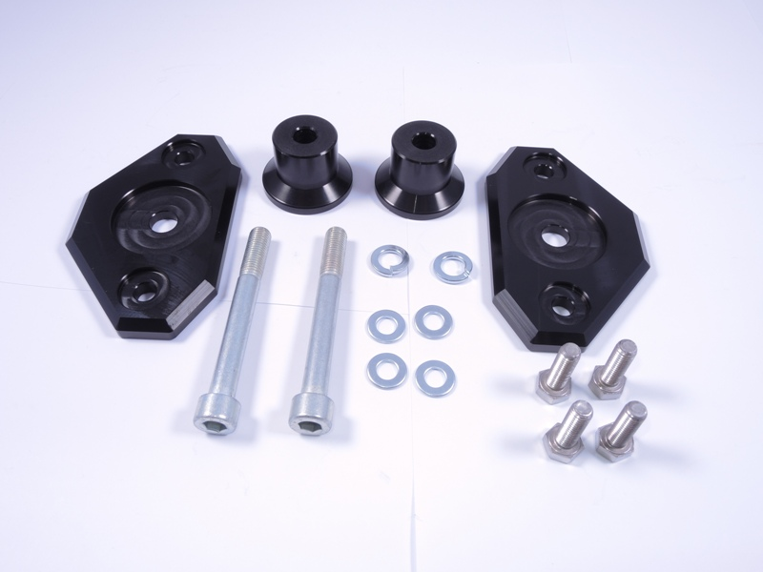
1
2
2
3
3
4
5
1
6
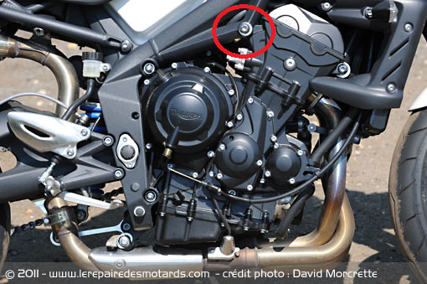

Warning! We recommend using medium strength thread glue (blue) during assembly.

