T15
Triumph Thruxton 1200/R 2016-

Kit for Left Side |  |  |  |  | Kit for Right Side
ID | Description | Cat. No. | Pcs |  |  | ID | Description | Cat.No. | Pcs.
1 | Aluminium Insert M10 | X1 | 1 |  |  | 1 | Aluminium Insert M10 | X1 | 1
2 | Dural. Nut M22x1,5mm | 446 | 1 |  |  | 2 | Dural. Nut M22x1,5mm | 446 | 1
3 | Dural. Bolt M22x1,5mm | 447 | 1 |  |  | 3 | Dural. Bolt M22x1,5mm | 447 | 1
4 | Bolt M12x150x1,25mm | 984 | 1 |  |  | 4 | Bolt M12x160x1,25mm | 949 | 1
5 | Steel Adapter | 755 | 1 |  |  | 5 | Steel Adapter | 756 | 1
6 | Bolt M6x60mm | 872 | 2 |  |  | 6 | Bolt M6x50mm | 867 | 2
7 | Dural. roller d=86,5mm | 1319 | 1 |  |  | 7 | Dural. Roller d=91,5mm | 1320 | 1
8 | Bolt M10x40mm | 854 | 1 |  |  | 8 | Bolt M10x40mm | 854 | 1
9 | Washer Flat M6 | 947 | 3 |  |  | 9 | Washer Flat M6 | 947 | 3

9
9
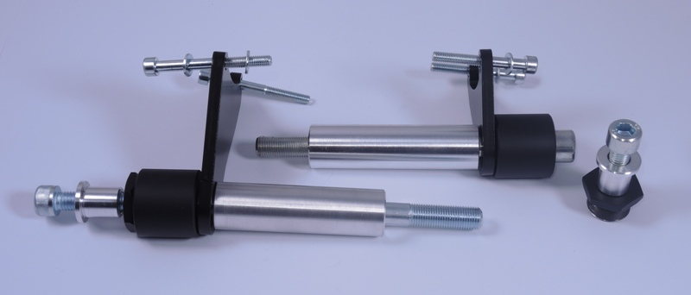
1
1
2
2
3
3
4
4

5
5
6
6
7

7
8
8

Mounting Instructions – Left Side:

- Unscrew the original M12 bolt.
- Unscrew the original M6 bolts from engine side.
- Take the ID.2 dural. nut and ID.4 M12 bolt and push through the bolt through the nut and ID.5 steel adapter. (bigger protector on the left side)
- Mount this assembly into original position of the M12 bolt, but dont tighten it yet.
- Equip the M6 ID.6 bolts with ID.9 flat washers.
- Push these bolts through the steel adapter and tighten. Into the space of upper bolt, between the steel adapter and engine, insert another ID.9 M6 washer.
- Now tighten even the M12 bolt.
- Mount the ID.3 dural. bolt into dural. nut on the steel adapter and use medium strength thread glue. Tighten the nut.
- Now you can proceed with mounting of the protector itself. Insert ID.1 aluminum insert and ID.8 M10 bolt into the protector.
- Full assembly including the protector mount into the M10 thread in the dural. bolt and again, don’t forget to use the thread glue for better performance.

Note: We recommend using medium strenght thread glue during assembly (blue color).

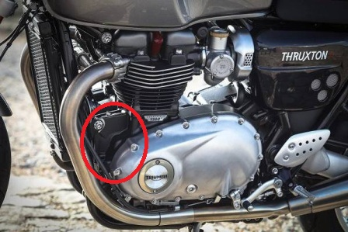
Mounting Instructions – Right Side:

- Unscrew the original M12 bolt.
- Unscrew the original M6 bolts from engine side.
- Take the ID.2 dural. nut and ID.4 M12 bolt and push through the bolt through the nut and ID.5 steel adapter. (smaller protector for right side)
- Mount this assembly into original position of the M12 bolt, but dont tighten it yet.
- Equip the M6 ID.6 bolts with ID.9 flat washers.
- Push these bolts through the steel adapter and tighten.
- Now tighten even the M12 bolt.
- Mount the ID.3 dural. bolt into dural. nut on the steel adapter and use medium strength thread glue. Tighten the nut.
- Now you can proceed with mounting of the protector itself. Insert ID.1 aluminum insert and ID.8 M10 bolt into the protector.
- Full assembly including the protector mount into the M10 thread in the dural. bolt and again, don’t forget to use the thread glue for better performance

Note: We recommend using medium strenght thread glue during assembly (blue color).

