T16S
Triumph Speed Triple 1050 2016-

Kit for left side: |  |  |  |  | Kit for right side:
ID. | Description | Cat.no. | Pcs |  |  | ID. | Description | Cat.no. | Pcs
1 | Slider RDmoto | SL | 1 |  |  | 1 | Slider RDmoto | SL | 1
2 | Cover | SLcap.. | 1 |  |  | 2 | Cover | SLcap.. | 1
3 | Dural. adapter for SL01 | DV-318 | 1 |  |  | 3 | Dural. adapter for SL01 | DV-318 | 1
4 | Screw l M10x30mm | 882 | 1 |  |  | 4 | Screw l M10x30mm | 882 | 1
5 | Screw M6x25 | 877 | 3 |  |  | 5 | Screw M6x25 | 877 | 3
6 | Screw M4x16 | 876 | 2 |  |  | 6 | Screw M4x16 | 876 | 2
7 | Dural. nut M22x1,5mm | 446 | 1 |  |  | 7 | Dural. nut M22x1,5mm | 446 | 1
8 | Dural. screw M22x1,5mm | 447 | 1 |  |  | 8 | Dural. screw M22x1,5mm | 447 | 1
9 | Screw M12x80mm | 956 | 1 |  |  | 9 | Screw M12x80mm | 956 | 1
10 | Washer M12 | 803 | 1 |  |  | 10 | Washer M12 | 803 | 1
11 | Nut M12 | 811 | 1 |  |  | 11 | Nut M12 | 811 | 1
12 | Spring washer M10 | 801 | 1 |  |  | 12 | Spring washer M10 | 801 | 1

Mounting tutorial – Left side

- Remove the original M12bolt from the motorcycle frame, fixed from the rear side by nut.
- Insert the M12 ID.9 bolt into the ID.7 nut.
- Attach this assembly to the frame of the motorcycle, from the rear side use ID.10 washer and ID.11 nut.
- Insert the special screw ID.8 into the nut.
- Insert the M10x30 ID.4 screw and ID.12 pad into ID.3 adapter. Attach the adapter to the thread in the duralumin screw.
- Install slider ID.1 using ID.5 screws, insert the ID.2 cap and tighten by using ID.6 screws.

Repeat the same procedure for the right side.

When mounting, we recommend using a medium strenght thread glue.

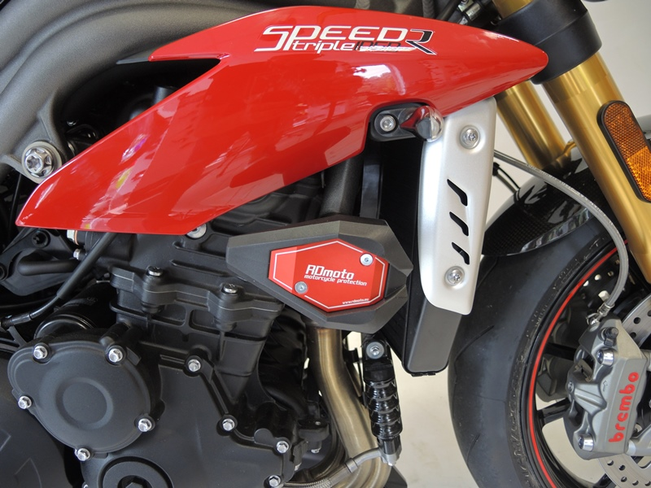
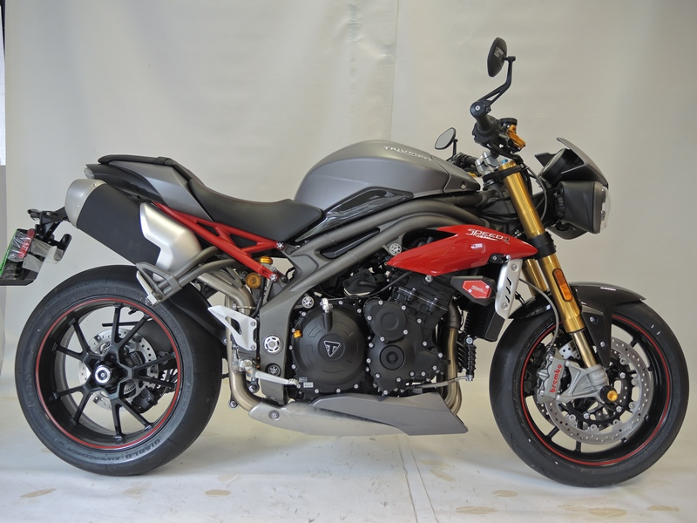

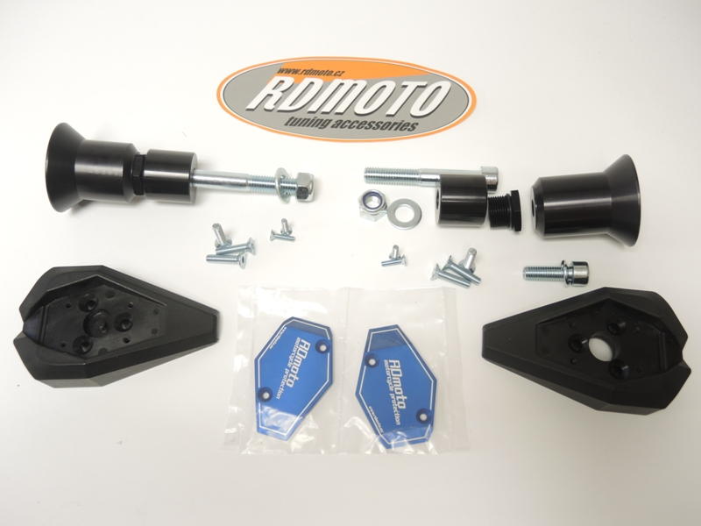
9
7
8
3
4,12
1
10,11
5
6
2
1
3
4,12
8
7
10,11
9

