T16
Triumph Speed Triple 1050 2016-

Kit for left side |  |  |  |  | Kit for right side
ID | Description | Cat. No. | Pcs |  |  | ID | Description | Cat. No. | Pcs
1 | Steel insert M10 | X1 | 1 |  |  | 1 | Steel insert M10 | X1 | 1
2 | Dural. nut M22x1,5mm | 446 | 1 |  |  | 2 | Dural. nut M22x1,5mm | 446 | 1
3 | Dural. screw M22x1,5mm | 447 | 1 |  |  | 3 | Dural. screw M22x1,5mm | 447 | 1
4 | Screw M12x80mm | 956 | 1 |  |  | 4 | Screw M12x80mm | 956 | 1
5 | Washer M12-flat | 803 | 1 |  |  | 5 | Washer M12-flat | 803 | 1
6 | Nut M12-safety | 811 | 1 |  |  | 6 | Nut M12-safety | 811 | 1
7 | Dural. roller d=20mm | 2 | 1 |  |  | 7 | Dural. roller d=15mm | 8 | 1
8 | Screw M10x60mm | 850 | 1 |  |  | 8 | Screw M10x60mm | 850 | 1

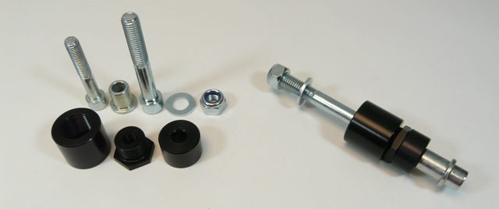

Mounting instructions – left side :

- Remove the original M12 screw
- Take the dural. nut (ID 2) and put the ID 4 screw through it. Then, using the nut screw the bolt all the way inside the motorcycle frame, securing it in place from rear side with ID 6 nut and ID 5 washer.
- Insert the dural. screw (ID 3) into the dural. nut and tighten.
- Put the steel insert (ID 1) into the crash protector with ID 8 screw. From rear side, attach the ID 7 dural. roller.
- Take this full assembly and fit it into the M10 thread inside the dural. screw on your motorcycle.

Note – We recommend using medium strenght glue for threads of all screws (blue color).

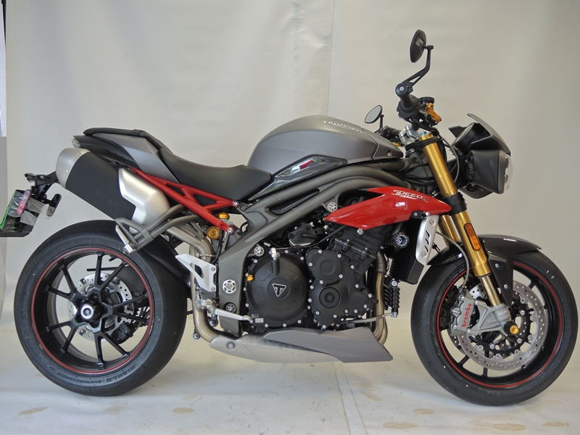

Mounting instructions – right side :

- Remove the original M12 screw
- Take the dural. nut (ID 2) and put the ID 4 screw through it. Then, using the nut screw the bolt all the way inside the motorcycle frame, securing it in place from rear side with ID 6 nut and ID 5 washer.
- Insert the dural. screw (ID 3) into the dural. nut and tighten.
- Put the steel insert (ID 1) into the crash protector with ID 8 screw. From rear side, attach the ID 7 dural. roller.
- Take this full assembly and fit it into the M10 thread inside the dural. screw on your motorcycle.

Note – We recommend using medium strenght glue for threads of all screws (blue color).

