T2-2SD
Triumph Speed Triple 1050´05-´10

Fitting kit left side: Fitting kit right side:
ID | Description | Cat.N | Qt
1 | Bolt M12x70x1,25 | 937 | 1
2 | Bracket for SLD | 537 | 1
3 | Dural. cylinder | 148 | 1
4 | Dural. reduction | 149 | 1
5 | Washer M8 | 802 | 2
6 | Bolt M8 | 815 | 2
ID | Description | Cat.N | Qt
1 | Bolt M12x100 | 986 | 1
2 | Bracket for SLD | 537 | 1
3 | Dural. cylinder | 148 | 1
4 | Dural. reduction | 149 | 1
5 | Nut M12 | 811 | 1
6 | Washer M12 | 803 | 1
7 | Washer M8 | 802 | 2
8 | Bolt M8 | 815 | 2

Instruction to assembly left side:
- Dismantle orig. bolt M12 from frame.
- Throught the bracket for SLD ID.2, dural. adapter ID.4 and dural.cylinder ID.3 insert bolt ID.1.
- This kit gripping on the frame.
- Use bolts ID.6 and washers ID.5 make assembly SLD.
Instruction to assembly right side:
- Dismantle orig. bolt M12 from frame.
- Throught the bracket for SLD ID.2, dural. adapter ID.4 and dural.cylinder ID.3 insert bolt ID.1.
- This kit gripping on the frame.
- Thighten bolt from back side, use nut and washer ID.5 a ID.6.
- Use bolts ID.8 and washers ID.7 make assembly SLD.

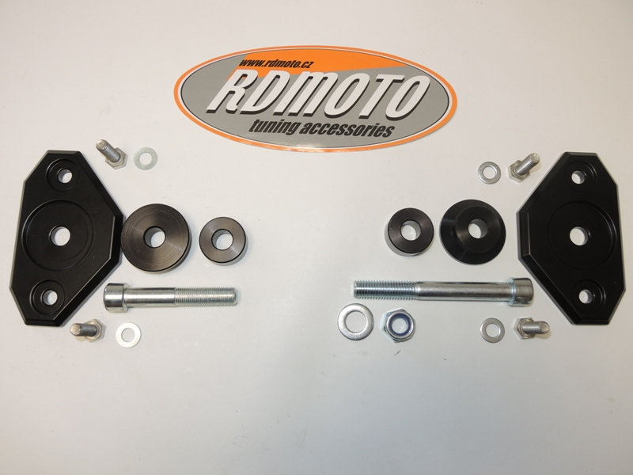
All threads, use glue for bolts- medium strength.

2
36
1
1
4
3
2
4
5
6
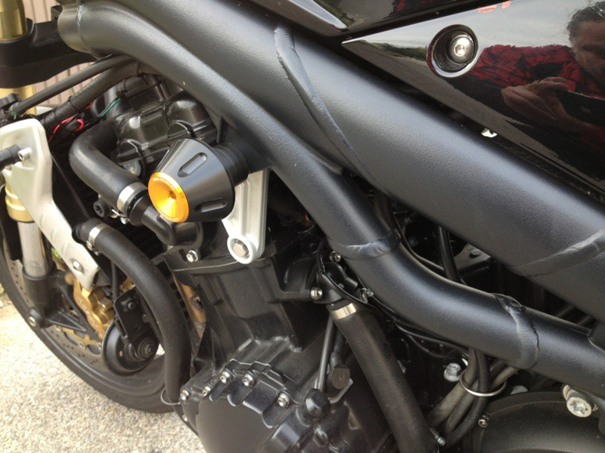
Place for protectors- ilustration photo.

