T2PM
Triumph Speed Triple 1050 ´05-´10

Fitting kit:
ID | Description | Cat.No | Qty
1 | Crash slider | PM1 | 1
2 | Bolt | 817 | 3
3 | AL cap | capPM | 1

Assembly:
- Dismantle original part.
- Use original O-ring for slider.
- Mount slider on engine.
- Use bolts ID.2 and gripped AL cap.

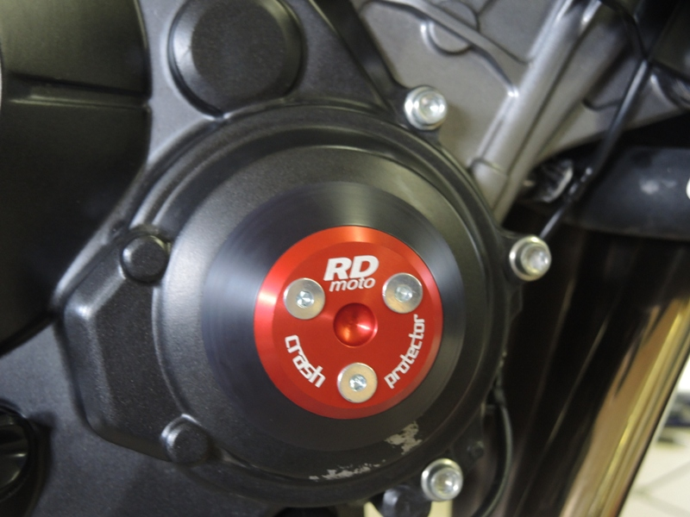

Note: During installation, we recommend using glue on the threads (blue color). Do not use it on thread slider.

