T3-2
Triumph Speed Triple T509/955i
2002-2004

Fitting kit left side: Fitting kit right side:
ID | Description | Cat.no | QTY
1 | Bolt M12x70x1,25 | 937 | 1
2 | Steel box | X2 | 1
3 | Dural. cylinder | 148 | 1
ID | Description | Cat.no | QTY
1 | Bolt M12x100 | 986 | 1
2 | Steel box | X2 | 1
3 | Dural.cylinder | 148 | 1
4 | Washer M12 | 803 | 1
5 | Nut M12 | 811 | 1

Instruction to assembly-left side:

- Dismantle orig. bolt form frame M12.
- Insert steel box ID.3 into the protector.
- Insert bolt ID.1 and under the protektor put dural.cylinder ID.3.
- This kit mount on the frame.

Instruction to assembly-right side:
- Dismantle orig. bolt from frame M12.
- Insert steel box ID.3 into the protector.
- Insert bolt ID.1 and under the protektor put dural.cylinder ID.3.
- This set mount on the frame.
- Use bolt and washer and fixed this kit ID.4 a ID.5.

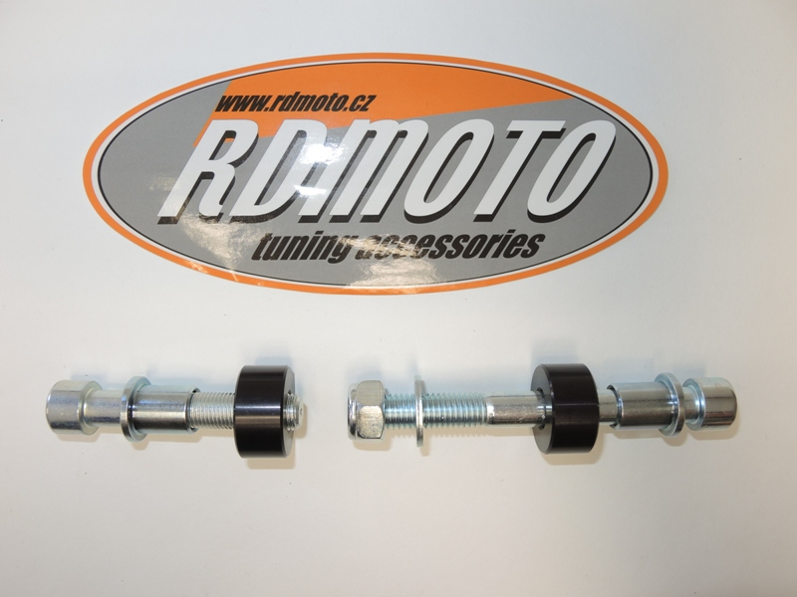

2
5
1
2
1
4
3
3
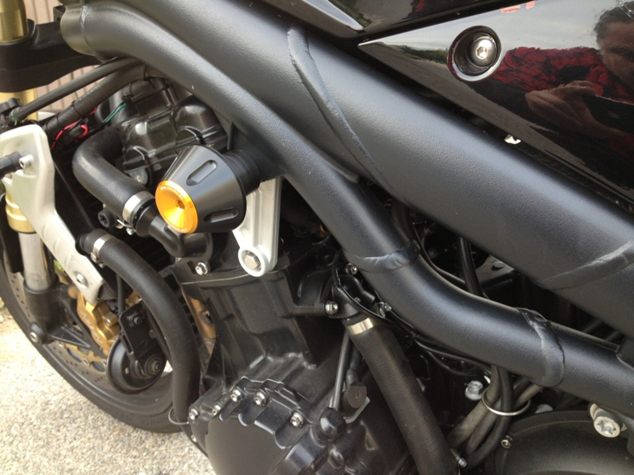
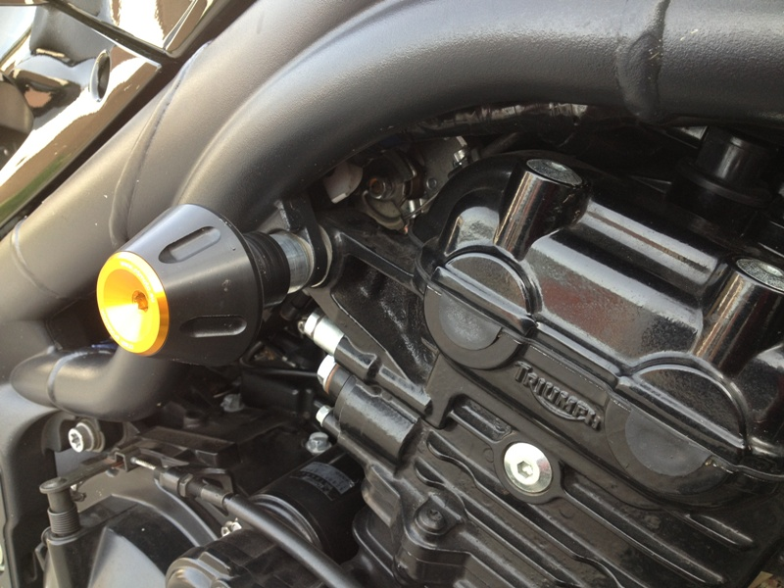
Warning:
We recommend use the glue of all threads. Medium strong.

