T3SDM
Triumph Speed Triple T509/955i
2002-2004

Kit for Left Side |  |  |  |  | Kit for Right Side
ID | Description | Cat.No | Pcs |  |  | ID | Description | Cat.No | Pcs
1 | Dural. adapter under slider | 537/B | 1 |  |  | 1 | Dural. adapter under slider | 537/B | 1
2 | Dural. sleeve l=40mm | 12 | 1 |  |  | 2 | Dural. sleeve l=40mm | 12 | 1
3 | Dural. adapter (left) | 619 | 1 |  |  | 3 | Dural. adapter (right) | 620 | 1
4 | Washer M12 | 803 | 1 |  |  | 4 | Washer M12 | 803 | 2
5 | Bolt M12x40x1,25mm | 933 | 1 |  |  | 5 | Bolt M12x65mm | 963 | 1
6 | Bolt M10x65mm | 943 | 1 |  |  | 6 | Bolt M10x65mm | 943 | 1
7 | Stainless steel bolt M6x20mm | 1024 | 2 |  |  | 7 | Stainless steel bolt M6x20mm | 1024 | 2
8 | Stainless steel washer M6 | 1023 | 2 |  |  | 8 | Stainless steel washer M6 | 1023 | 2
9 | Spring washer M10 | 801 | 1 |  |  | 9 | Spring washer M10 | 801 | 1
 |  |  |  |  |  | 10 | Lock nuts M12 | 811 | 1

ID2
ID2
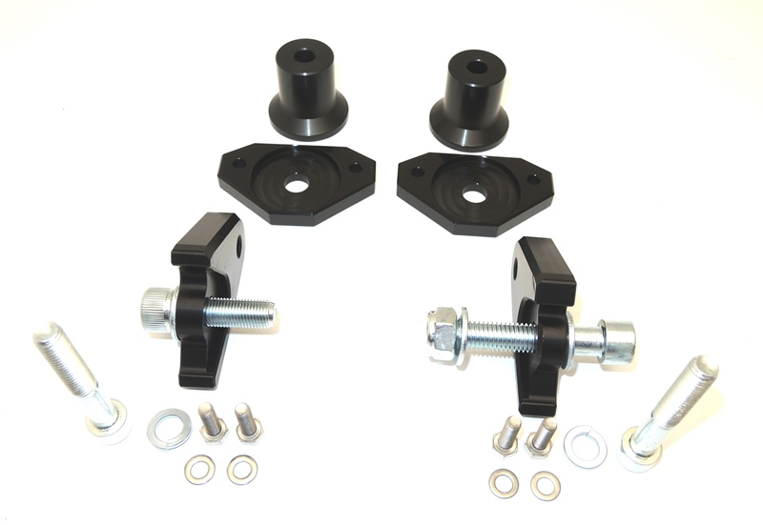
ID1
ID7
Left adapter ID.3
Right adapter ID.3
ID1
ID4
ID4
ID5
ID5
ID6
ID6
ID7
ID8
ID8
ID9
ID9
ID10

Mounting - left side:

- Remove original bolt M12 from the motorcycle frame.
- Screw the dural. Adapter (ID3) to the motorcycle frame using M12 bolt (ID5). Do not forget washer M12 (ID4).
- Take the dural. Adapter under the slider (plate, ID1) and dural. Sleeve (ID2)
- Mount on the dural. adapter using M10 bolt (ID6) and spring washer M10 (ID9)
- Install the slider on the dural. adapter under the slider using bolts M6 (ID7) and washers (ID8).

Mounting – right side:

- Remove original bolt M12 from the motorcycle frame.
- Attach the dural. Adapter (ID3) to the motorcycle frame using M12 bolt (ID5) and lock nut M12 (ID 11). Do not forget two washers M12 (ID4).
- Take the dural. Adapter under the slider (plate, ID1) and dural. Sleeve (ID2)
- Mount on the dural. adapter using M10 bolt (ID6) and spring washer M10 (ID9)
- Install the slider on the dural. adapter under the slider using bolts M6 (ID7) and washers (ID8).

Warning - We recommend using medium strength thread glue during assembly.

ILUSTRAČNÍ FOTO MÍSTA MONTÁŽE

