T3S
Triumph Speed Triple T509/955i
2002-2004

Kit for the left side |  |  |  |  | Kit for the right side
ID | Description | Cat.no. | Pcs |  |  | ID | Description | Cat.no. | pcs
1 | Bolt M10x30 | 882 | 1 |  |  | 1 | Bolt M10x30 | 882 | 1
2 | Slider adapter | DV317 | 1 |  |  | 2 | Slider adapter | DV317 | 1
3.1 | Bolt M12x40x1,25mm | 933 | 1 |  |  | 3.2 | Bolt M12x65mm | 963 | 1
4 | Washer M10 | 801 | 1 |  |  | 4 | Washer M10 | 801 | 1
5.1 | Duralový adapter (left) | 619 | 1 |  |  | 5.2 | Duralový adapter (right) | 620 | 1
6 | Washer M12 | 803 | 1 |  |  | 6 | Washer M12 | 803 | 2
7 | Bolt M6x25 | 677 | 3 |  |  | 7 | Bolt M6x25 | 677 | 3
8 | Bolt M4x12 | 676 | 2 |  |  | 8 | Bolt M4x12 | 676 | 2
 |  |  |  |  |  | 9 | Nut M12 (safety) | 811 | 1

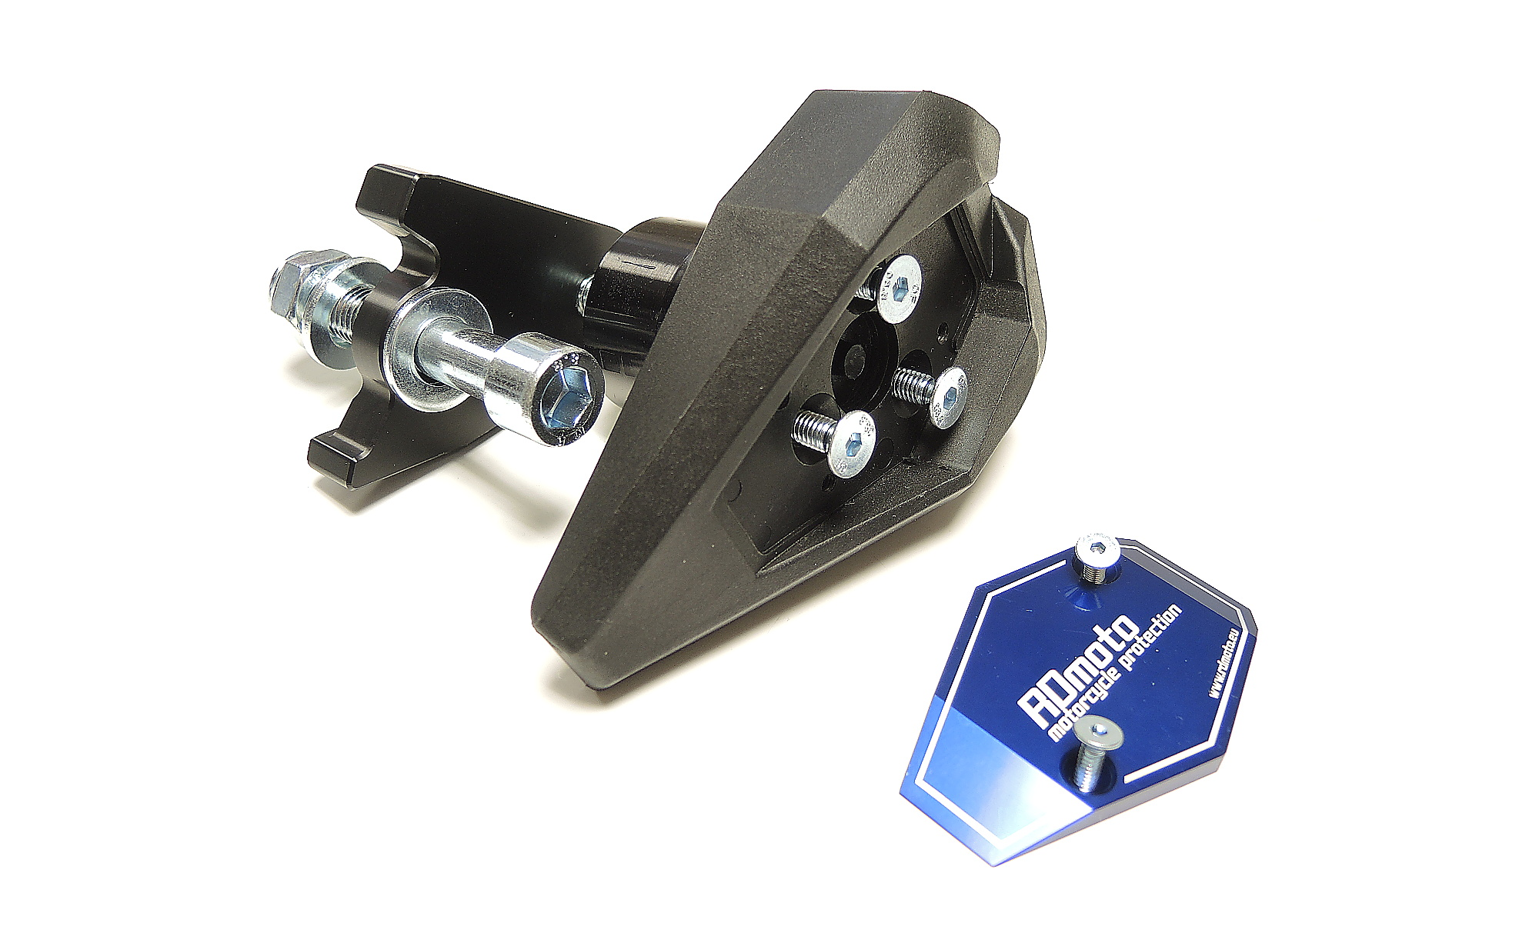

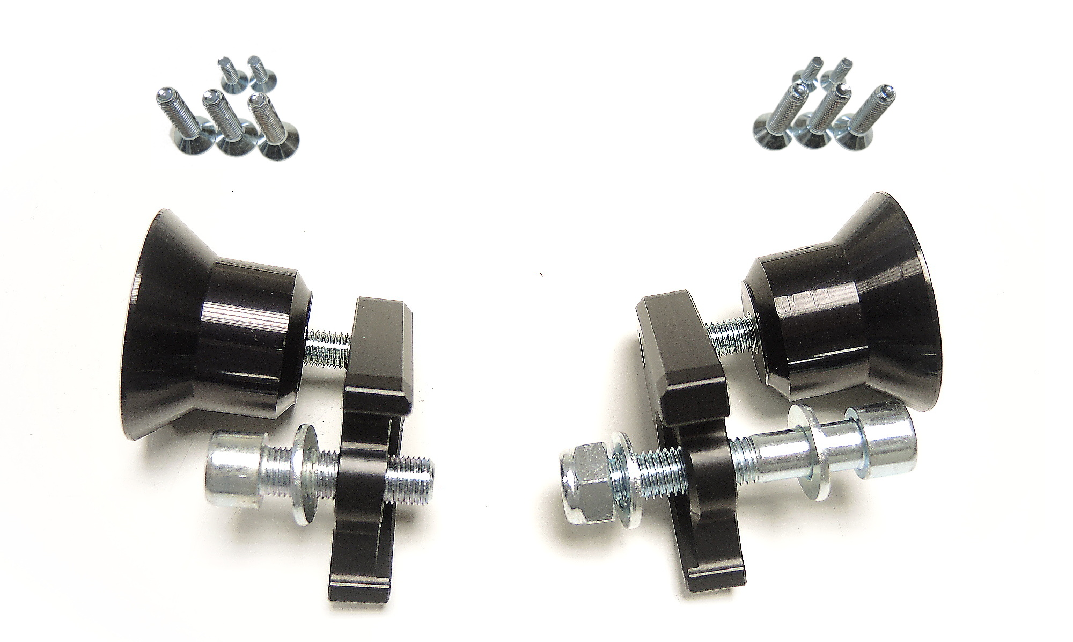
ID8
direction

ID7

ID2

ID1

ID5.1
ID5.2

ID9

ID3.1
ID3.1
ID6

Installation for the left side:

- Remove original M12 bolt from the frame of motorcycle.
- Mount dural adapter (ID5.1) on the frame of motorcycle using bolt M12 (ID3.1). Don’t forget to place M10 washer (ID6).
- Now fit slider adapter (ID2) on the dural adapter (ID5.1) using bolt M10 (ID1).
- Fit slider on the slider adapter using three M6 bolts (ID7).
- Fit coloured cover on the slider using two M4 bolts (ID6).

Installation for the right side:

- Remove original M12 bolt from the frame of motorcycle.
- Mount dural adapter (ID5.1) on the frame of motorcycle using bolt M12 (ID3.1) and safety nut M12 (ID9). Don’t forget to place M10 washer (ID6).
- Now fit slider adapter (ID2) on the dural adapter (ID5.1) using bolt M10 (ID1).
- Mount slider on the slider adapter using three M6 bolts (ID7).
- Mount coloured cover on the slider using two M4 bolts (ID6).

We recommend to use the glue (medium strong) on all threads.

