T3
Triumph Speed Triple T509/955i
2002-2004

Kit for the left side: |  |  |  |  | Kit for the right side:
ID | Description | Cat.no. | Pcs |  |  | ID | Description | Cat.no. | pcs
1 | Bolt M10x40mm | 854 | 1 |  |  | 1 | Bolt M10x40mm  Left side adapter  Right side adapter | 854 | 1
2 | Steel insert | X1 | 1 |  |  | 2 | Steel insert | X1 | 1
3 | Bolt M12x40x1,25mm | 933 | 1 |  |  | 3 | Bolt M12x65mm | 963 | 1
4 | Washer M10 | 801 | 1 |  |  | 4 | Washer M10 | 801 | 1
5.1 | Dural adapter (left side) | 619 | 1 |  |  | 5.2 | Dural adapter (right side) | 620 | 1
6 | Washer M12 | 803 | 1 |  |  | 6 | Washer M12 | 803 | 2
 |  |  |  |  |  | 7 | Nut M12 (pojistná) | 811 | 1
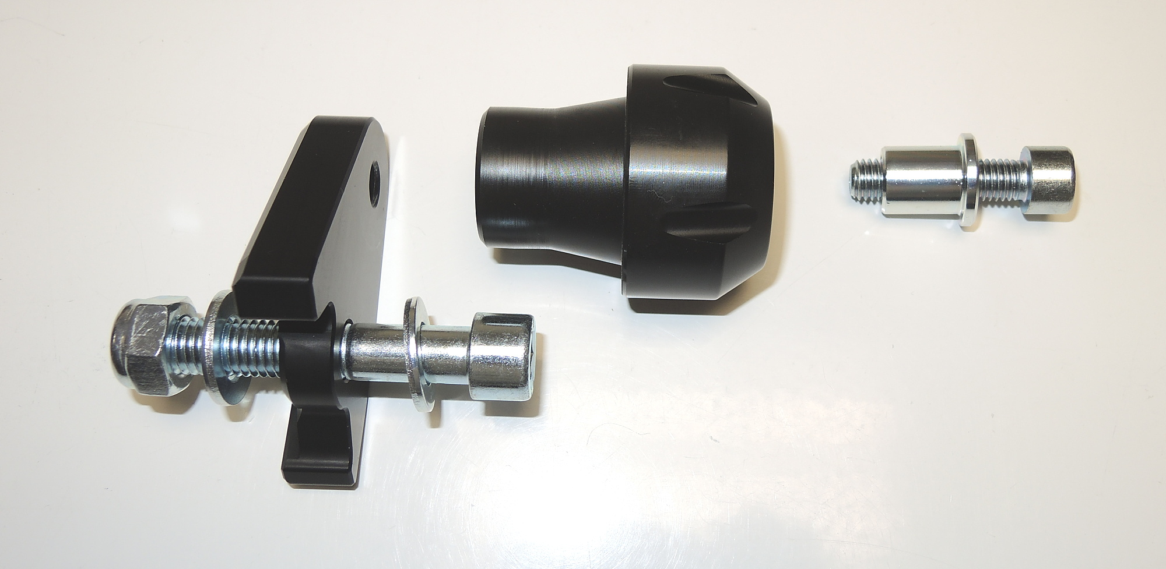

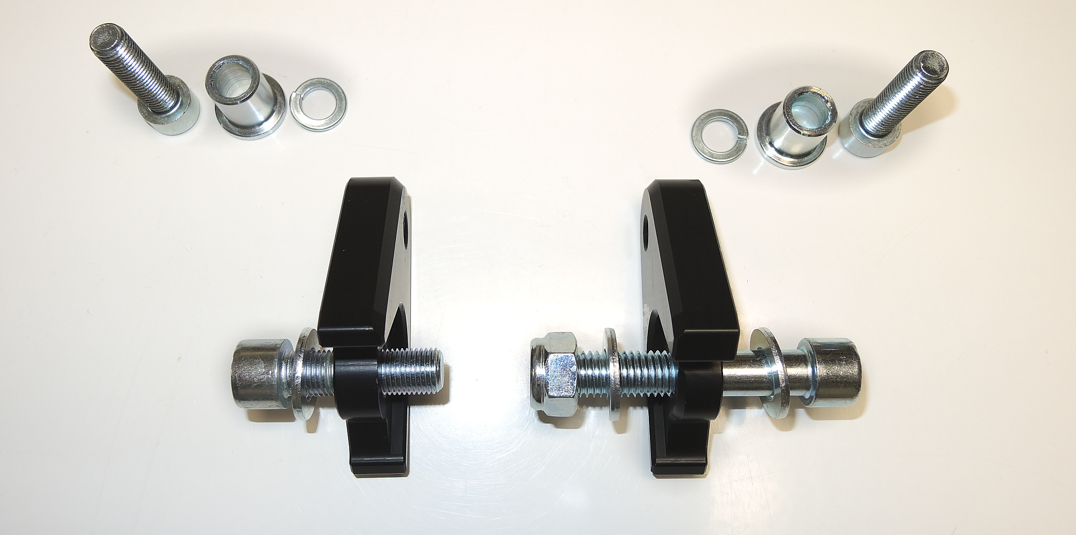
ID4
ID2
ID1

ID5.1
ID5.2

ID7
ID6

ID3

Instructions – left side:

- Remove original M12 bolts from the frame of motorcycle.
- Mount dural adapter (ID5.1) on the frame of motorcycle using bolt M12 (ID3). Don’t forget to place washer M12 (ID6).
- Now fit protector using bolt M10 (ID1) and steel washer (ID2) according to the picture above. Don’t forget to place washer M10 (ID4).

Instructions – right side:

- Remove original M12 bolts from the frame of motorcycle.
- Mount dural adapter (ID5.2) on the frame of motorcycle using bolt M12 (ID3) and safety nut M12 (ID7). Don’t forget to place two washers M12 (ID6).
- Now fit protector using bolt M10 (ID1) and steel washer (ID2) according to the picture above. Don’t forget to place washer M10 (ID4).

We recommend to use the glue on all threads (blue colour – medium strong).

