T4-2S
Triumph Street Triple 675 2007-
Triumph Street Triple 675R 2009-

Kit for the left side |  |  |  |  | Kit for the right side
No. | Description | Cat.no. | Pcs |  |  | No. | Description | Cat.no. | Pcs
1 | Dural.holder for slider | 316 | 1 |  |  | 1 | Dural.holder for slider | 316 | 1
2 | Bolt M10x58x1,25 | 901 | 1 |  |  | 2 | Bolt M10x58x1,25 | 901 | 1
3 | Bolt M6x25 | 877 | 3 |  |  | 3 | Bolt M6x25 | 877 | 3
4 | Bolt M4x12 | 876 | 2 |  |  | 4 | Bolt M4x12 | 876 | 2
Installation:

- Installation of the left and right protector make in gripping about the attached photo above.
- Into the alu. holder ID.1 insert bolt ID.2. This holder is mounting on the motorcycle frame.
- Place slide rand tighten it by bolts ID.3. Insert cover and use bolts ID.4. Same assembly done on the oposite side of bike.

Warning – we recommend to use safety glue on threads of all bolts (moderate strong – blue colour).
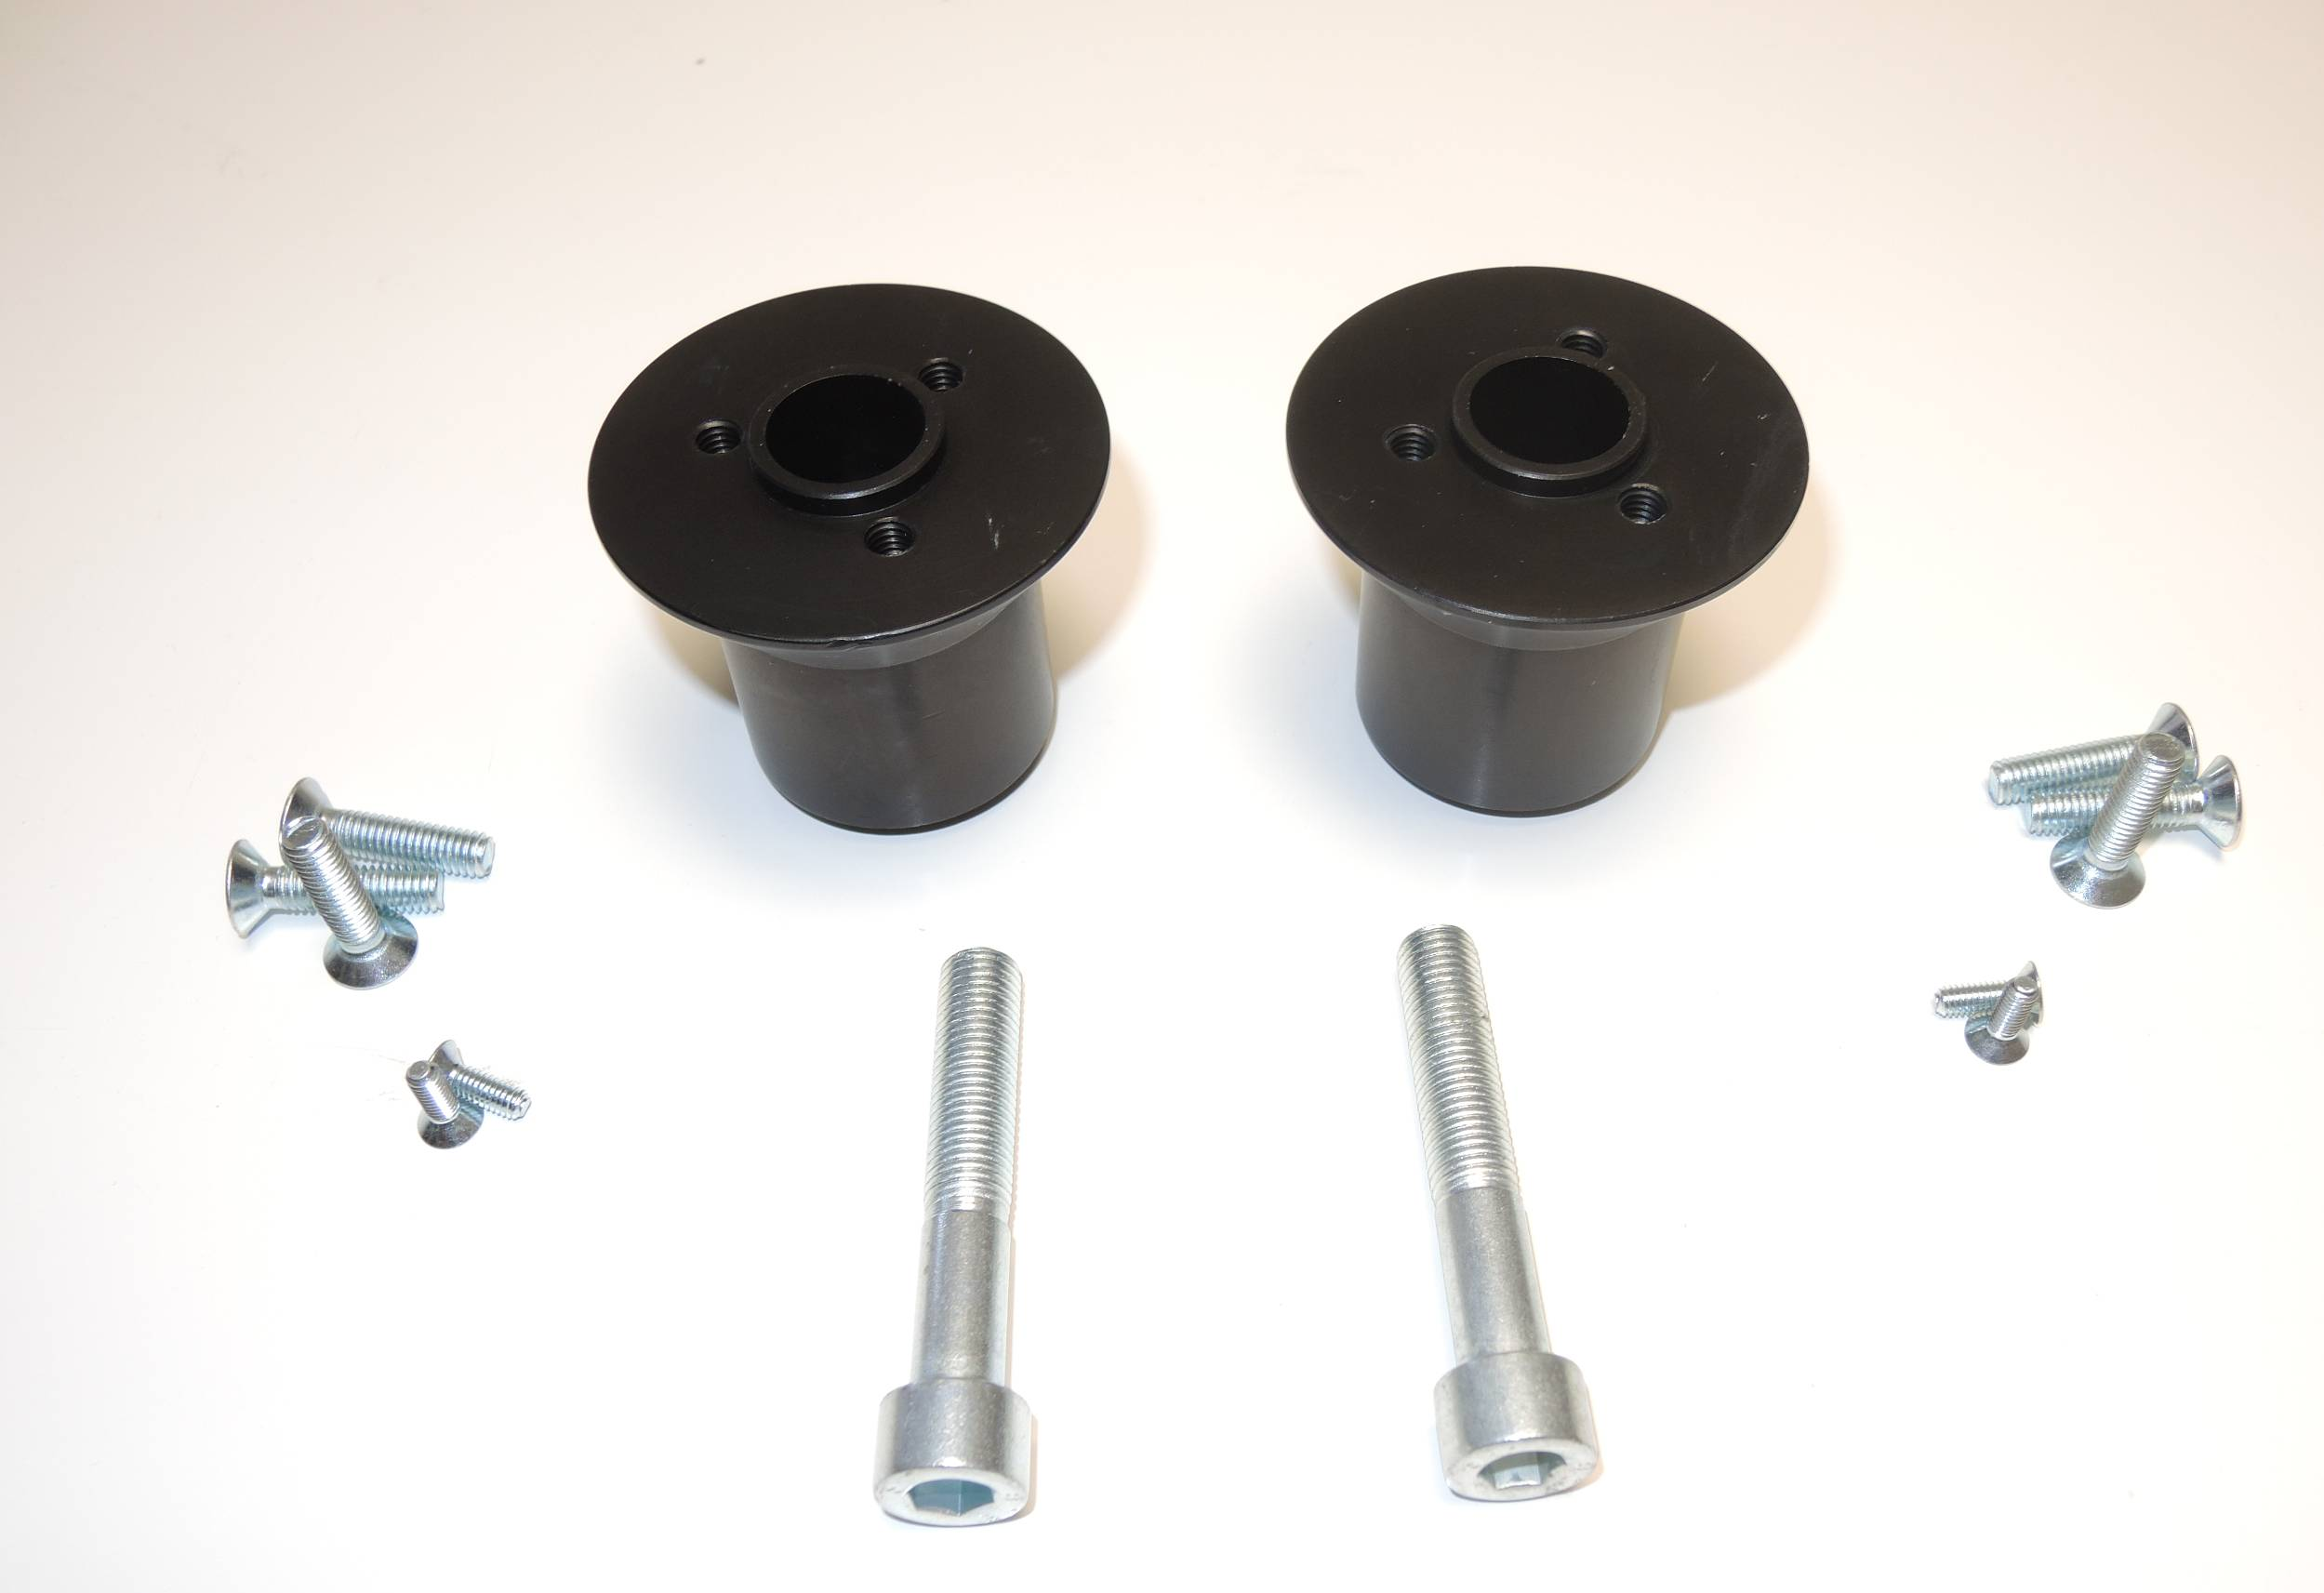
3
1
1
3
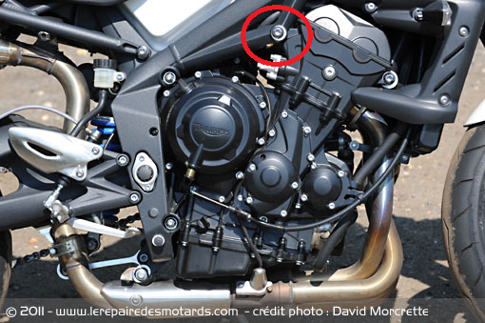
4
2
4
2

