T4SD
Triumph Street Triple 675 2007-
Triumph Street Triple 675R 2009-

Kit for left side |  |  |  |  | Kit for right side
ID | Description | Cat. No. | Pcs |  |  | ID | Description | Cat. No. | Pcs
1 | Dural. adapter | 613 | 1 |  |  | 1 | Dural. adapter | 614 | 1
2 | Bolt M10x35mm | 847 | 1 |  |  | 2 | Bolt M10x35mm | 847 | 1
3 | Bolt M10x120x1,25mm | 895 | 1 |  |  | 3 | Bolt M10x110x1,25mm | 928 | 1
4 | Bolt M10x60x1,25mm | 896 | 1 |  |  | 4 | Bolt M10x60x1,25mm | 896 | 1
5 | Dural. roller d=40mm | 71 | 1 |  |  | 5 | dural. roller d=32,5mm | 68 | 1
6 | Dural roller d=15mm | 9 | 1 |  |  | 6 | dural roller d=15mm | 9 | 1
7 | Plastic cover M10 | X4 | 2 |  |  | 7 | Plastic cover M10 | X4 | 2
8 | Bolt 8x25 | 815 | 2 |  |  | 8 | Bolt 8x25 | 815 | 2
9 | Washer flat M8 | 802 | 2 |  |  | 9 | Washer flat M8 | 802 | 2
10 | SLD adapter | 537 | 1 |  |  | 10 | SLD adapter | 537 | 1
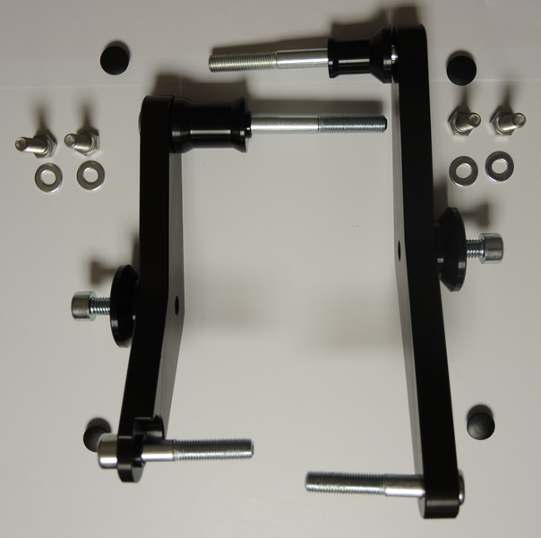 |  | 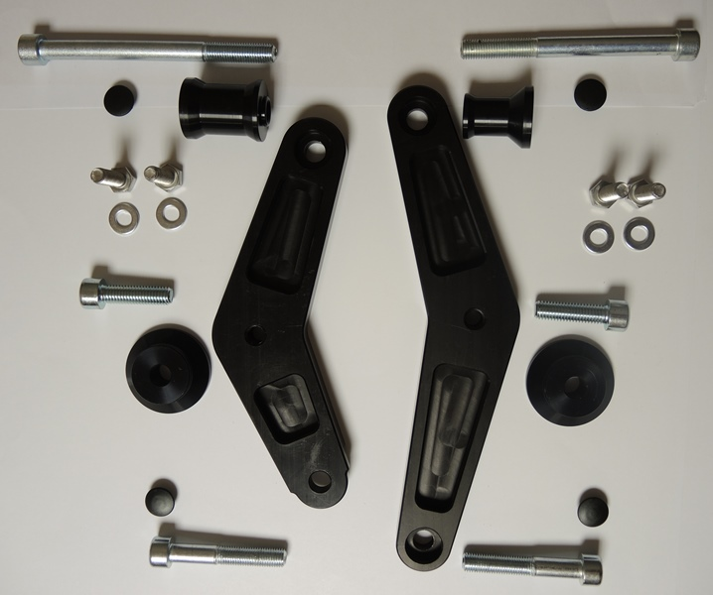

Mounting kit – left side

- Mount the dural. adapter (ID.1) using bolt ID. 3 and ID.4. During assembly, fit the dural. adapter (ID.5) onto bolt ID.3.
- If the dural. adapter is correctly fitted, you can proceed with mounting of crash protector. Slid the SLD adapter ID.10 and roller ID.6 onto bolt ID.2, and then fit the dural. adapter onto the whole assembly. Finally, use bolts ID.8 and washers ID.9 to tighten the protector. You can now put the plastic covers onto bolt heads.
- pokud máte duralový adaptér správně namontován, můžete začít montovat padací protektor. Na šroub (poz.2) navlékněte SLD adaptér (poz.10), váleček (poz.6) a poté celou tuto sestavu namontujte na duralový adaptér. Na konec pomocí šroubů(poz.8) a podložek(poz.9) připevněte padací protektor. Na hlavy šroubů můžete dát plastové krytky (poz.7)

Note – We recommend using medium strenght blue color glue for threads of all bolts.

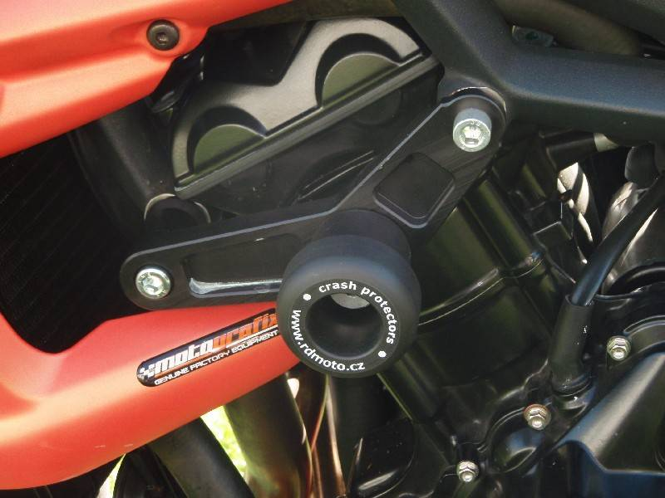

Mounting Instructions – Right side

- Use bolts ID. 3 and ID. 4 to mount the dural adapter ID.1. During assembly, fit the ID.5 dural. roller onto ID.3 bolt.
- If you the assembly is correctly fitted, you can proceed with installation of crash protector. Fit the SLD adapter ID.10 and roller ID. 6 onto bolt ID.2 and then fit this whole assembly onto dural. adapter. Finally, faster the crash protector with bolts ID. 8 and washers ID.9. You can now put the plastic covers onto bolt heads.

Note – We recommend using medium strenght glue for threads of all screws.

