T4
Triumph Street Triple 675 2007-
Triumph Street Triple 675R 2009-

Kit for the left side |  |  |  |  | Kit for the right side
No. | Description | Cat.no. | Pcs |  |  | No. | Description | Cat.no. | Pcs
1 | Duralumin adapter | 613 | 1 |  |  | 1 | Duralumin adapter | 614 | 1
2 | Bolt M10x35mm | 847 | 1 |  |  | 2 | Bolt M10x35mm | 847 | 1
3 | Bolt M10x120x1,25mm | 895 | 1 |  |  | 3 | Bolt M10x110x1,25mm | 928 | 1
4 | Bolt M10x60x1,25mm | 896 | 1 |  |  | 4 | Bolt M10x60x1,25mm | 896 | 1
5 | Dural. cylinder d=40mm | 71 | 1 |  |  | 5 | Dural. cylinder d=32,5mm | 68 | 1
6 | Steel box M10 | X1 | 1 |  |  | 6 | Steel box M10 | X1 | 1
7 | Plastic cover M10 | X4 | 2 |  |  | 7 | Plastic cover M10 | X4 | 2

Installation – the left side:

- use the bolt (No. 3) and the bolt (No. 4) for mounting of the duralumin adapter (No. 1), give the duralumin cylinder (No. 5) on the bolt (No. 3) during the installation
- if you mounted duralumin adapters, you can mount the crash protector. Give the steel box (No. 6) and the crash protector on the bolt (No. 2).
- all this set mount on the duralumin adapter
- give the plastic covers (No. 7) on the head of bolt

Warning – we recommend to use safety glue on threads of all bolts (moderate strong – blue colour).

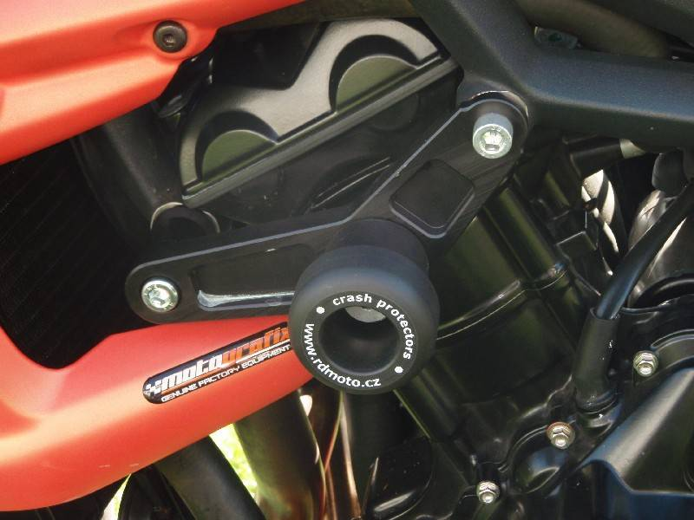

Installation – the right side:

- use the bolt (No. 3) and the bolt (No. 4) for mounting of the duralumin adapter (No. 1), give the duralumin cylinder (No. 5) on the bolt (No. 3) during the installation
- if you mounted duralumin adapters, you can mount the crash protector. Give the steel box (No. 6) and the crash protector on the bolt (No. 2).
- all this set mount on the duralumin adapter
- give the plastic covers (No. 7) on the head of bolt

Warning – we recommend to use safety glue on threads of all bolts (moderate strong – blue colour).

