T5S
Triumph Daytona 675 2006-2010
Triumph Daytona 675R 2011-

Kit for the left side |  |  |  |  | Kit for the right side
ID | Description | Cat.no. | Pcs |  |  | No. | Description | Cat.no. | Pcs
1 | Slider adapter | DV-313 | 1 |  |  | 1 | Slider adapter | DV-318 | 1
2 | Washer M10 (spring) | 801 | 1 |  |  | 2 | Washer M10 (spring) | 801 | 1
3 | Bolt M10x25mm | 868 | 1 |  |  | 3 | Bolt M10x40mm | 854 | 1
4 | 3M tape | - | 1 |  |  | 4 | 3M tape | - | 1
5 | Bolt M6x25 | 877 | 3 |  |  | 5 | Bolt M6x25 | 877 | 3
6 | Bolt M4x16 | 876 | 2 |  |  | 6 | Bolt M4x16 | 876 | 2
7 | Steel adapter | 589 | 1 |  |  | 7 | Steel adapter | 590 | 1
8 | Bolt M10x110x1,25mm | 928 | 1 |  |  | 8 | Bolt M10x115x1,25mm | 894 | 1
9 | Bolt M10x58x1,25mm | 901 | 1 |  |  | 9 | Bolt M10x60x1,25mm | 896 | 1
10 | Dural. cylinder d=32,5mm | 136 | 1 |  |  | 10 | Dural. cylinder d=28mm | 135 | 1

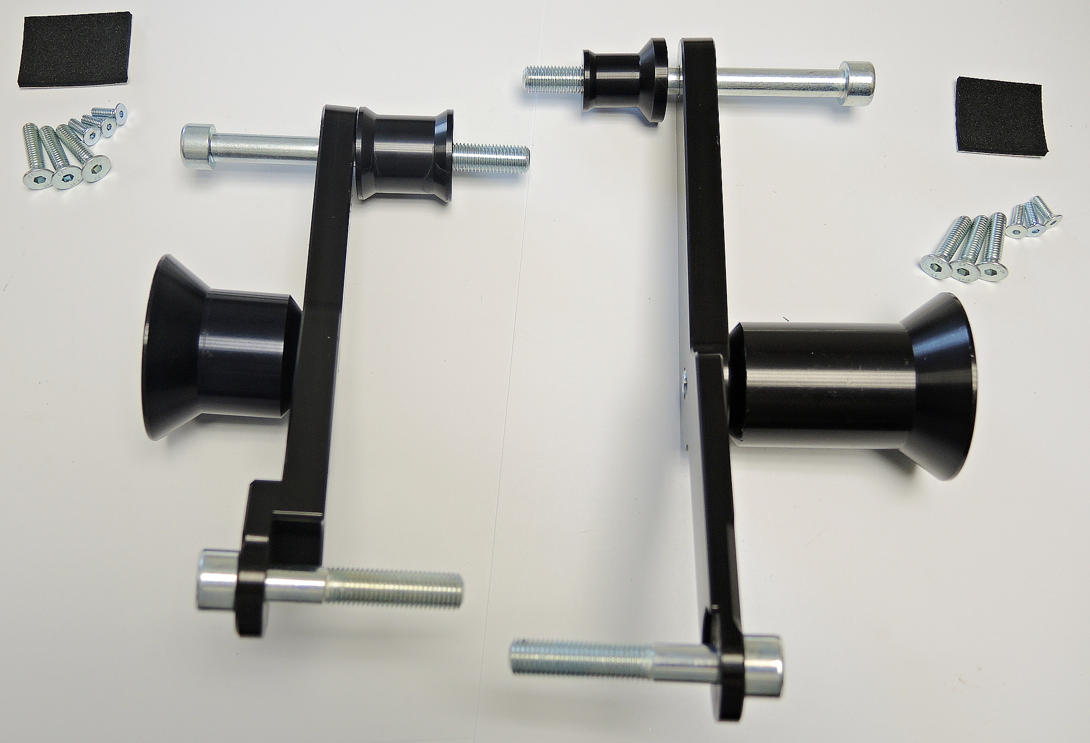

LEFT SIDE INSTRUCTIONS

- Demontujte původní šrouby podle obrázku.
- Stick 3M tape on the motorcycle to prevent its damage.
- Fit steel adapter ID7 on the motorcycle using bolts ID8 and ID9. Place cylinder ID10 on the longer front bolt.
- Fit slider adapter ID1 using bolt ID3 and washer ID2.
- Fit slider using three M6 bolts.
- Fit coloured cover using two M4 bolts.

We recommend to use the glue on all threads (medium strong).

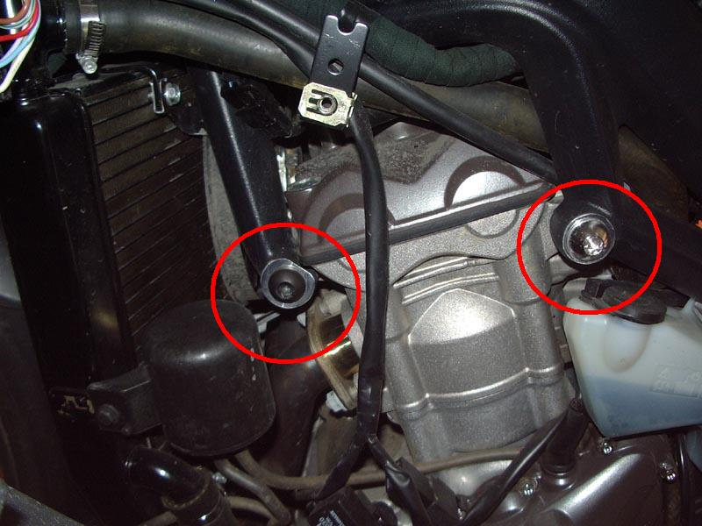

RIGHT SIDE INSTRUCTIONS

- Demontujte původní šrouby podle obrázku.
- Stick 3M tape on the motorcycle to prevent its damage.
- Fit steel adapter ID7 on the motorcycle using bolts ID8 and ID9. Place cylinder ID10 on the longer front bolt.
- Fit slider adapter ID1 using bolt ID3 and washer ID2.
- Fit slider using three M6 bolts.
- Fit coloured cover using two M4 bolts.

We recommend to use the glue on all threads (medium strong).

