T6S
Triumph Sprint 1050 2005-
Left side mounting kit: Right side mounting kit:
ID | Description | Cat.No. | Pcs
1 | Bolt M6x25 | 877 | 3
2 | Bolt M4x16 | 876 | 2
3 | Dural.cylinder 5mm | 294 | 1
4 | Poly. Cylinder 60mm | X14 | 1
5 | Bolt M12x110x1,25 | 910 | 1
6 | Bolt M8x30 | 942 | 1
7 | Bolt M12x40 | 858 | 1
8 | Dural. adapter | 345 | 1
9 | Frame adapter | 594 | 1
10 | 3M sticker | - | 1
ID | Description | Cat.No. | Pcs
1 | Bolt M6x25 | 877 | 3
2 | Bolt M4x16 | 876 | 2
3 | Dural. cylinder 15mm | 295 | 1
4 | Poly. Cylinder 50mm | X13 | 1
5 | Bolt M12x100x1,25 mm | 911 | 1
6 | Bolt M8x30 | 942 | 1
7 | Bolt M12x40 | 858 | 1
8 | Dural. adapter | 345 | 1
9 | Frame adapter | 593 | 1
10 | 3M sticker | - | 1
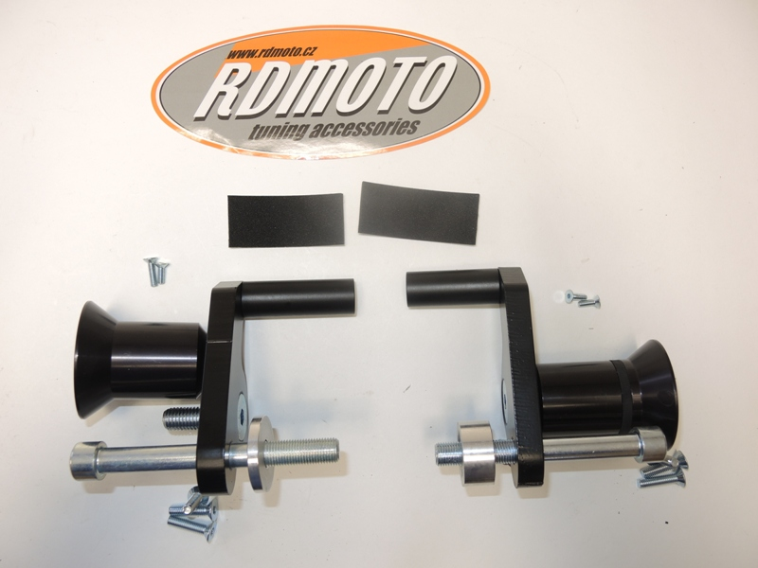

10

4
6
6
9
2

2
8

4
9
8
7
7

1

5
1
5
3

3

Instrucitons:

- We recommend to use the glue on all threads.
- Remove original bolt M12 from the frame of motorcycle.
- Mount poly. Cylinde ID on the adapter ID9 using bolt ID6.
- Insert bolt ID7 from back side into the adapter. Using this bolt fit adapter for slider ID8.
- Insert bolt ID5 with cylinder ID3 into the adapter ID9.
- Mount this kit on the frame of motorcycle.
- Fit slider on the adapter using three bolts M6 (ID1).
- Fit coloured cover on the slider using two bolts M4 (ID2).

