T6
Triumph Sprint 1050 2005-
Fitting kit left side: Fitting kit right side:
ID | Description | Cat.N | QTY
1 | Steel box M12 | X2 | 1
2 | Dural.cylinder d=70 | 420 | 1
3 | Dural.cylinder d=5 | 294 | 1
4 | Poly.cylinder d=60 | X14 | 1
5 | Bolt M12x110x1,25 | 910 | 1
6 | Bolt M8x30 | 942 | 1
7 | Bolt M12x40 | 858 | 1
8 | Bolt M12x50 | 869 | 1
9 | Dural. adapter | 594 | 1
10 | 3M Tape |  | 1
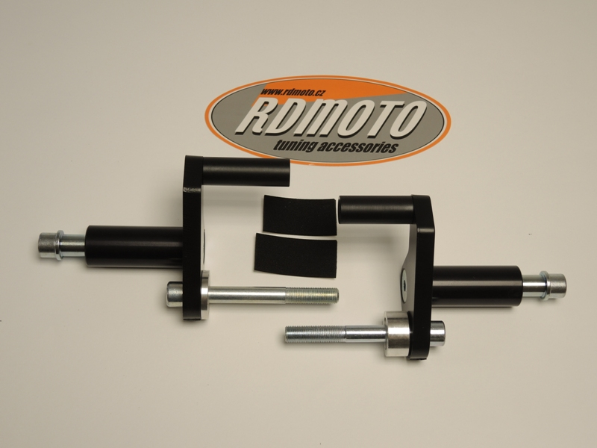
ID | Description | Cat.N | QTY
1 | Steel box M12 | X2 | 1
2 | Dural. cylinder d=70mm | 420 | 1
3 | Dural. cylinder d=15mm | 295 | 1
4 | Poly.cylinder d=50mm | X13 | 1
5 | Bolt M12x100x1,25mm | 911 | 1
6 | Bolt M8x30mm | 942 | 1
7 | Bolt M12x40mm | 858 | 1
8 | Bolt M12x50mm | 869 | 1
9 | Dural. adapter | 593 | 1
10 | 3M tape |  | 1
10

4
6
4

6
2
9

7
8
2
1

7
8

1
1
5
3
5
9
3

Instr.to assembly left side:
- Take out original bolt M12 from frame.
- Gripping Poly cylinder ID.4 on the dural.adapter ID.9 use bolt ID.6.
- Insert bolt ID.7 from back side into the adapter and mount dural. cylinder ID.2.
- Use bolt ID.5, put on the bolt dural. cylinder ID.3.
- Mount this kit on the frame, you can use 3M tape.
- Put fairiing on the bike.
- Take bolt ID.8, insert steel box ID.1 into the protector and mount it on the dural. cylinder.

Instr.to assembly right side:
- Take out original bolt M12 from frame.
- Gripping Poly cylinder ID.4 on the dural.adapter ID.9 use bolt ID.6.
- Insert bolt ID.7 from back side into the adapter and mount dural. cylinder ID.2.
- Use bolt ID.5, put on the bolt dural. cylinder ID.3.
- Mount this kit on the frame, you can use 3M tape.
- Put fairiing on the bike.
- Take bolt ID.8, insert steel box ID.1 into the protector and mount it on the dural. cylinder.

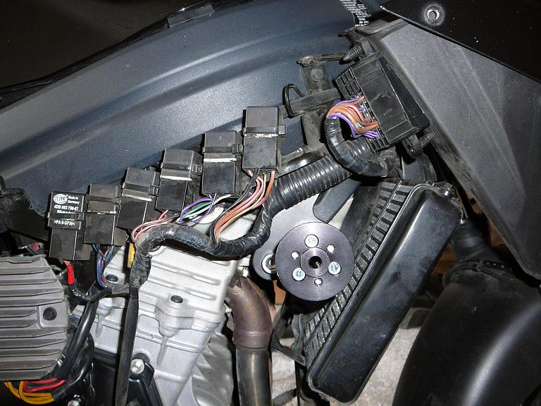
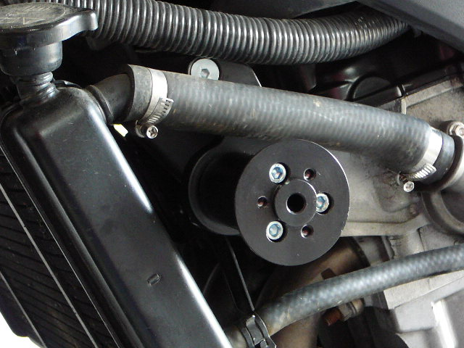
Warning: We recommend use the glue of all threads. Medium strong.

