T7S
Triumph Tiger 1050 2007-

Kit for left side |  |  |  |  | Kit for right side
Note | Description | Cat.No. | Pcs. |  |  | Note | Description | Cat.No. | Pcs.
1 | Slider RDmoto | SL | 1 |  |  | 1 | Slider RDmoto | SL | 1
2 | Cover | SLcap.. | 1 |  |  | 2 | Cover | SLcap.. | 1
3 | Adapter moto | DV-316 | 1 |  |  | 3 | Adapter moto | DV-350 | 1
4 | Bolt M10x20mm | 819 | 1 |  |  | 4 | Bolt M12x30mm | 855 | 1
5 | Bolt M6x25 | 877 | 3 |  |  | 5 | Bolt M6x25 | 877 | 3
6 | Bolt M4x16 | 876 | 2 |  |  | 6 | Bolt M4x16 | 876 | 2
7 | Duralumin adapter | 591 | 1 |  |  | 7 | Duralumin adapter | 592 | 1
8 | Bolt M12x60x1,25mm | 916 | 1 |  |  | 8 | Bolt M12x80mm | 956 | 1
9 | Bolt M8x60mm | 839 | 1 |  |  | 9 | Bolt M12x130mm | 886 | 1
10 | Duralumin cylinder d=10mm | 103 | 1 |  |  | 10 | Duralumin cylinder d=34mm | 105 | 1
11 | Duralumin cylinder d=21mm | 104 | 1 |  |  | 11 | Nut M12 (safety) | 811 | 2
 |  |  |  |  |  | 12 | washer M12 | 803 | 2

Warning – we recommend to use safety glue on threads of all bolts (medium strong – blue colour).

Installation – the left side:

- use the bolt (No. 8) and the bolt (No. 9) for the mounting of the duralumin adapter (No. 7), give the duralumin cylinders (No. 10) and (No. 11) on the bolt (No. 8) and (No. 9) during the installation
- if you mounted duralumin adapters, you can mount gripping for slider. Use bolt (No. 4) for mounting of duralumin adapter (No. 3). You have to mount adapter with thread M6 up, then slider have the right rotation.
- put slider (No. 1) and use the bolts (No. 5) for mounting
- insert in slider the cover (No. 2) and use the bolts (No. 6) for gripping

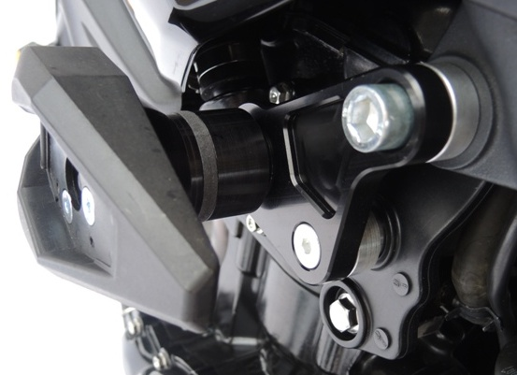
1.

2.

3.

4. insert in slider the cover (No. 2) and use the bolts (No. 6) for gripping

Installation – the right side:

1. Take duralumin adapter (note 7) and from the back Put the screw (note 4) to the following thread the bolt-through from the other side of duralumin duralumin cylinder adapter (note 3) and pull the slider had good rotation, you must attach the thread adapter M6 up
2. Remove the plastic cover on the cooler.
3. screw (note 8) and screw (note 9) Alu mount adapter (note 7), when mounting thread the screw (note 9) duralumin cylinder (note 10). During the installation, use nut M12 (note 11) with washers M12 (note12)
4. Attach the slider (note 1) and fasten bolts (note 5)
5. Insert the slider cover (note 2) and fasten bolts (note 6)
6. Install the plastic back on the bike

Warning – we recommend to use safety glue on threads of all bolts (moderate strong – blue colour).
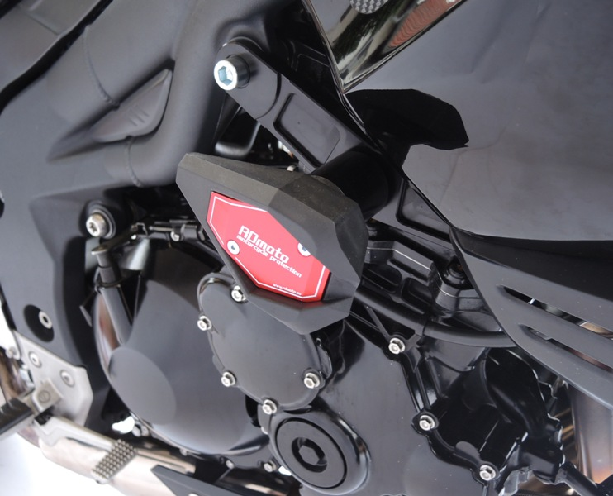
1.
2.
4.

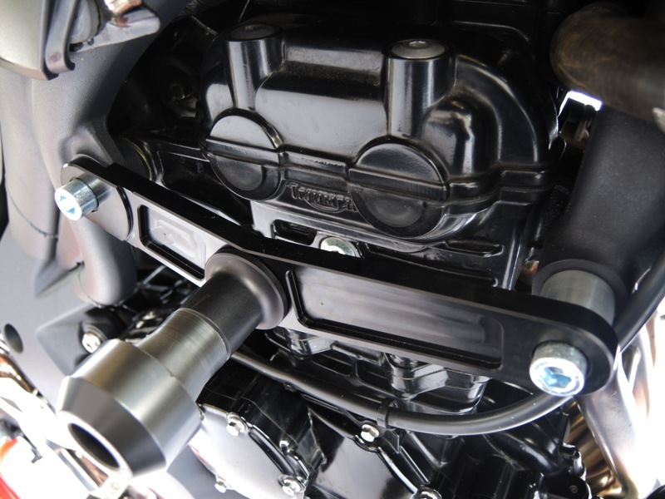
3.

