T7
Triumph Tiger 1050

Kit for the left side |  |  |  |  | Kit for the right side
No. | Description | Cat.no. | Pcs |  |  | No. | Description | Cat.no. | Pcs
1 | Duralumin adapter | 591 | 1 |  |  | 1 | Duralumin adapter | 592 | 1
2 | Bolt M10x50mm | 849 | 1 |  |  | 2 | Bolt M12x60mm (kužel.hlava) | 955 | 1
3 | Bolt M12x60x1,25mm | 916 | 1 |  |  | 3 | Bolt M12x80mm | 956 | 1
4 | Bolt M8x60mm | 839 | 1 |  |  | 4 | Bolt M12x130mm | 886 | 1
5 | Dural. cylinder d=10mm | 103 | 1 |  |  | 5 | Dural. cylinder d=34mm | 105 | 1
6 | Dural. cylinder d=21mm | 104 | 1 |  |  | 6 | Dural. cylinder d=30mm | 171 | 1
7 | Dural. cylinder d=15mm | 9 | 1 |  |  | 7 | Special nut | X17 | 1
8 | Steel box M10 | X1 | 1 |  |  | 8 | Nut M12 (safety) | 811 | 2
 |  |  |  |  |  | 9 | Pad M12 | 803 | 2

Installation – the left side:

Warning – we recommend to use safety glue on threads of all bolts (moderate strong – blue colour).

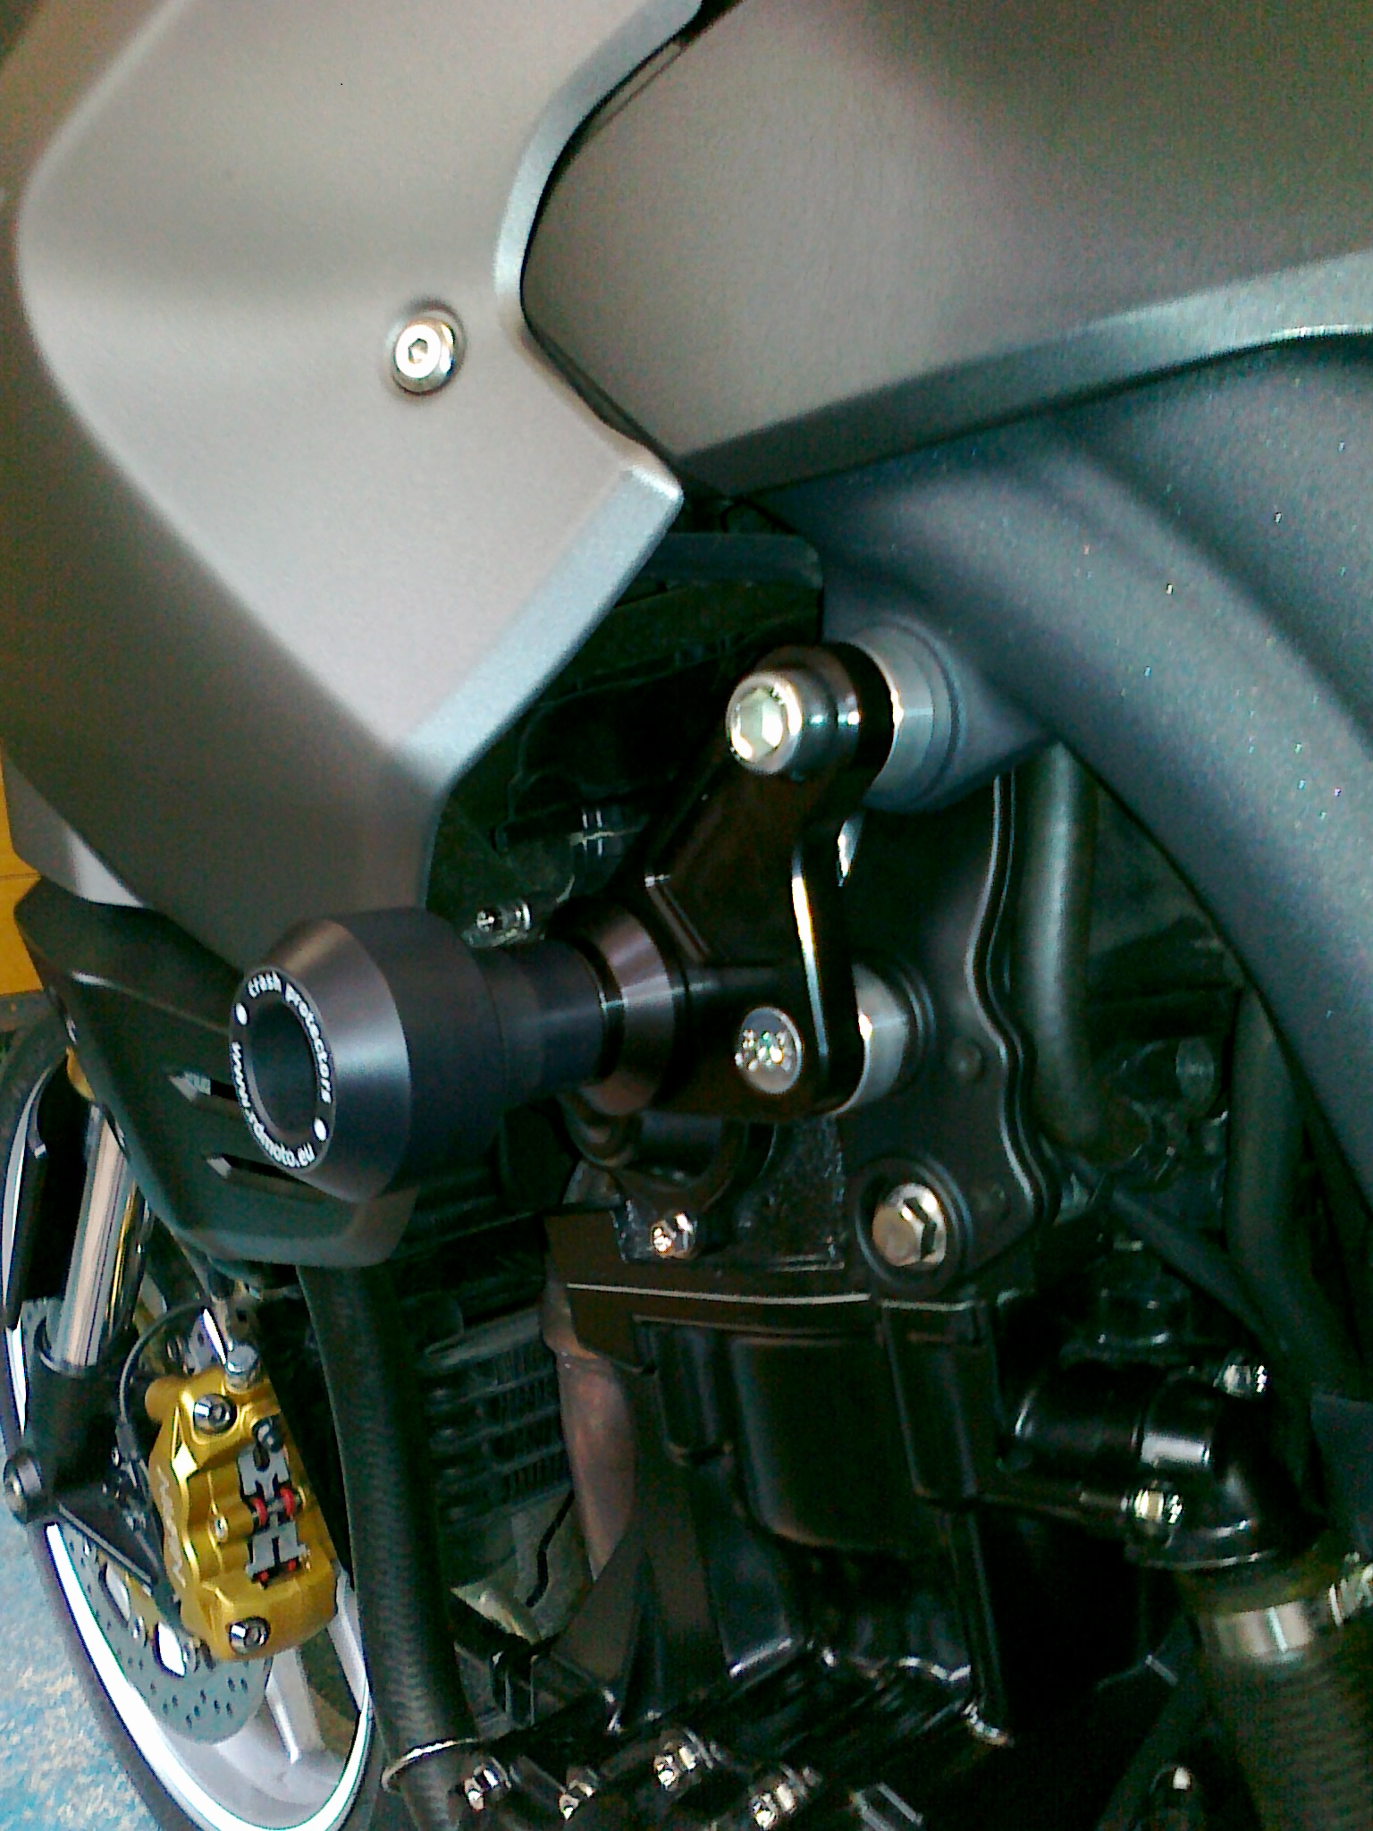
- Put inside steel housing (note 8) to the crash protector.
- Through crash protector and dural. cylinder (note 7) insert bolt (note 2) Whole sets mounting on the adapter (note 1).
- Bolt (note 3) and bolt (note 4) mounting duralumin adapter (note 1), Put on the bolts (note 3) and (note 4) duralumin cylinder (note 5) and (note 6)
- Put on cover on the protectors PHV1 and PHV2.

Installation – the right side:

Warning – we recommend to use safety glue on threads of all bolts (moderate strong – blue colour).

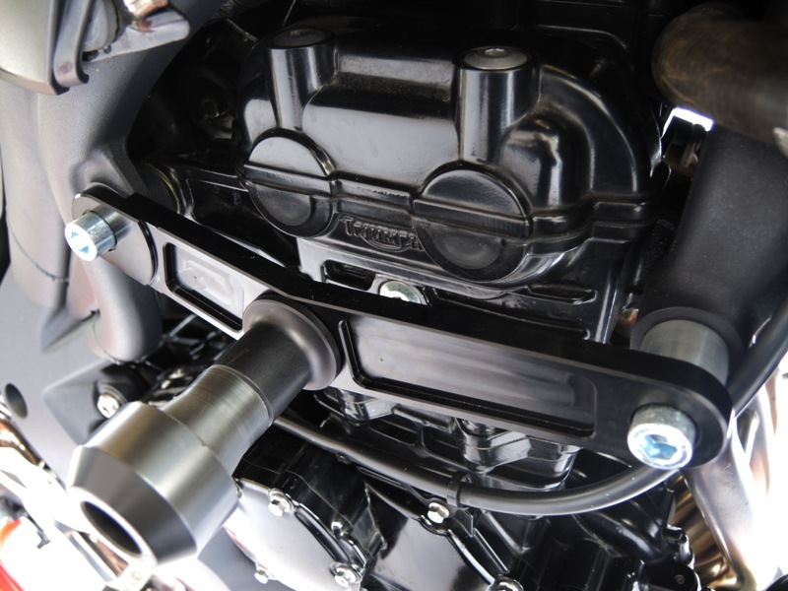
- Tako on duralumin adapter (note 1) from the back side Put the screw (note 2).
- From front side put on the bolt duralumin adapter (note 6) and crash protector. This set fixed by special nut (note 7).
- Take off plastic cover
- Take off original bolts from bike.
- Put on the adapter (note 1) on the bike, just do it screw (note 3) rear, and screw (note 4) front. Put on the bolt (note 4).
- Put in duralumin cylinder (note 5) between adapter and frame.
- Use the nut (note 8) and washer (note 9) to tightening
- Put on the bike plastic cover
- On the protectors PHV1 and PHV2 mounting color cover.

