T8
Triumph Sprint GT 1050 2010-

Kit for the left side |  |  |  |  | Kit for the right side
No. | Description | Cat.no. | Pcs |  |  | No. | Description | Cat.no. | Pcs
1 | Steel box M12 | X2 | 1 |  |  | 1 | Steel box M12 | X2 | 1
2 | Dural. cylinder d=70mm | 420 | 1 |  |  | 2 | Dural. cylinder d=70mm | 420 | 1
3 | Poly d=50mm | X13 | 1 |  |  | 3 | Dural. cylinder d=15mm | 295 | 1
4 | Bolt M12x90x1,25mm | 931 | 1 |  |  | 4 | Poly d=50mm | X13 | 1
5 | Bolt M8x25mm | 831 | 1 |  |  | 5 | Bolt M12x110x1,25mm | 910 | 1
6 | Bolt M12x40mm | 858 | 1 |  |  | 6 | Bolt M8x25mm | 831 | 1
7 | Bolt M12x40mm | 857 | 1 |  |  | 7 | Bolt M12x40mm | 858 | 1
8 | Duralumin adapter | 594 | 1 |  |  | 8 | Bolt M12x40mm | 857 | 1
9 | 3M tape |  | 1 |  |  | 9 | Duralumin adapter | 593 | 1
 |  |  |  |  |  | 10 | 3M tape |  | 1
Installation – the left side:

- remove the original bolt M12
- use the bolt (No. 5) for mounting of the poly cylinder (No. 3) on the duralumin adapter (No. 8)
- give the bolt (No. 4) into the duralumin adapter
- mount the duralumin adapter on the frame of the motorcycle, stick the 3M tape (No. 9) on the frame of the motorcycle at the point of touching
- insert the bolt (No. 6) into the back side of adapter and screw up it together with the duralumin cylinder (No. 2)
- now you can mount the side plastic back
- take the bolt (No. 7), give the steel box (No. 1) together with protector on the bolt and you can mount it into the thread M12, which is in duralumin cylinder.

Warning – we recommend to use safety glue on threads of all bolts (moderate strong – blue colour).

ILLUSTRATIVE PHOTOS OF Place of the installation

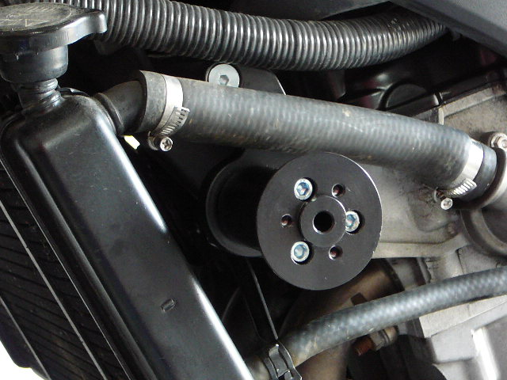

Installation – the right side:

- remove the original bolt M12
- use the bolt (No. 6) for mounting of the poly cylinder (No. 4) on the duralumin adapter (No. 9)
- give the bolt (No. 5) into the duralumin adapter, insert the distance cylinder (No. 3) on the bolt on the other side
- mount the duralumin adapter on the frame of the motorcycle, stick the 3M tape (No. 10) on the frame of the motorcycle at the point of touching
- insert the bolt (No. 7) into the back side of adapter and screw up it together with the duralumin cylinder (No. 2)
- now you can mount the side plastic back
- take the bolt (No. 8), give the steel box (No. 1) together with protector on the bolt and you can mount it into the thread M12, which is in duralumin cylinder.

Warning – we recommend to use safety glue on threads of all bolts (moderate strong – blue colour).

ILLUSTRATIVE PHOTOS OF Place of the installation

