T9SDM
Triumph Tiger 800 2011-

Fitting kit left side: Fitting kit right side:
ID | Description | Cat.N | Qty
1 | Duralumin adapter | 595 | 1
2 | Bolt M10x145x1,25mm | 909 | 1
3 | Bolt M10x70x1,25mm | 898 | 1
4 | Dural. spacer d=83mm | 278 | 1
5 | Dural. spacer d=34mm | 279 | 1
6 | Plastic cover - black | X4 | 2
7 | Dural.spacer for SLD | 12 | 1
8 | Dural.holder for SLDM | 537/B | 1
9 | Bolt M10x60 | 860 | 1
10 | Bolt M6x20 | 1024 | 2
11 | Washer M6 | 1023 | 2
ID | Description | Cat.N | Qty
1 | Duralumin adapter | 596 | 1
2 | Bolt M10x100x1,25mm | 892 | 1
3 | Bolt M10x70x1,25mm | 898 | 1
4 | Dural. spacer d=26mm | 280 | 1
5 | Dural. spacer d=33mm | 281 | 1
6 | Plastic cover - black | X4 | 2
7 | Dural.spacer for SLD | 12 | 1
8 | Dural.holder for SLDM | 537/B | 1
9 | Bolt M10x85 | 981 | 1
10 | Bolt M6x20 | 1024 | 2
11 | Washer M6 | 1023 | 2
12 | 3M tape | - | -

Installation – the left side:

- Take out original bolts from fram as shown on the picture. Dural.adapter ID.1 Mount by bolts ID.2 and ID.3, under the adapter put dural. spacers ID.4 and ID.5.
- This set mounting on the frame, left hand side.
- Plastic covers ID.6 place into the bolts head.
- Dural. spacer ID.7 and bracket ID.8 mounting on the adapter by bolt ID.9.
- Place slider and for mounting use bolts and washers ID. 10 and ID.11.

Installation – the right side:

- Take out original bolts from fram as shown on the picture. Dural.adapter ID.1 Mount by bolts ID.2 and ID.3, under the adapter put dural. spacers ID.4 and ID.5. Stick 3M Tape, where is adapter touching with OEM fairing.
- This set mounting on the frame, right hand side.
- Plastic covers ID.6 place into the bolts head.
- Dural. spacer ID.7 and bracket ID.8 mounting on the adapter by bolt ID.9.
- Place slider and for mounting use bolts and washers ID. 10 and ID.11.

Warning – we recommend to use safety glue on threads of all bolts (moderate strong – blue colour).

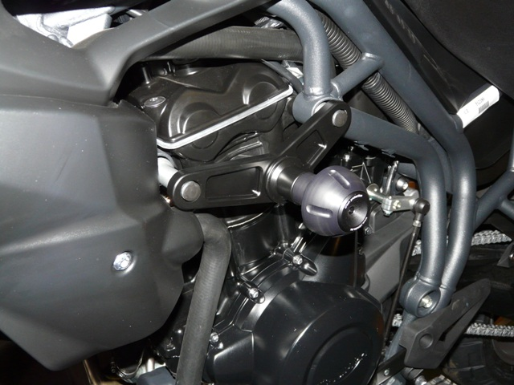
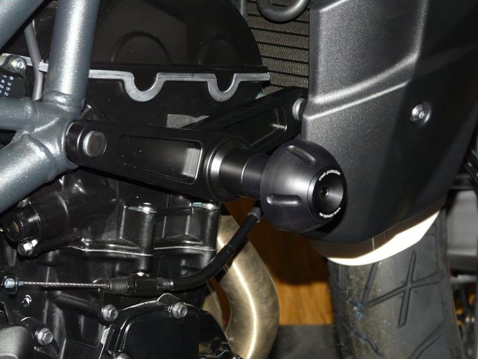
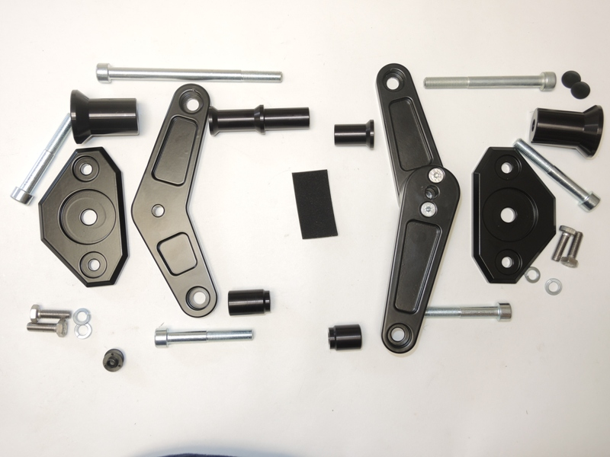
9
8
1
10,11
5
7
2
4
6
3
6
9
4
5
12
1
3
7
2
10,11
8
Ilustration photo, place for assembly kit.

