T9S
Triumph Tiger 800 2011-

Kit for the left side |  |  |  |  | Kit for the right side
No. | Description | Cat.no | Pcs |  |  | No. | Description | Cat.no | Pcs
1 | Slider RDmoto | SL | 1 |  |  | 1 | Slider RDmoto | SL | 1
2 | Cover | SLcap.. | 1 |  |  | 2 | Cover | SLcap.. | 1
4 | Slider adapter | DV-318 | 1 |  |  | 4 | Slider adapter | DV-318 | 1
6.1 | Bolt M10x30mm | 882 | 1 |  |  | 6.2 | Bolt M10x55mm | 1002 | 1
8 | Bolt M6x25 | 877 | 3 |  |  | 8 | Bolt M6x25 | 877 | 3
9 | Bolt M4x16 | 876 | 2 |  |  | 9 | Bolt M4x16 | 876 | 2
10.1 | Bolt M10x145x1,25mm | 909 | 1 |  |  | 10.2 | Bolt M10x100x1,25mm | 892 | 1
11.1 | Bolt M10x70x1,25mm | 898 | 1 |  |  | 11.2 | Bolt M10x70x1,25mm | 898 | 1
12.1 | Duralumin adapter | 595 | 1 |  |  | 12.2 | Duralumin adapter | 596 | 1
13.1 | Duralumin cylinder d=83mm | 278 | 1 |  |  | 13.2 | Dural.cylinder d=26mm | 280 | 1
14.1 | Duralumin cylinder d=34mm | 279 | 1 |  |  | 14.2 | Dural.cylinder d=33mm | 281 | 1
15 | Washer M10 (safety) | 801 | 1 |  |  | 15 | Washer M10 (safety) | 801 | 1
16 | Plastic cover - black | X4 | 2 |  |  | 16 | Plastic cover - black | X4 | 2
 |  |  |  |  |  | 17 | Tape 3M |  | 1
 |  |  | ID14.2
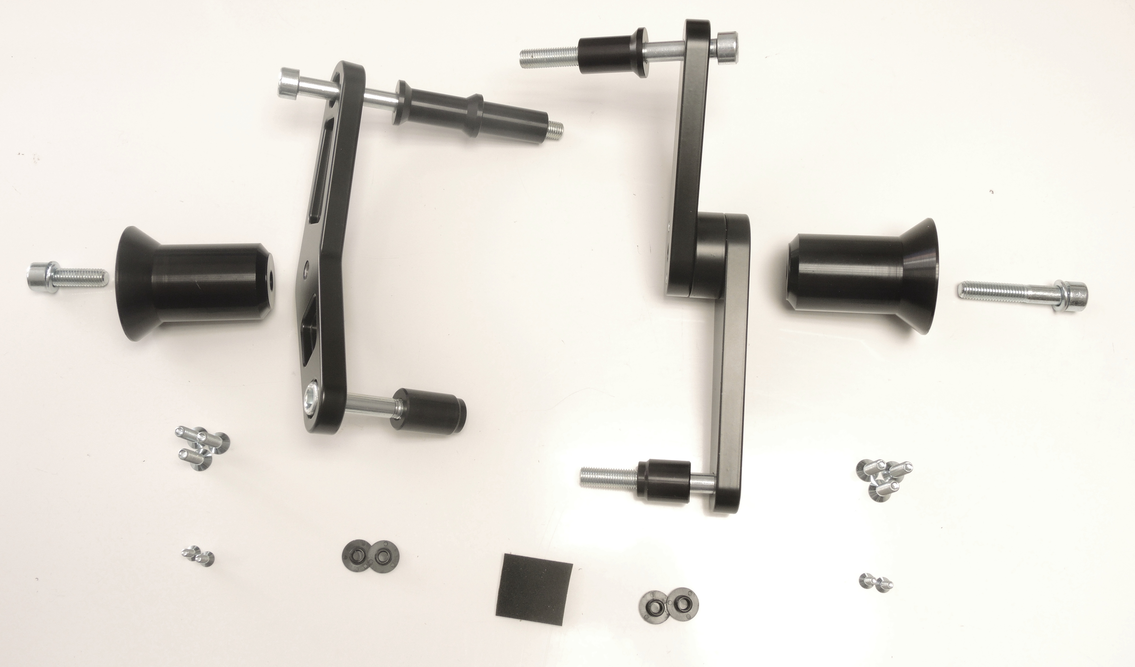
ID10.2
ID13.1
ID10.1

ID4
ID4
ID6.1
ID10
ID12.1
ID12.2
ID6.2
ID10

ID14.1
ID11.1
ID13.2
ID8
ID8
ID11.2

ID9
ID9

Installation – left side:

- Remove original bolts from the frame of motorcycle.
- Fit dural adapter (ID12.1) on the frame of motorcycle using two bolts M10 (ID10.1 + ID11.1). Don’t forget to place two spacers (ID13.1 + ID14.1) under dural adapter.
- Using bolt M10 (ID6.1) fit slider adapter (ID4) on dural adapter (ID12.1). Don’t forget to use safety washer (ID10).
- Fit slider on slider adapter (ID4) using three bolts M6 (ID8).
- Insert coloured cover into slider. Fit coloured cover using two screws M4 (ID9).

Warning! We recommend to use safety glue on threads of all bolts (medium strong – blue colour).

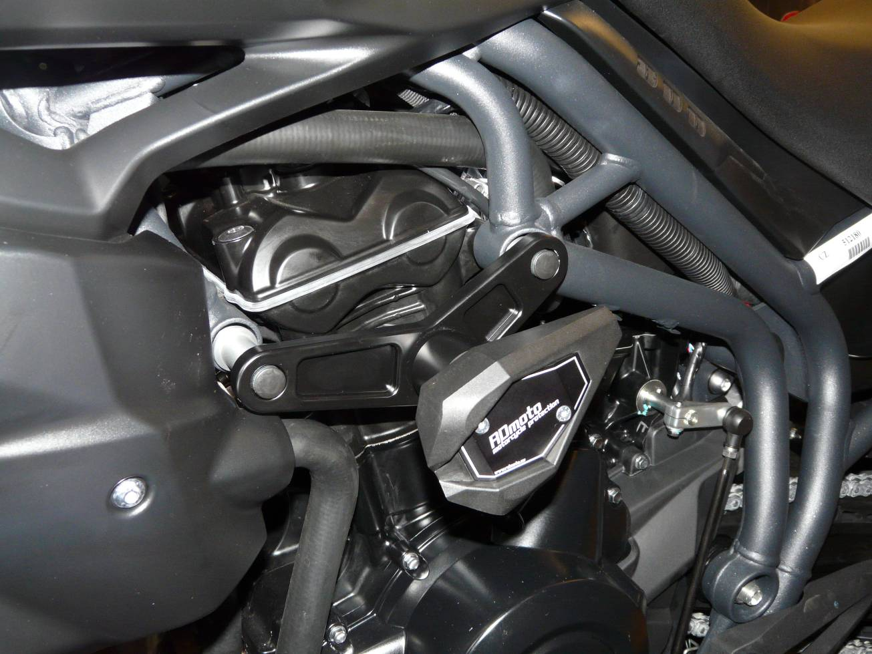

Installation – right side:

- Remove original bolts from the frame of motorcycle.
- Fit dural adapter (ID12.2) on the frame of motorcycle using two bolts M10 (ID10.2 + ID11.2). Don’t forget to place two spacers (ID13.2 + ID14.2) under dural adapter.
- Insert tape 3M between engine and drual adapter (ID12.2).
- Using bolt M10 (ID6.2) fit slider adapter (ID4) on dural adapter (ID12.2). Don’t forget to use safety washer (ID10).
- Fit slider on slider adapter (ID4) using three bolts M6 (ID8).
- Insert coloured cover into slider. Fit coloured cover using two bolts M4 (ID9).

Warning! We recommend to use safety glue on threads of all bolts (medium strong – blue colour).

