T9
Triumph Tiger 800 2011-

Kit for the left side |  |  |  |  | Kit for right side
No. | Description | Cat.no | Pcs |  |  | No. | Description | Cat.no | Pcs
1 | Duralumin adapter | 595 | 1 |  |  | 1 | Duralumin adapter | 596 | 1
2 | Bolt M10x70mm | 851 | 1 |  |  | 2 | Bolt M10x95mm | 822 | 1
3 | Bolt M10x145x1,25mm | 909 | 1 |  |  | 3 | Bolt M10x100x1,25mm | 892 | 1
4 | Bolt M10x70x1,25mm | 898 | 1 |  |  | 4 | Bolt M10x70x1,25mm | 898 | 1
5 | Dural. cylinder d=83mm | 278 | 1 |  |  | 5 | Dural. cylinder d=26mm | 280 | 1
6 | Dural. cylinder d=34mm | 279 | 1 |  |  | 6 | Dural. cylinder d=33mm | 281 | 1
7 | Dural.cylinder d=30mm | 11 | 1 |  |  | 7 | Dural.cylinder d=30mm | 11 | 1
8 | Pad M10 (safety) | 801 | 1 |  |  | 8 | Pad M10 (safety) | 801 | 1
9 | Plastic cover - black | X4 | 2 |  |  | 9 | Plastic cover - black | X4 | 2
10 | Steel box M10 | X1 | 1 |  |  | 10 | Steel box M10 | X1 | 1
 |  |  |  |  |  | 11 | Tape 3M |  | 1

Installation – the left side:

- use the bolt (No. 3) and the bolt (No. 4) for mounting of duralumin adapter (No. 1), for mounting put on bolts duralumin cylinders (No. 5 and No. 6)
- if you mounted duralumin adapter, you can mount the crash protector. On bolt (No. 2) give steel box (No. 10) and the crash protector. Under crash protector give on bolt duralumin cylinder (No. 11). Use all this set for mounting on duralumin adapter.
- on bolts (No. 3) and (No. 4) give the plastic cover (No. 9)

Warning – we recommend to use safety glue on threads of all bolts (moderate strong – blue colour).

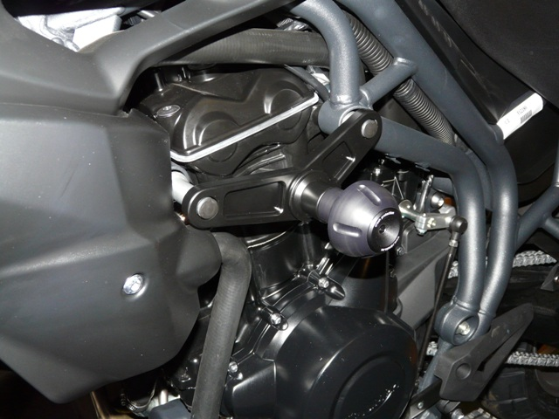

Installation – the right side:

- use the bolt (No. 3) and the bolt (No. 4) for mounting of duralumin adapter (No. 1), for mounting put on bolts duralumin cylinders (No. 5 and No. 6). Use the tape 3M (No. 11) to place, where duralumin adapter can touch to engine or plastics.
- if you mounted duralumin adapter, you can mount the crash protector. On bolt (No. 2) give steel box (No. 10) and the crash protector. Under crash protector give on bolt duralumin cylinder (No. 11). Use all this set for mounting on duralumin adapter.
- on bolts (No. 3) and (No. 4) give the plastic cover (No. 9)

Warning – we recommend to use safety glue on threads of all bolts (moderate strong – blue colour).

