Y11SDM
Yamaha FJR 1300 2001-2005

Fitting kit left side: Fitting kit right side:
ID | Description | Cat.no | QTY
1 | Dural.bracket | 537/B | 1
2 | Dural.spacer for bracket | 13 | 1
3 | Dural cylinder d=15 | 1148 | 2
4 | Bolt M12x80x1,25 | 908 | 2
5 | Duralumin adapter | 670 | 1
6 | Washer M6 | 1023 | 2
7 | Bolt M6x20 | 1024 | 2
8 | Bolt M10x70 | 851 | 1
ID | Description | Cat.no | QTY
1 | Dural.bracket | 537/B | 1
2 | Dural.spacer for bracket | 13 | 1
3 | Dural cylinder d=5 | 1149 | 2
4 | Bolt M12x65x1,25 | 940 | 2
5 | Duralumin adapter | 671 | 1
6 | Washer M6 | 1023 | 2
7 | Bolt M6x20 | 1024 | 2
8 | Bolt M10x70 | 851 | 1

4
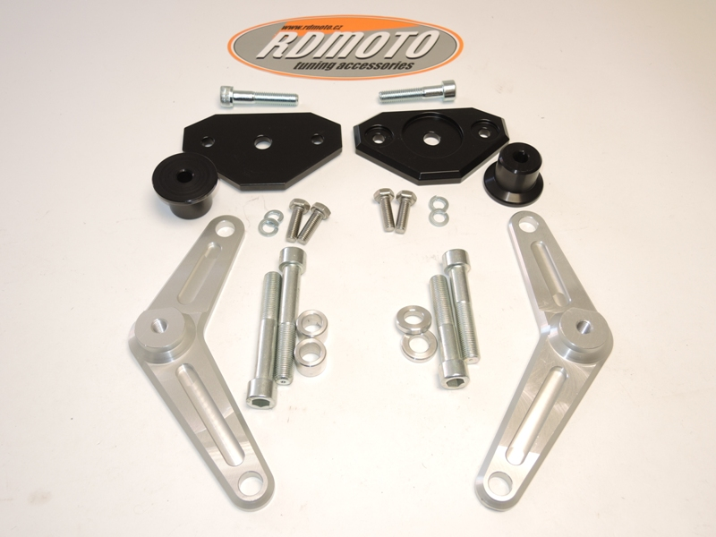

8
1
8

1

2
2
5
3
7
4
3
6
4
5
Instruction to assembly-left side:

- Take down fairing from left and right side.
- Make assembly on the left side, takeoff bolts from frame.
- Insert dural.cylinders d=15mm into the wholes in frame.
- For fixing the dural. adapter use bolts ID.4 M12x80mm- 55Nm.

Instruction to assembly-right side:

- Make assembly on the right side, takeoff bolts from frame.
- Insert dural.cylinders d=5mm into the wholes in frame.
- For fixing the dural. adapter use bolts ID.4 M12x65mm- 55Nm.

- Put fairings back on the bike.
- Place duralspacer ID.2 under the dural. bracket ID.1. This set mounting on the dural. adapter. Take the bolt ID.8.
- Place slider on the dural bracket and tighten it by bolts with washers ID.6, ID.7

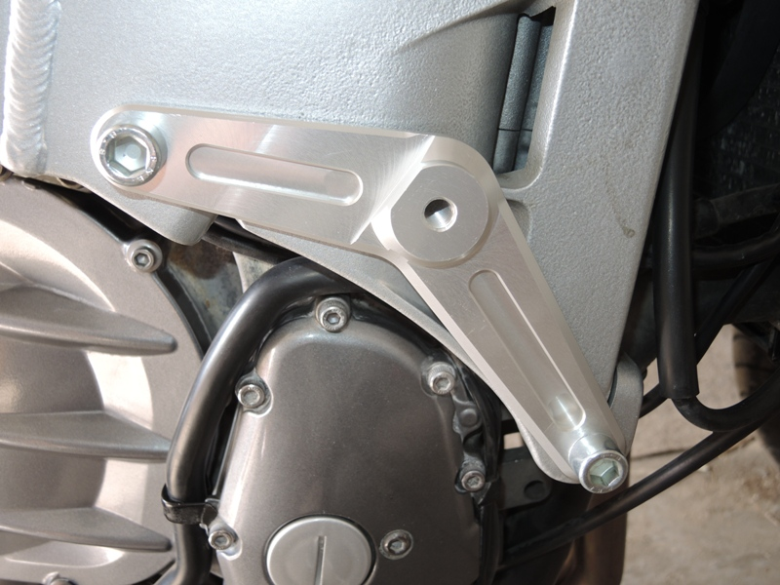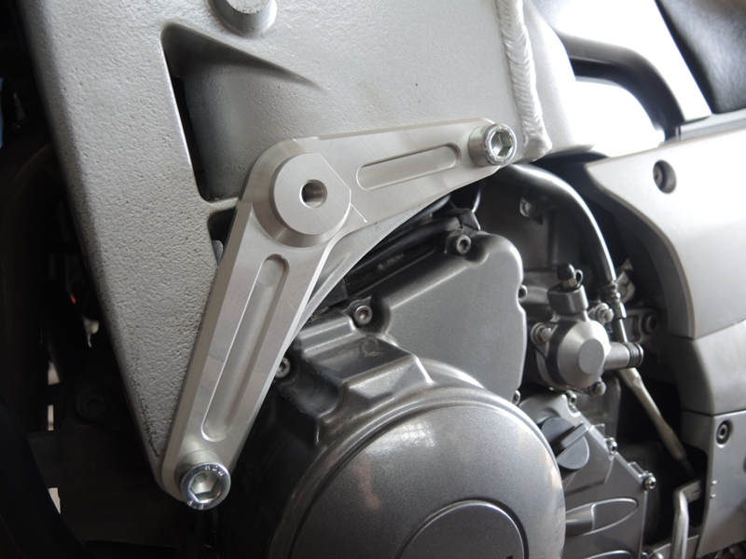

Warning: We recommend use the glue of all threads. Medium strong.

