Y11S
Yamaha FJR 1300 1998-2005

Fitting kit left side: Fitting kit right side:
ID | Popis | Kat.č | Ks
1 | Dural. adapter | 670 | 1
2 | Bolt M12x80x1,25 | 908 | 2
3 | Dural.cylinder d=15 | 1148 | 2
4 | Dural. adapterr | 317 | 1
5 | Bolt M10x30 | 882 | 1
6 | Bolt M6x25 | 877 | 3
7 | Bolt M4x16 | 876 | 2
ID | Popis | Kat.č | Ks
1 | Dural. adapter | 671 | 1
2 | Bolt M12x65x1,25 | 940 | 2
3 | Dural.cylinder d=5 | 1149 | 2
4 | Dural. adapter | 317 | 1
5 | Bolt M10x30 | 882 | 1
6 | Bolt M6x25 | 877 | 3
7 | Bolt M4x16 | 876 | 2

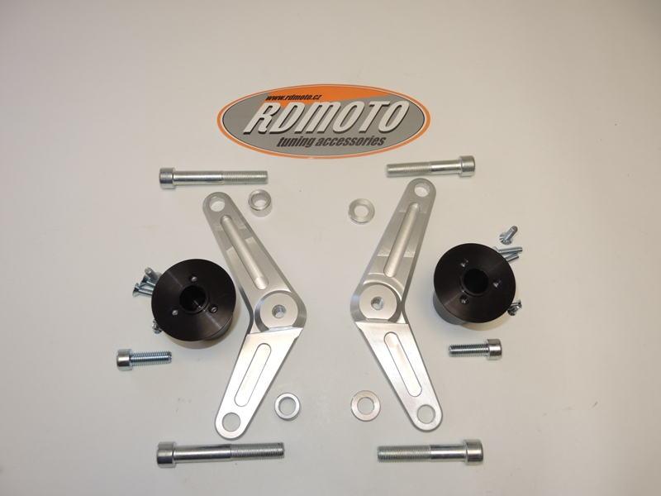

Instruction to assembly-left side:

- Take down fairing from left and right side.
- Make assembly on the left side, také off bolts from frame.
- Insert dural.cylinders d=15mm into the holes in frame.
- For fixing the dural. adapter use bolts ID.2 M12x80mm- 55Nm.

Instruction to assembly-right side:

- Make assembly on the right side, takeoff bolts from frame.
- Insert dural.cylinders d=5mm into the holes in frame.
- For fixing the dural. adapter use bolts ID.2 M12x65mm- 55Nm.

- Put fairing on the bike.
- Take bolts ID.5 and gripping dural.adapters ID.4.
- For mounting sliders use bolts ID.6.
- Insert aluminum ca pand thighten it by bolts ID.7.

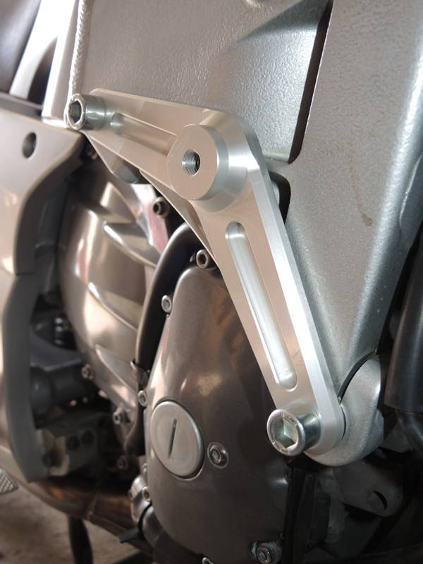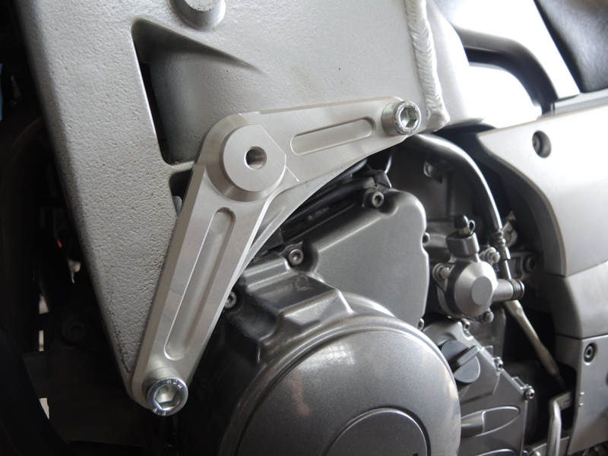
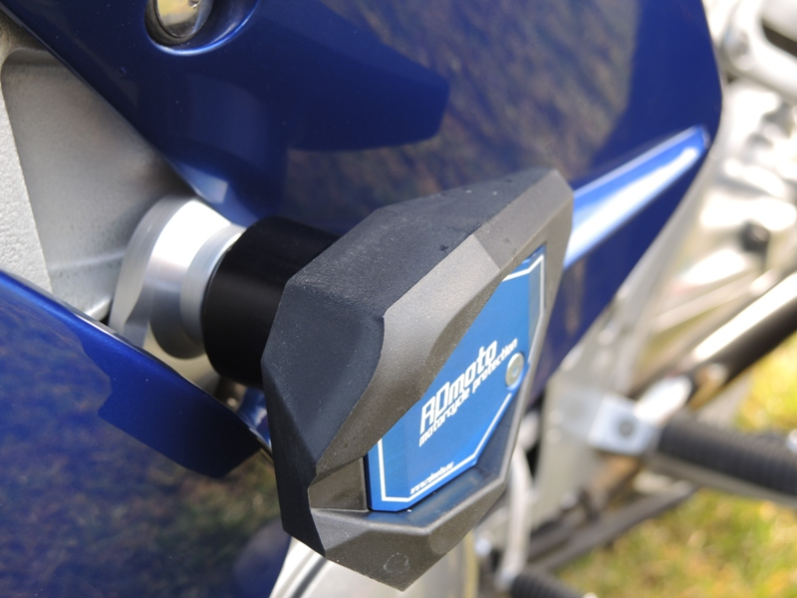

Warning: We recommend use the glue of all threads. Medium strong.

