Y11
Yamaha FJR 1300 1998-2005

Fitting kit left side: Fitting kit right side:
ID | Description | Cat.no | QTY
1 | Steel box | X1 | 1
2 | Bolt M10x40 | 854 | 1
3 | Dural cylinder d=15 | 1148 | 2
4 | Bolt M12x80x1,25 | 908 | 2
5 | Duralumin adapter | 670 | 1
ID | Description | Cat.no | QTY
1 | Steel box | X1 | 1
2 | Bolt M10x40 | 854 | 1
3 | Dural cylinder d=5 | 1149 | 2
4 | Bolt M12x65x1,25 | 940 | 2
5 | Duralumin adapter | 671 | 1

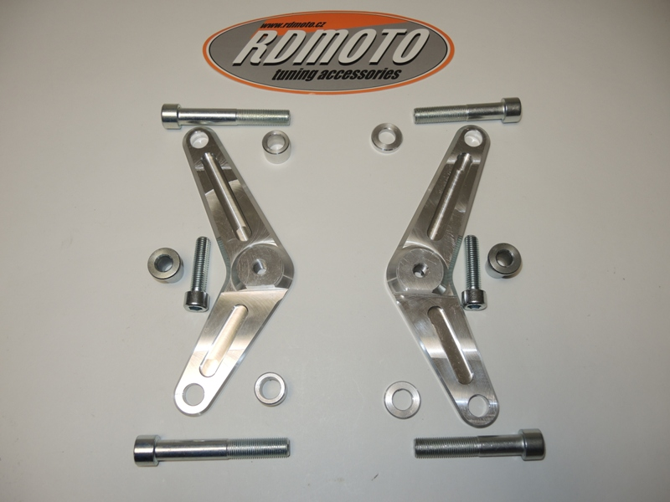

4
4
3

5

3

2
1
1

2
4
3
4
3
Instruction to assembly-left side:

- Take down fairing from left and right side.
- Make assembly on the left side, takeoff bolts from frame.
- Insert dural.cylinders d=15mm into the wholes in frame.
- For fixing the dural. adapter use bolts ID.4 M12x80mm- 55Nm.

Instruction to assembly-right side:

- Make assembly on the right side, takeoff bolts from frame.
- Insert dural.cylinders d=5mm into the wholes in frame.
- For fixing the dural. adapter use bolts ID.4 M12x65mm- 55Nm.

- Put fairings back on the bike.
- Insert steel boxes ID.1 into the protectors.
- Take bolts ID.2 and fixing protectors on the dural.adpaters.

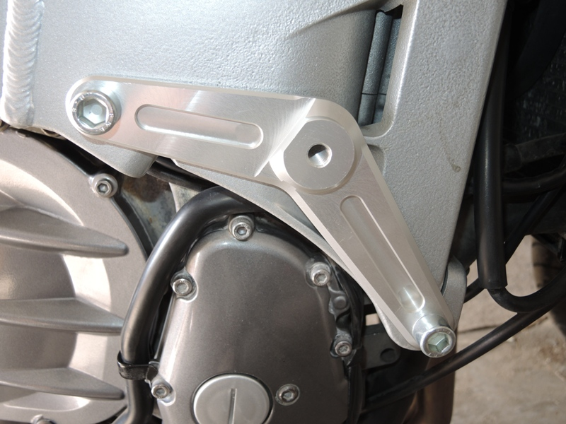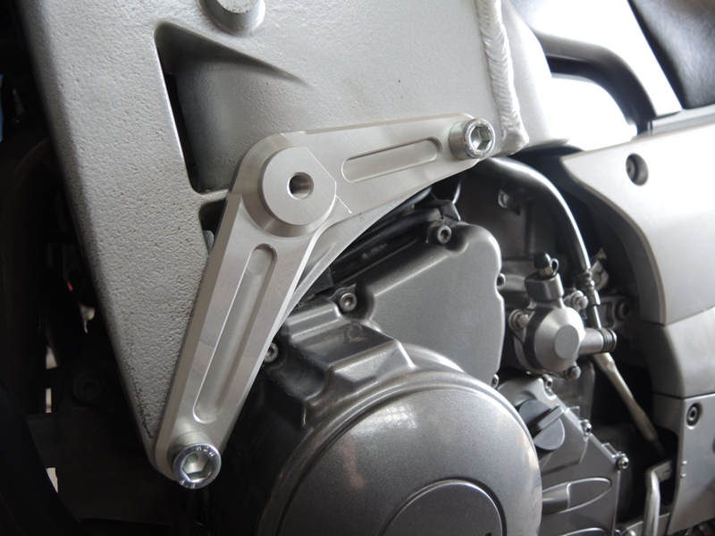
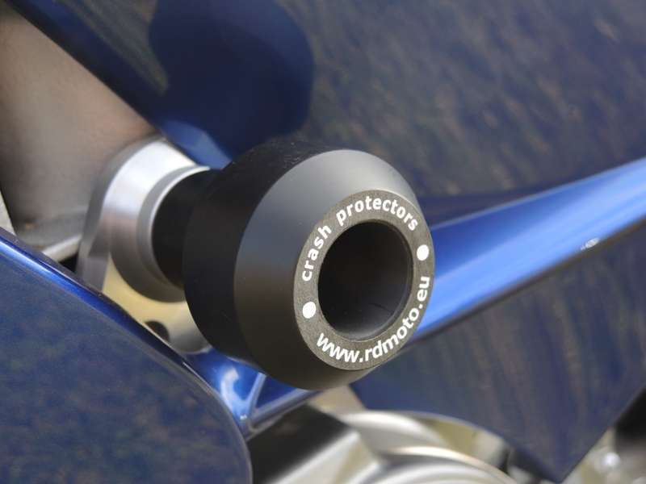

Warning: We recommend use the glue of all threads. Medium strong.

